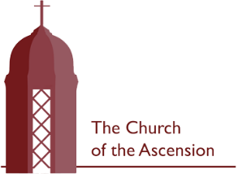
Sunday 12 July 2026
Trinity 6

A very warm welcome to church today to all regulars, visitors and newcomers.
WHAT’S ON?

Today
9am Morning Prayer
10am Holy Communion
Hymns: 33, 34, 66, 237, 329

Monday
9am Morning Prayer

There is no Morning Prayer on Tuesday this week.

Wednesday
9am Morning Prayer
10am Holy Communion (St Swithun)

Saturday 18 July
2-4.30pm Vicarage Garden Party in aid of
Homes of Promise, Uganda

Next Sunday
9am Morning Prayer
10am Holy Communion (Trinity 7)

Thursday 23 July
12.30pm Funeral for John Ray

Welcome
We invite everyone to stay for refreshments after all our services. If you are new or visiting today, we would love to get to know you!

Summer Music Concert
We hosted a fantastic concert last Sunday from the Tracey King Studios which made £500 for church funds. Huge thanks to Tracey and her students for a marvellous afternoon and a fabulous amount raised.
Sermons
An audio recording of the previous week’s sermon is now available on our A Church Near You page. Just scan the QR Code and find the notice for last Sunday, then scroll to ‘More Info’ and simply click. (If you are using a mobile device, you may be asked to download Soundcloud).



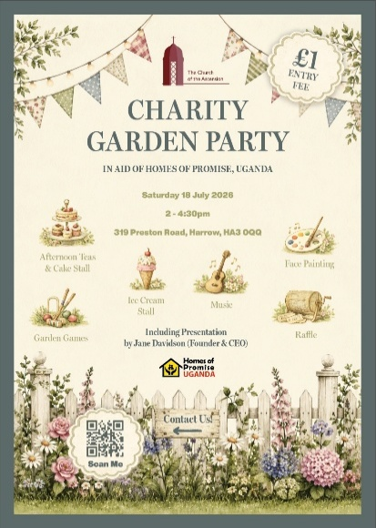

Charity Garden Party – Next Saturday 18 July
2-4.30pm
at The Vicarage, 319 Preston Road
There will be afternoon tea, cake stall, and a quiet area inside as well as a presentation by Homes of Promise, Uganda for whom we are fund raising. In the garden, there’s live music, dance troupe, garden games, face painting and crafts. Our Grand Draw is at 4.20pm with top prizes - £100 in Cash, two hairdresser’s vouchers, pub voucher, fruit pannier, photoshoot and bottle of fizz all donated by local businesses. £1 entry for adults. Please come and bring friends to what we plan will be the first in a series of annual charity events at the vicarage.
Collect
Lord of all power and might,
the author and giver of all good things:
graft in our hearts the love of your name,
increase in us true religion,
nourish us with all goodness,
and of your great mercy keep us in the same;
through Jesus Christ your Son our Lord,
who is alive and reigns with you,
in the unity of the Holy Spirit,
one God, now and for ever.

Post Communion Prayer
Lord God, whose Son is the true vine
and the source of life,
ever giving himself that the world may live:
may we so receive within ourselves
the power of his death and passion
that, in his saving cup,
we may share his glory
and be made perfect in his love;
for he is alive and reigns, now and for ever.

Second Reading: Romans 8.1-11
There is therefore now no condemnation for those who are in Christ Jesus. For the law of the Spirit of life in Christ Jesus has set you free from the law of sin and of death. For God has done what the law, weakened by the flesh, could not do: by sending his own Son in the likeness of sinful flesh, and to deal with sin, he condemned sin in the flesh, so that the just requirement of the law might be fulfilled in us, who walk not according to the flesh but according to the Spirit. For those who live according to the flesh set their minds on the things of the flesh, but those who live according to the Spirit set their minds on the things of the Spirit. To set the mind on the flesh is death, but to set the mind on the Spirit is life and peace. For this reason the mind that is set on the flesh is hostile to God; it does not submit to God’s law—indeed it cannot, and those who are in the flesh cannot please God.
But you are not in the flesh; you are in the Spirit, since the Spirit of God dwells in you. Anyone who does not have the Spirit of Christ does not belong to him. But if Christ is in you, though the body is dead because of sin, the Spirit is life because of righteousness. If the Spirit of him who raised Jesus from the dead dwells in you, he who raised Christ from the dead will give life to your mortal bodies also through his Spirit that dwells in you.

First Reading: Genesis 25.19-34
These are the descendants of Isaac, Abraham’s son: Abraham was the father of Isaac, and Isaac was forty years old when he married Rebekah, daughter of Bethuel the Aramean of Paddan-aram, sister of Laban the Aramean. Isaac prayed to the Lord for his wife, because she was barren; and the Lord granted his prayer, and his wife Rebekah conceived. The children struggled together within her; and she said, ‘If it is to be this way, why do I live?’ So she went to inquire of the Lord. And the Lord said to her,
‘Two nations are in your womb,
and two peoples born of you shall be divided;
one shall be stronger than the other,
the elder shall serve the younger.’
When her time to give birth was at hand, there were twins in her womb. The first came out red, all his body like a hairy mantle; so they named him Esau. Afterwards his brother came out, with his hand gripping Esau’s heel; so he was named Jacob. Isaac was sixty years old when she bore them.
When the boys grew up, Esau was a skilful hunter, a man of the field, while Jacob was a quiet man, living in tents. Isaac loved Esau, because he was fond of game; but Rebekah loved Jacob.

Once when Jacob was cooking a stew, Esau came in from the field, and he was famished. Esau said to Jacob, ‘Let me eat some of that red stuff, for I am famished!’ (Therefore he was called Edom.) Jacob said, ‘First sell me your birthright.’ Esau said, ‘I am about to die; of what use is a birthright to me?’ Jacob said, ‘Swear to me first.’ So he swore to him, and sold his birthright to Jacob. Then Jacob gave Esau bread and lentil stew, and he ate and drank, and rose and went his way. Thus Esau despised his birthright.

Contact the Vicar
(Sunday through Wednesday)
nickjones.ascension@gmail.com
07515 736822

Gospel: Matthew 13.1-9, 18-23
That same day Jesus went out of the house and sat beside the lake. Such great crowds gathered around him that he got into a boat and sat there, while the whole crowd stood on the beach. And he told them many things in parables, saying: ‘Listen! A sower went out to sow. And as he sowed, some seeds fell on the path, and the birds came and ate them up. Other seeds fell on rocky ground, where they did not have much soil, and they sprang up quickly, since they had no depth of soil. But when the sun rose, they were scorched; and since they had no root, they withered away. Other seeds fell among thorns, and the thorns grew up and choked them. Other seeds fell on good soil and brought forth grain, some a hundredfold, some sixty, some thirty. Let anyone with ears listen!’
‘Hear then the parable of the sower. When anyone hears the word of the kingdom and does not understand it, the evil one comes and snatches away what is sown in the heart; this is what was sown on the path. As for what was sown on rocky ground, this is the one who hears the word and immediately receives it with joy; yet such a person has no root, but endures only for a while, and when trouble or persecution arises on account of the word, that person immediately falls away. As for what was sown among thorns, this is the one who hears the word, but the cares of the world and the lure of wealth choke the word, and it yields nothing. But as for what was sown on good soil, this is the one who hears the word and understands it, who indeed bears fruit and yields, in one case a hundredfold, in another sixty, and in another thirty.’

