
SPIRE & LIGHT United Churches
United Benefice of St Keverne, St Ruan with St Grade & St.Wynwallow (The Lizard)

*If you do not wish to receive these notices, please let your Churchwarden know*

2nd August 2026


Readings
Isaiah 55:1-5
Psalm 145:8-9,15-22
Romans 9:1-5
Matthew 14:13-21

9.30am – Holy Communion - St.Peter’s, Coverack
9.30am – Holy Communion (BCP) - St.Wynwallow, The Lizard
11am – Morning Prayer (BCP) – St.Keverne

11am – Treveddon Field for the Vintage Car Rally (not 11.15am Morning Prayer in St Ruan Church)

Next week – Sunday August 9th
9.30am – Morning Prayer - St.Peter’s, Coverack
9.30am – Holy Communion - St.Ruan, Ruan Minor
11am – Holy Communion - St.Keverne
11.15am – Café Church – St.Wynwallow, The Lizard
6pm – Evensong – St.Grade



The Prayer Spot
On the Way Prayers

The holiday season is in full swing. Lord we pray that our churches can be places of prayer, historic interest, architectural wonder, perfect peace and generous hospitality to all who visit us this holiday period. As church communities we can be stretched, by members themselves being on holiday or entertaining visitors, by extra events, and by the fact that most of us welcome so many new and returning holiday makers. Give us the strength and tenacity to keep going. Bless all who visit us here in Kerrier and may they return refreshed and with really happy memories of welcoming churches.

Last week we heard the great news that a Pastoral Priest has been appointed to come and join our ministry team. We pray for Stewart and his wife as they prepare to move to Cornwall, to leave their current lifestyle which will maybe quite different from what they are going to experience here. We pray for the work that Stewart has done in ministering to members of the RAF and we pray that his ministry here will help us all to become more pastorally aware and better able to service our communities.

We all care deeply for our congregations and communities and praying for them, particularly when in need, can be the most important thing we can do, so let us pray for anyone known to us who needs the support of our collective prayers right now. Lord comfort all for whom we have prayed and give them peace.

Whatever the weather, we are prone to moan! Lord help us to enjoy each season and work with the challenges that this hot, dry summer is bringing. May we do all we can to help those who are struggling with the heat and, if we are struggling, help us to find ways to keep cool and calm. We pray particularly for those places suffering from wildfires – particularly in SW France and Spain. We pray too for all those suffering from the aftermath of the earthquake in Japan and those in Venezuela who are still searching for the bodies of loved ones. Lord your planet is fragile and we haven’t always treated it as carefully as we should have done. Help us now to do everything we can to protect and rescue it.

God of the Summer may this be for us a season of growth and friendship, a season of activity and celebration. May vigour and love flow strongly through our veins.
Amen

The Diocese of Truro’s Prayer Diary for this week

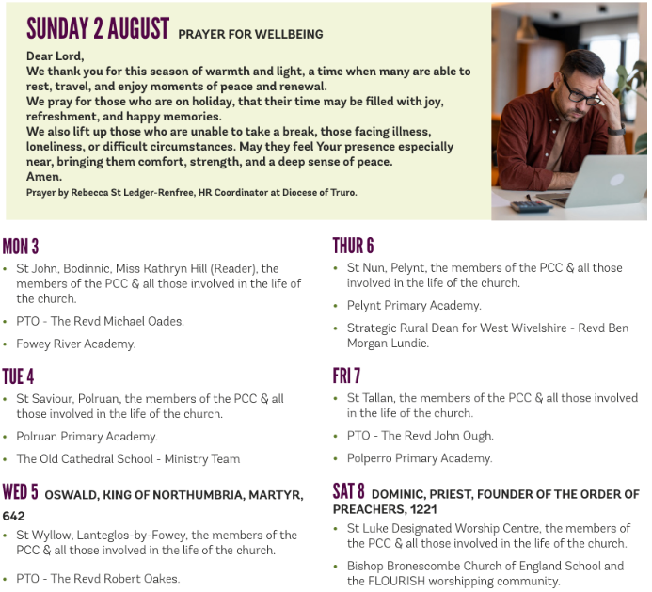

We pray for the Deanery that we belong to and we thank you for the faithful people you have brought together here. Remind us that we have each been brought to faith by Our Saviour Jesus Christ.
Lord Jesus, we thank you for your presence in our lives and the love you give us to share with others. Keep us strong in our faith and close to you.
Help us to be always there for others in their time of need, you have given us each gifts to use to reach out to others and to give comfort to those around us.
Heavenly Father we live in a world slowly destroying itself, through greed, hatred, and with no concern for others. Remind us that we can bring love, care and understanding into the world, by reaching out into our communities and showing your love to all we meet. Loving God, be with us always. Remind us that we are brothers and sisters in Christ Jesus, that God is ever present in our lives, through his wonderful Holy Spirit that he has given to you as a free gift to us all.
Mighty God, everything you do reveals your Majesty. Open our eyes to see what you are doing in our lives. Let us marvel at your good gifts and your wise provision. Your acts are amazing Lord. We cannot comprehend the number of blessings you pour out to us from day to day. As we gather today around your name, we pray that you will fill our hearts, our minds and our souls. Transform us Lord and make us more like you. Through Jesus Christ our Lord. Amen
God bless you all. Samuel Buchanan

