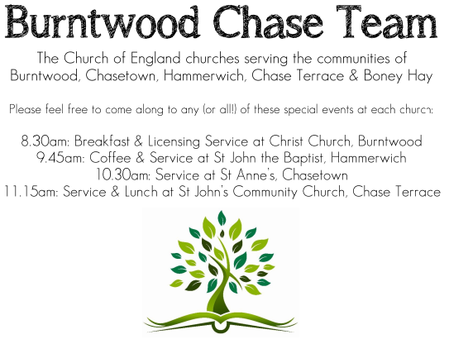
CHRIST CHURCH, BURNTWOOD
Registered Charity Nos: 1217129

SERVICE ON SUNDAY 26TH JULY 2026 at 10 am

MORNING WORSHIP

The 8th Sunday after Trinity

First Bible Reading - Kings 3: 5-12

5 At Gibeon the Lord appeared to Solomon in a dream by night, and God said, “Ask what I should give you.” 6 And Solomon said, “You have shown great and steadfast love to your servant my father David because he walked before you in faithfulness, in righteousness, and in uprightness of heart toward you, and you have kept for him this great and steadfast love and have given him a son to sit on his throne today.

7 And now, O Lord my God, you have made your servant king in place of my father David, although I am only a little child; I do not know how to go out or come in. 8 And your servant is in the midst of the people whom you have chosen, a great people so numerous they cannot be numbered or counted. 9 Give your servant, therefore, an understanding mind to govern your people, able to discern between good and evil, for who can govern this great people of yours?”
10 It pleased the Lord that Solomon had asked this. 11 God said to him, “Because you have asked this and have not asked for yourself long life or riches or for the life of your enemies but have asked for yourself understanding to discern what is right.
12 I now do according to your word. Indeed, I give you a wise and discerning mind; no one like you has been before you, and no one like you shall arise after you.

Gospel Reading - Matthew 13: 31-33, 44-52

31 He put before them another parable: “The kingdom of heaven is like a mustard seed that someone took and sowed in his field; 32 it is the smallest of all the seeds, but when it has grown it is the greatest of shrubs and becomes a tree, so that the birds of the air come and make nests in its branches.” 33 He told them another parable: “The kingdom of heaven is like yeast that a woman took and mixed in with three measures of flour until all of it was leavened.”

⁴⁴ “The kingdom of heaven is like treasure hidden in a field, which a man found and reburied; then in his joy he goes and sells all that he has and buys that field. ⁴⁵ “Again, the kingdom of heaven is like a merchant in search of fine pearls; ⁴⁶ on finding one pearl of great value, he went and sold all that he had and bought it.

⁴⁷ “Again, the kingdom of heaven is like a net that was thrown into the sea and caught fish of every kind; ⁴⁸ when it was full, they drew it ashore, sat down, and put the good into baskets but threw out the bad. ⁴⁹ So it will be at the end of the age. The angels will come out and separate the evil from the righteous ⁵⁰ and throw them into the furnace of fire, where there will be weeping and gnashing of teeth.

⁵¹ “Have you understood all this?” They answered, “Yes.” ⁵² And he said to them, “Therefore every scribe who has become a disciple in the kingdom of heaven is like the master of a household who brings out of his treasure what is new and what is old.”

Collect for Today

Almighty Lord and everlasting God, we beseech you to direct, sanctify and govern both our hearts and bodies in the ways of your laws and the works of your commandments; that through your most mighty protection, both here and ever, we may be preserved in body and soul; through our Lord and Saviour Jesus Christ, who is alive and reigns with you, in the unity of the Holy Spirit, one God, now and for ever. Amen.

Forthcoming Services in Church

Wednesday 22nd July Morning Prayer 9.30am

Sunday 26th July Morning Worship 10am

Sunday 2nd August Holy Communion 10am

Date Of Future Event For Your Diary
Saturday 14th November Christmas Fayre 2-4pm

Food bank

We are continuing to support this important ministry for people in need in our local community, for which the following items are always needed: ‘Long Life Milk, Custard, Rice Pudding, Cereals’. Many thanks for your support. The Food Bank is very grateful for whatever you may be able to donate.
Floodlighting
If you would like to commemorate a special occasion by floodlighting our Church. Please contact Chris Brown on 01543 683862 for details.

Prayer Chain

Christ Church is blessed with a very active prayer chain. If you, or anyone you know, feel that they would like others to pray for them, please speak to Chris Brown on 01543 683862.

Home Visits and Communion

For anyone who is unable to attend church and would like a Home Visit and Communion, please contact the Vicar and he will be able to carry this out.

Vicar’s Contact Details

Rev’d Stephen Morgan - Telephone: 07305 852152

Church Wardens Contact Details

Judith Rogers - Telephone: 01543 324718
Mike Holmes - Telephone: 01543 672970

Church Office Telephone: 01543 642187 [Please leave a message and we will respond]
Church Web Site:www.christchurchburntwood.org.uk
Church Email: christchurchburntwood15@gmail.com
Facebook: www.facebook.com/group/christchurchburntwood/

Next Sunday’s Service – The 9th Sunday after Trinity

Sunday 2nd August – Holy Communion at 10am

Bible Readings: Isaiah 55: 1-5 and Matthew 14: 13-21

