Palm 17: 1 to 7 & 16
Mothers’ Union – August Meeting
Please remember that the MU are having lunch together at the Café in the Community Centre on Wednesday 5th August, meeting at 12noon. This is instead of the meeting in church.
Please stand, if able, and join in with the verses in bold italics

Hear a just cause, O Lord; attend to my cry;
give ear to my prayer from lips free of deceit.
From you let my vindication come;
let your eyes see the right.

If you try my heart, if you visit me by night,
if you test me, you will find no wickedness in me;
my mouth does not transgress.
As for what others do, by the word of your lips
I have avoided the ways of the violent.
My steps have held fast to your paths;
my feet have not slipped.

I call upon you, for you will answer me, O God;
incline your ear to me, hear my words.
Wondrously show your steadfast love,
O saviour of those who seek refuge
from their adversaries at your right hand.

As for me, I shall behold your face in righteousness;
when I awake I shall be satisfied, beholding your likeness.

Glory be to the Father and to the Son and to the Holy Spirit,
as it was in the beginning, is now and ever shall be,
world without end. Amen

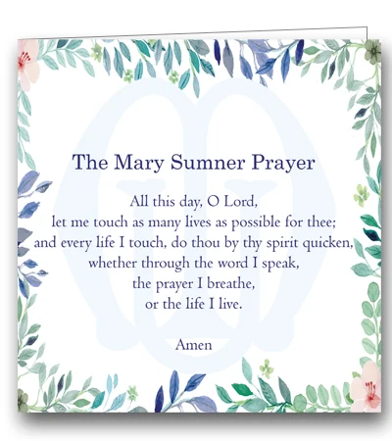

In our weekly prayers for our parish
This week we pray for God’s blessing on Dumbles Close, Eaton Avenue, and Elka Rise
Distribution of Communion –currently the Priest will dip the communion wafer in the wine while we discern a safe way to bring the common cup back into worship, as we want everyone to feel included and safe. We also have gluten free wafers available.
Refreshments After the Morning Service
Please stay seated after the service and a hot drink will be brought to you in the pews. Do not get up and head to the back of church, it is becoming a hazard, and a risk as trays of hot drinks could be knocked over.

All Saints Church
Church contact information
Contact: Rev’d Christine - revchristine@outlook.com
The Rectory, The Village, West Hallam, DE7 6GR
Landline 0115 646 1497
Rev’d Ailsa -revailsahunt@gmail.com
Tel - 07356064856

Churchwardens – Mrs Janet Wheeldon, -Tel: 0115 8771593
Mrs Linda Gregory – linda.gregory3@icloud.com
https://www.achurchnearyou.com/church/13402/
https://www.facebook.com/allsaintskirkhallam
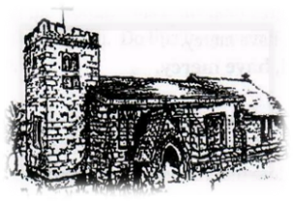
Kirk Hallam
Disabled Toilet in Friendship House.
Disabled Toilet in Friendship House.

Working with God to transform lives & communities.
Please can you ensure your mobile is on silence, or off during the service, it is affecting people with hearing aids and the loop system.

2nd August – Ninth Sunday After Trinity
10.00am CW Communion Service with Rev’d Christine
6.00pm BCP Evening Prayer with Rev’d Jan

Forthcoming Events
Mon 3rd 12noon Internment of ashes for David Holmes
Tues 4th 6.30pm Home Group in Friendship House
Weds 5th 9.30am Morning Prayer at UCAS
Weds 5th 12noon Mothers Union Lunch in Com Café
Thurs 6th 2.00pm Funeral for Grace Beadsmore in Church
Fri 7th 6.00pm Choir in Friendship House
Sat 8th 10.00am Prayer Meeting in Friendship House

9th August – Tenth Sunday After Trinity
& Mary Sumner Day (Founder of the Mothers’ Union)
10.00am Iona Communion Service with Rev’d Christine
6.00pm Iona Evening Prayer with Eileen & Julie
It’s Good to Talk! If you spot that someone is missing, please pop a news sheet through their door, & if you’ve time, call for a chat - just to check they’re OK & to let them know that they are not forgotten!

Little Words of Wisdom
Can’t sleep? Don’t count sheep, talk to the Good Shepherd

