Notices:

CONTEMPLATIVE PRAYER GROUP – ALL SAINTS, CUDDESDON – 5pm on Wednesdays
ALL WELCOME – 30 minutes of silent prayer FOLLOWED BY: Midweek Eucharist 6pm in All Saints Cuddesdon.

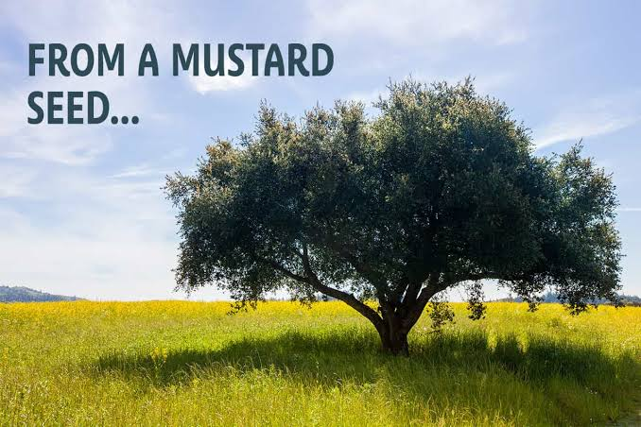

Next week’s service: (All Welcome – why not invite a friend?)
Sunday 2nd August
Cuddesdon, All Saint’s 8.00am Holy Communion (BCP)
9.30am Parish Communion
Garsington, St Mary’s 9.30am Parish Communion
Horspath, St Giles: 11.00am Morning Worship

Administrator and Contact details for booking baptisms, weddings, pastoral visits,
07540051798 Email gchbenefice@gmail.com


The weekly pew sheet for St Mary’s, Garsington, All Saints’, Cuddesdon and St Giles’, Horspath

Sunday 26th July Trinty 8 (Green)
Cuddesdon, All Saint s 9.30am Parish Communion
Garsington, St Mary’s 9.30am Breakfast discussion
Horspath, St Giles: 11.00for 11.15 Family Time followed by picnic

Collect.
Almighty Lord and everlasting God,
we beseech you to direct, sanctify and govern
both our hearts and bodies
in the ways of your laws
and the works of your commandments;
that through your most mighty protection, both here and ever,
we may be preserved in body and soul;
through our Lord and Saviour Jesus Christ,
who is alive and reigns with you,
in the unity of the Holy Spirit,
Post Communion
Strengthen for service, Lord,
the hands that have taken holy things;
may the ears which have heard your word
be deaf to clamour and dispute;
may the tongues which have sung your praise be free from deceit;
may the eyes which have seen the tokens of your love
shine with the light of hope;
and may the bodies which have been fed with your body
be refreshed with the fullness of your life;
glory to you for ever.
1 Kings 3.5-12
⁵At Gibeon the Lord appeared to Solomon in a dream by night; and God said, ‘Ask what I should give you.’ ⁶And Solomon said, ‘You have shown great and steadfast love to your servant my father David, because he walked before you in faithfulness, in righteousness, and in uprightness of heart towards you; and you have kept for him this great and steadfast love, and have given him a son to sit on his throne today. ⁷And now, O Lord my God, you have made your servant king in place of my father David, although I am only a little child; I do not know how to go out or come in. ⁸And your servant is in the midst of the people whom you have chosen, a great people, so numerous they cannot be numbered or counted. ⁹Give your servant therefore an understanding mind to govern your people, able to discern between good and evil; for who can govern this your great people?’
10 It pleased the Lord that Solomon had asked this. ¹¹God said to him, ‘Because you have asked this, and have not asked for yourself long life or riches, or for the life of your enemies, but have asked for yourself understanding to discern what is right, ¹²I now do according to your word. Indeed I give you a wise and discerning mind; no one like you has been before you and no one like you shall arise after you.

Romans 8.26-end
26 Likewise the Spirit helps us in our weakness; for we do not know how to pray as we ought, but that very Spirit intercedes with sighs too deep for words. ²⁷And God, who searches the heart, knows what is the mind of the Spirit, because the Spirit intercedes for the saints according to the will of God.
28 We know that all things work together for good for those who love God, who are called according to his purpose. ²⁹For those whom he foreknew he also predestined to be conformed to the image of his Son, in order that he might be the firstborn within a large family.³⁰And those whom he predestined he also called; and those whom he called he also justified; and those whom he justified he also glorified.
31 What then are we to say about these things? If God is for us, who is against us?³²He who did not withhold his own Son, but gave him up for all of us, will he not with him also give us everything else? ³³Who will bring any charge against God’s elect? It is God who justifies. ³⁴Who is to condemn? It is Christ Jesus, who died, yes, who was raised, who is at the right hand of God, who indeed intercedes for us.³⁵Who will separate us from the love of Christ? Will hardship, or distress, or persecution, or famine, or nakedness, or peril, or sword? ³⁶As it is written,
‘For your sake we are being killed all day long;
we are accounted as sheep to be slaughtered.’
³⁷No, in all these things we are more than conquerors through him who loved us.³⁸For I am convinced that neither death, nor life, nor angels, nor rulers, nor things present, nor things to come, nor powers, ³⁹nor height, nor depth, nor anything else in all creation, will be able to separate us from the love of God in Christ Jesus our Lord.

Matthew 13.31-33,44-52
31 He put before them another parable: ‘The kingdom of heaven is like a mustard seed that someone took and sowed in his field; ³²it is the smallest of all the seeds, but when it has grown it is the greatest of shrubs and becomes a tree, so that the birds of the air come and make nests in its branches.’
33 He told them another parable: ‘The kingdom of heaven is like yeast that a woman took and mixed in with three measures of flour until all of it was leavened.’
44 ‘The kingdom of heaven is like treasure hidden in a field, which someone found and hid; then in his joy he goes and sells all that he has and buys that field.
45 ‘Again, the kingdom of heaven is like a merchant in search of fine pearls; ⁴⁶on finding one pearl of great value, he went and sold all that he had and bought it.
47 ‘Again, the kingdom of heaven is like a net that was thrown into the sea and caught fish of every kind; ⁴⁸when it was full, they drew it ashore, sat down, and put the good into baskets but threw out the bad. ⁴⁹So it will be at the end of the age. The angels will come out and separate the evil from the righteous ⁵⁰and throw them into the furnace of fire, where there will be weeping and gnashing of teeth.
51 ‘Have you understood all this?’ They answered, ‘Yes.’ ⁵²And he said to them, ‘Therefore every scribe who has been trained for the kingdom of heaven is like the master of a household who brings out of his treasure what is new and what is old.’

Please pray for growth in all of the churches in our Benefice God of mission, who alone brings growth to your Church, send your Holy Spirit to give vision to our planning, wisdom and love to our actions, joy to our worship, and power to our witness. Help our churches (St Mary’s, Garsington; All Saints’, Cuddesdon and St Giles’, Horspath) to grow in numbers, in spiritual commitment to you, in generous giving, and in loving service to each other and to our local communities. Amen.

Please pray for:
- The people of Venezuela, Gaza, Palestine, Iran, Israel, Lebanon, Syria; Ukraine, Yemen, Sudan and all conflict zones – for a lasting ceasefire, peace with justice, reconciliation, mercy and compassion
- For all those struggling to cope with the recent extreme heat, especially the elderly, the vulnerable and those with no home or shelter.
- For a safe harvest, for farmers struggling with drought, and for all who work to provide our food and drink.
- All refugees, asylum seekers, and those who support refugees
- Our parishes of Garsington, Cuddesdon and Horspath, our Churchwardens, Clergy, Treasurers, Secretaries and PCCs
- Our Benefice Safeguarding Officer, (Kathryn) and all that we do to keep children and vulnerable adults safe
- Story-time Church, Sunday Fun Time, Action Stations, Family Time, our all-age Eucharists, and all our work with children, young people and families
- Our Church Primary schools in Garsington and Horspath – for the Headteachers, staff and pupils and governors and for rest and refreshment during the school holidays.
- For Ripon College Cuddesdon – for the Principal the Revd Dr Harriet Harris, for all members of staff and all the community – particularly those who left those who remain, and those who will begin training in September or October

Those who are sick, grieving, or in any kind of need, remembering especially:
Reverend Tom and his family as they mourns the death of his Father.
Garsington:
Cuddesdon: Julie Grindod,
Horspath: Anne & Bob Adams, John Llewellyn,
For those who have died, and those who grieve for them including Sylvia Morris Ronald Griffiths, and David Ruffels from Garsington; Judith Hetherington and Shirley Woodcock from Horspath;, Christopher Efstratiou, and Alan from Cuddesdon

