The Winterbournes and Compton Valence

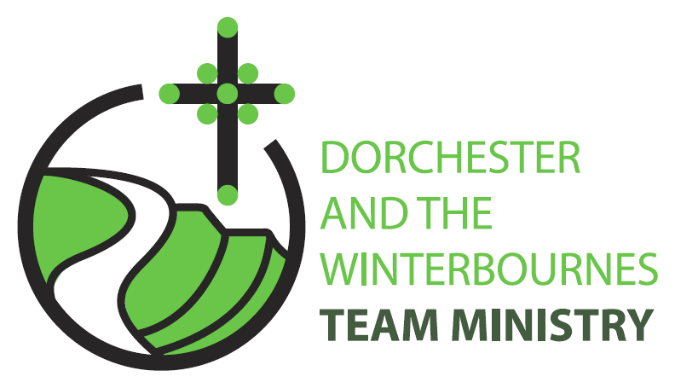

Trinity 5
11th July 2026

Welcome to this service in the Ordinary Season. We rejoice today in God’s call to be fruitful; and that with him, we can grow the Kingdom in our village communities. So we are encouraged to work in partnership with God, side by side bringing the Gospel to our neighbours and friends. In our prayers we continue to pray for refugees and for communities afflicted by war and for the continued peace processes in Iran and Israel and Ukraine. We also pray for those affected by Climate Change and extreme heat, wildfires and famine

Collect
Almighty God,
send down upon your Church
the riches of your Spirit,
and kindle in all who minister the gospel
your countless gifts of grace;
through Jesus Christ our Lord.
All: Amen

Reading: Romans 8: 1-11

There is therefore now no condemnation for those who are in Christ Jesus. ² For the law of the Spirit of life in Christ Jesus has set you free from the law of sin and of death. ³ For God has done what the law, weakened by the flesh, could not do: by sending his own Son in the likeness of sinful flesh, and to deal with sin, he condemned sin in the flesh, ⁴ so that the just requirement of the law might be fulfilled in us, who walk not according to the flesh but according to the Spirit. ⁵ For those who live according to the flesh set their minds on the things of the flesh, but those who live according to the Spirit set their minds on the things of the Spirit. ⁶ To set the mind on the flesh is death, but to set the mind on the Spirit is life and peace. ⁷ For this reason the mind that is set on the flesh is hostile to God; it does not submit to God’s law—indeed it cannot, ⁸ and those who are in the flesh cannot please God.
⁹ But you are not in the flesh; you are in the Spirit, since the Spirit of God dwells in you. Anyone who does not have the Spirit of Christ does not belong to him. ¹⁰ But if Christ is in you, though the body is dead because of sin, the Spirit is life because of righteousness. ¹¹ If the Spirit of him who raised Jesus from the dead dwells in you, he who raised Christ from the dead will give life to your mortal bodies also through his Spirit that dwells in you.

This is the word of the Lord.
All: Thanks be to God.

Gospel Reading: Matthew 13: 1-9, 18-23

Hear the Gospel of our Lord Jesus Christ according to Matthew.
All: Glory to you, O Lord.

That same day Jesus went out of the house and sat beside the lake. ² Such great crowds gathered around him that he got into a boat and sat there, while the whole crowd stood on the beach. ³ And he told them many things in parables, saying: ‘Listen! A sower went out to sow. ⁴ And as he sowed, some seeds fell on the path, and the birds came and ate them up. ⁵ Other seeds fell on rocky ground, where they did not have much soil, and they sprang up quickly, since they had no depth of soil. ⁶ But when the sun rose, they were scorched; and since they had no root, they withered away. ⁷ Other seeds fell among thorns, and the thorns grew up and choked them. ⁸ Other seeds fell on good soil and brought forth grain, some a hundredfold, some sixty, some thirty. ⁹ Let anyone with ears listen!’
¹⁸ ‘Hear then the parable of the sower. ¹⁹ When anyone hears the word of the kingdom and does not understand it, the evil one comes and snatches away what is sown in the heart; this is what was sown on the path. ²⁰ As for what was sown on rocky ground, this is the one who hears the word and immediately receives it with joy; ²¹ yet such a person has no root, but endures only for a while, and when trouble or persecution arises on account of the word, that person immediately falls away. ²² As for what was sown among thorns, this is the one who hears the word, but the cares of the world and the lure of wealth choke the word, and it yields nothing. ²³ But as for what was sown on good soil, this is the one who hears the word and understands it, who indeed bears fruit and yields, in one case a hundredfold, in another sixty, and in another thirty.’
This is the Gospel of the Lord.
All: Praise to you, O Christ.

Post Communion Prayer
God of our pilgrimage,
You have led us to the living water;
Refresh and sustain us as we go forward on our journey,
In the name of Jesus Christ our Lord.
All: Amen
NOTICES:

Winterbournes Parish weekend retreat at Lee Abbey- 2027
If you would be interested in joining a group from our parish churches on a weekend retreat at Lee Abbey next spring/summer, please speak to Cathie (01305 889244) or Nigel (01305 889910). The cost is around £210 per person for full board (en-suite facilities, of which there is limited availability, cost a little more). If enough people are interested we would be able to receive a group discount. We think this could be an exciting opportunity for us to have time and a shared experience together listening to God and to each other. There will be time also to participate in a variety of activities.

PRAYERS FOR THE WEEK

From Christian Aid

Lord, hear us as we pray for your creation. We pray for an end to the destruction of the natural world. We hold before you communities who are watching their land become parched and their rivers dry up. We grieve for what has already been lost and damaged. Show us how to act now to help those most affected by the climate crisis. Energise us, that we may use our power to make change happen.

We watch in hope for the Lord: our God will hear us.

Lord, hear us as we pray with thanksgiving for peacemakers and changemakers. Strengthen those working for peace and protecting human rights. We pray for a just peace wherever there is conflict, thinking especially in the Middle East, an end to the war in Ukraine. Those affected by conflict in Sudan.

We watch in hope for the Lord: our God will hear us.

Lord, you welcome us when we are heavy laden with sorrow or pain, in you we find rest. We pray for all those known to us who are sick or suffering. Remembering particularly: Andreas, Maggie and Bruce, Baby Wren & Baby Ronnie and their families, John & Mandy
We pray for all who grieve, especially for communities living in poverty around the world who have suffered great losses: the loss of homes, the loss of access to clean water, the loss of family members. Bless those who mourn and give them your comfort. We also remember the families of those whose years mind occurs this month Ralph Browning, Maureen Marchant, Jack Kelsey, Bill Whitlle, Nina Lines, Trevor Bassett, Charles Delmain, Jacqueline Ann Nichols

We watch in hope for the Lord: our God will hear us.

