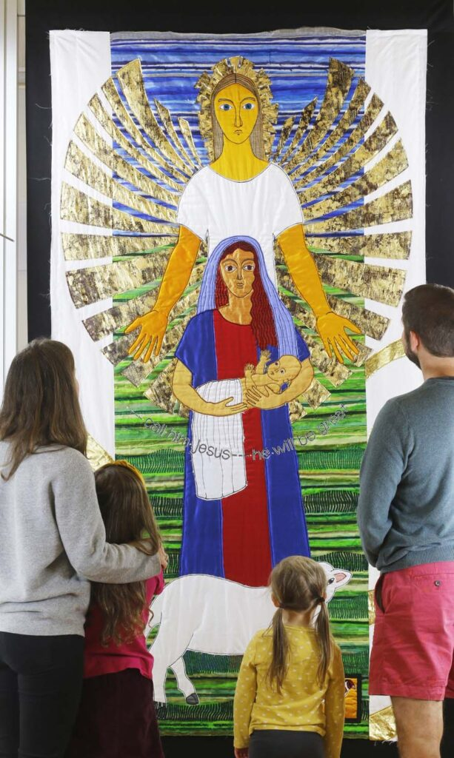
Threads through the Cross Tapestry

Holy Trinity Church Newsletter August 2026
Sunday and Wednesday Services are available to watch live or recorded on Facebook via the Holy Trinity Facebook page.

Future Events
Parish Trip to Southwark Cathedral: Saturday 26th September 2026
On Saturday 26th September Revd Rachel is leading a Parish Trip to visit Southwark Cathedral, which will include the chance to take in the ‘Cross’ section of the very beautiful ‘Threads through the Bible’ exhibition by tapestry artist Jacqui Parkinson https://www.jacqui-textile.com/bible/ . There will be free time to explore the cathedral and have some time in London, before finishing the day back at the cathedral for Choral Evensong (tbc) at 4pm. Here are some key details for the day:
Timings (to be confirmed nearer the time):
0915: Meet at Bishop’s Stortford station to buy tickets to London Bridge to board the train at 0937
~1100: Arrive Southwark cathedral and visit the exhibition
~1300: Free time to find lunch and explore Southwark/South Bank etc
1600: Choral Evensong (hopefully, tbc nearer the time)
~1645: Gather after evensong and return to London Bridge to get train home
~1815: Arrive Bishop’s Stortford
Cost: There is no charge to visit Southwark Cathedral or the tapestry exhibition, however if you are able, please make a donation at the visitor points. If you have a Senior Railcard or a Network Railcard the return train ticket is likely to be less than £20. If you don’t have a railcard, please pair up with someone with a Network Railcard to benefit from this reduced price.
Booking: So that Revd Rachel can let the cathedral know the size of our group, and to enable Revd Rachel to let you know of any updates to the plans, please book here via Eventbrite: https://www.eventbrite.co.uk/e/holy-trinity-day-trip-to-southwark-cathedral-tickets-1992767981677
If you can’t access the internet, please speak to Revd Rachel and she will add you to the list.
Book Club. Interested in joining the book club? First Friday of each month at 2pm in the church. The next meeting is 7th August at 2pm the book we have been reading is "Pheobe" a Deacon of the church at Cenchreae who was entrusted with a Letter from Paul to the Romans. Written by Paula Gooder.
The book for August is Daughter of Cana by Angela Hunt about twins Thomas and Tasmin who are hired to oversee a wedding feast when a miracle working guest draws her brother away to join him.
Daughter of Cana: Free Delivery when you spend £15 at Eden.co.uk , also available from Amazon as a Kindle download for £7.69 to use on Tablets or Kindles. Also available on Audible or it can also be purchased second hand on eBay and various second-hand book websites. If you are interested, please contact Jocelyn jgchurchwardenhtbs@outlook.com

Notices
We are delighted to announce that the new Treasurer is Peter Watson. He will attend the next PCC meeting on 13th September with Archdeacon Janet presiding.

Services in August

2nd August 9th Sunday after Trinity 10.00-11a.m. Holy Communion with Hymns
Readings: Isaiah 55: 1-5, Romans 9: 1-5, Matthew 14: 13-2
Self-service Refreshments after the service, please wash up your cup.

5th Aug 10.00-10.45 a.m. Wednesday Holy Communion.
7th Aug 09.15 -09.45 a.m. Friday Morning Prayer.

9th August 10th Sunday after Trinity 10.00-11a.m. Holy Communion with Hymns
Readings: 1 Kings 19: 9-18, Romans 10: 5-15, Matthew 14: 22-33
Prayer ministry is available after the service.
Refreshments are served after the service.

12th Aug 10.00-10.45 a.m. Wednesday Holy Communion.
14th Aug 09.15 -09.45 a.m. Friday Morning Prayer.

16th August 11th Sunday after Trinity 10.00-11a.m. Holy Communion with Hymns
Readings: Isaiah 56: 1, 6-8, Romans 11: 1-2a, 29-32, Matthew 15: 10-28,
Self-service Refreshments after the service, please wash up your cup.

19th Aug 10.00-10.45 a.m. Wednesday Holy Communion.
21st Aug 09.15 -09.45 a.m. Friday Morning Prayer.

23rd August 12th Sunday after Trinity 10.00-11a.m. Holy Communion with Hymns
Readings: Isaiah 51: 1-6, Romans 12: 1-8, Matthew 16: 13-20
Refreshments are served after the service.
12:30 Service of Holy Baptism

26th Aug 10.00-10.45 a.m. Wednesday Holy Communion.
28th Aug 09.15 -09.45 a.m. Friday Morning Prayer.

30th August 13th Sunday after Trinity 10.00-11a.m. Holy Communion with Hymns
Readings: Jeremiah 15: 15-21, Romans 12: 9-end, Matthew 16: 21-end
Self-service Refreshments after the service, please wash up your cup.

Donations.
If you would like to donate to the church there is a donation box and card reader by the main door, also a basket is handed round during the offertory hymn, or you can make a direct debit offering monthly by contacting Susan Self the Treasurer. Yellow Gift Aid envelopes are available in the back of the chairs if you are a taxpayer. If you use direct debit for giving, tokens are available to put in the offertory basket to be blessed at the altar.

Contact.If you would like to arrange a wedding, baptism, funeral or speak to a member of the ministry team, add someone to the intercessions prayer list or departed prayer list, have Home Communion or home visit, pray with someone or hire the church, please contact the church office at jgchurchwardenhtbs@outlook.com or call 01279 651671.

