Acrise church News for August 2026
Services for August
Sunday 2nd August Holy Communion BCP Sharon
Sunday 9th August Matins BCP Janet
Sunday 16th August Morning Prayer CW Paul
Sunday 23rd August Service of the word CW Bill
Sunday 30th August Benefice Eucharist at Denton Carol and Sharon
The Benefice Service will be at 10.00am and the other services at 9.30am.
Sunday 28th June: Benefice Eucharist at All Saints, Stanford
This was held to celebrate Reverend Stephen Dougal’s 20 years of ordained ministry and was very well attended. It was a happy occasion and an opportunity for the Benefice to thank Stephen for his valuable ministry. It was also a time for us to catch up with friends from other benefice churches as we enjoyed refreshments outside the church on this hot summer morning. Thanks to all those who organised and took part in the service and to all who provided refreshments. We wish Stephen well for his future.
Sunday 5th July: Holy Communion at St Martin’s Acrise.
Stephen led the Holy Communion after which we had a 10th Wedding Anniversary Blessing for Rob and Brenley Martin with their sons George and Cameron. They are well known members of our church family and attend our Family Services. George read a prayer as part of the blessing, his first time reading in church. Well done George. It was a moving and happy occasion and we wish the family many more years of happiness. Most people stayed for refreshments and a chat after the service.
Wednesday 15th July: Selsted C of E Primary School Leavers’ Service
We were pleased to welcome Year 6 leavers, all year 5, Headteacher Mrs Woodgate, with some other members of staff and parents. Lesley, from Denton and Wotton, one of the team who supports our benefice Primary Schools, led the service with Mrs Woodgate. It was a lively service with plenty of pupil participation, with readings and prayers, presenting items that remind them of their time at Selsted, and singing of ‘Jesus Loves Me’ and ‘When I Needed a Neighbour’.
Lesley gave an engaging talk about the importance of ‘resilience’ as the Year 6 leavers move on to the next stage of their lives, with topical reference to some of the England football team and how they had shown great resilience to get where they are now. The leavers then stood in the aisle facing one another and were given a candle each. These were lit by the staff to represent Jesus the light of the world being with them as they move on to secondary school. After the service the children lined up to ring the bell, a tradition at our Family Services.
The Garage Sale and Raffle: Saturday 27th June - Saturday 4th July
This was again a great success and is now an established community event which provides interest, enjoyment and social contact as well as raising money for the church. It is now our most significant fundraiser after the Acrise Festival.
We thank Richard for organising the event and providing the venue at his home: thanks also to the Garage Sales Team who support him, especially Victoria.
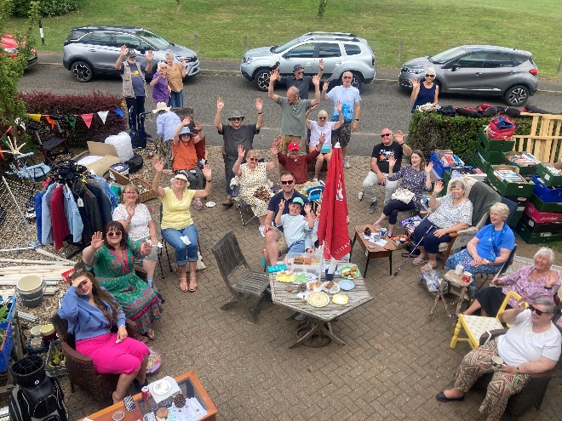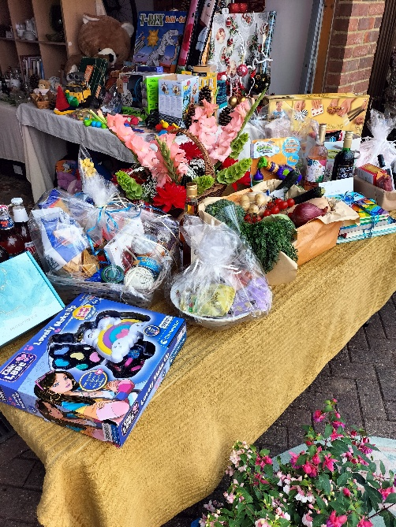
The get together and draw for the raffle prizes on Saturday 4th July.
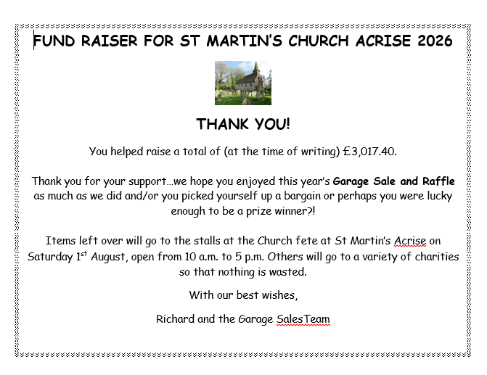
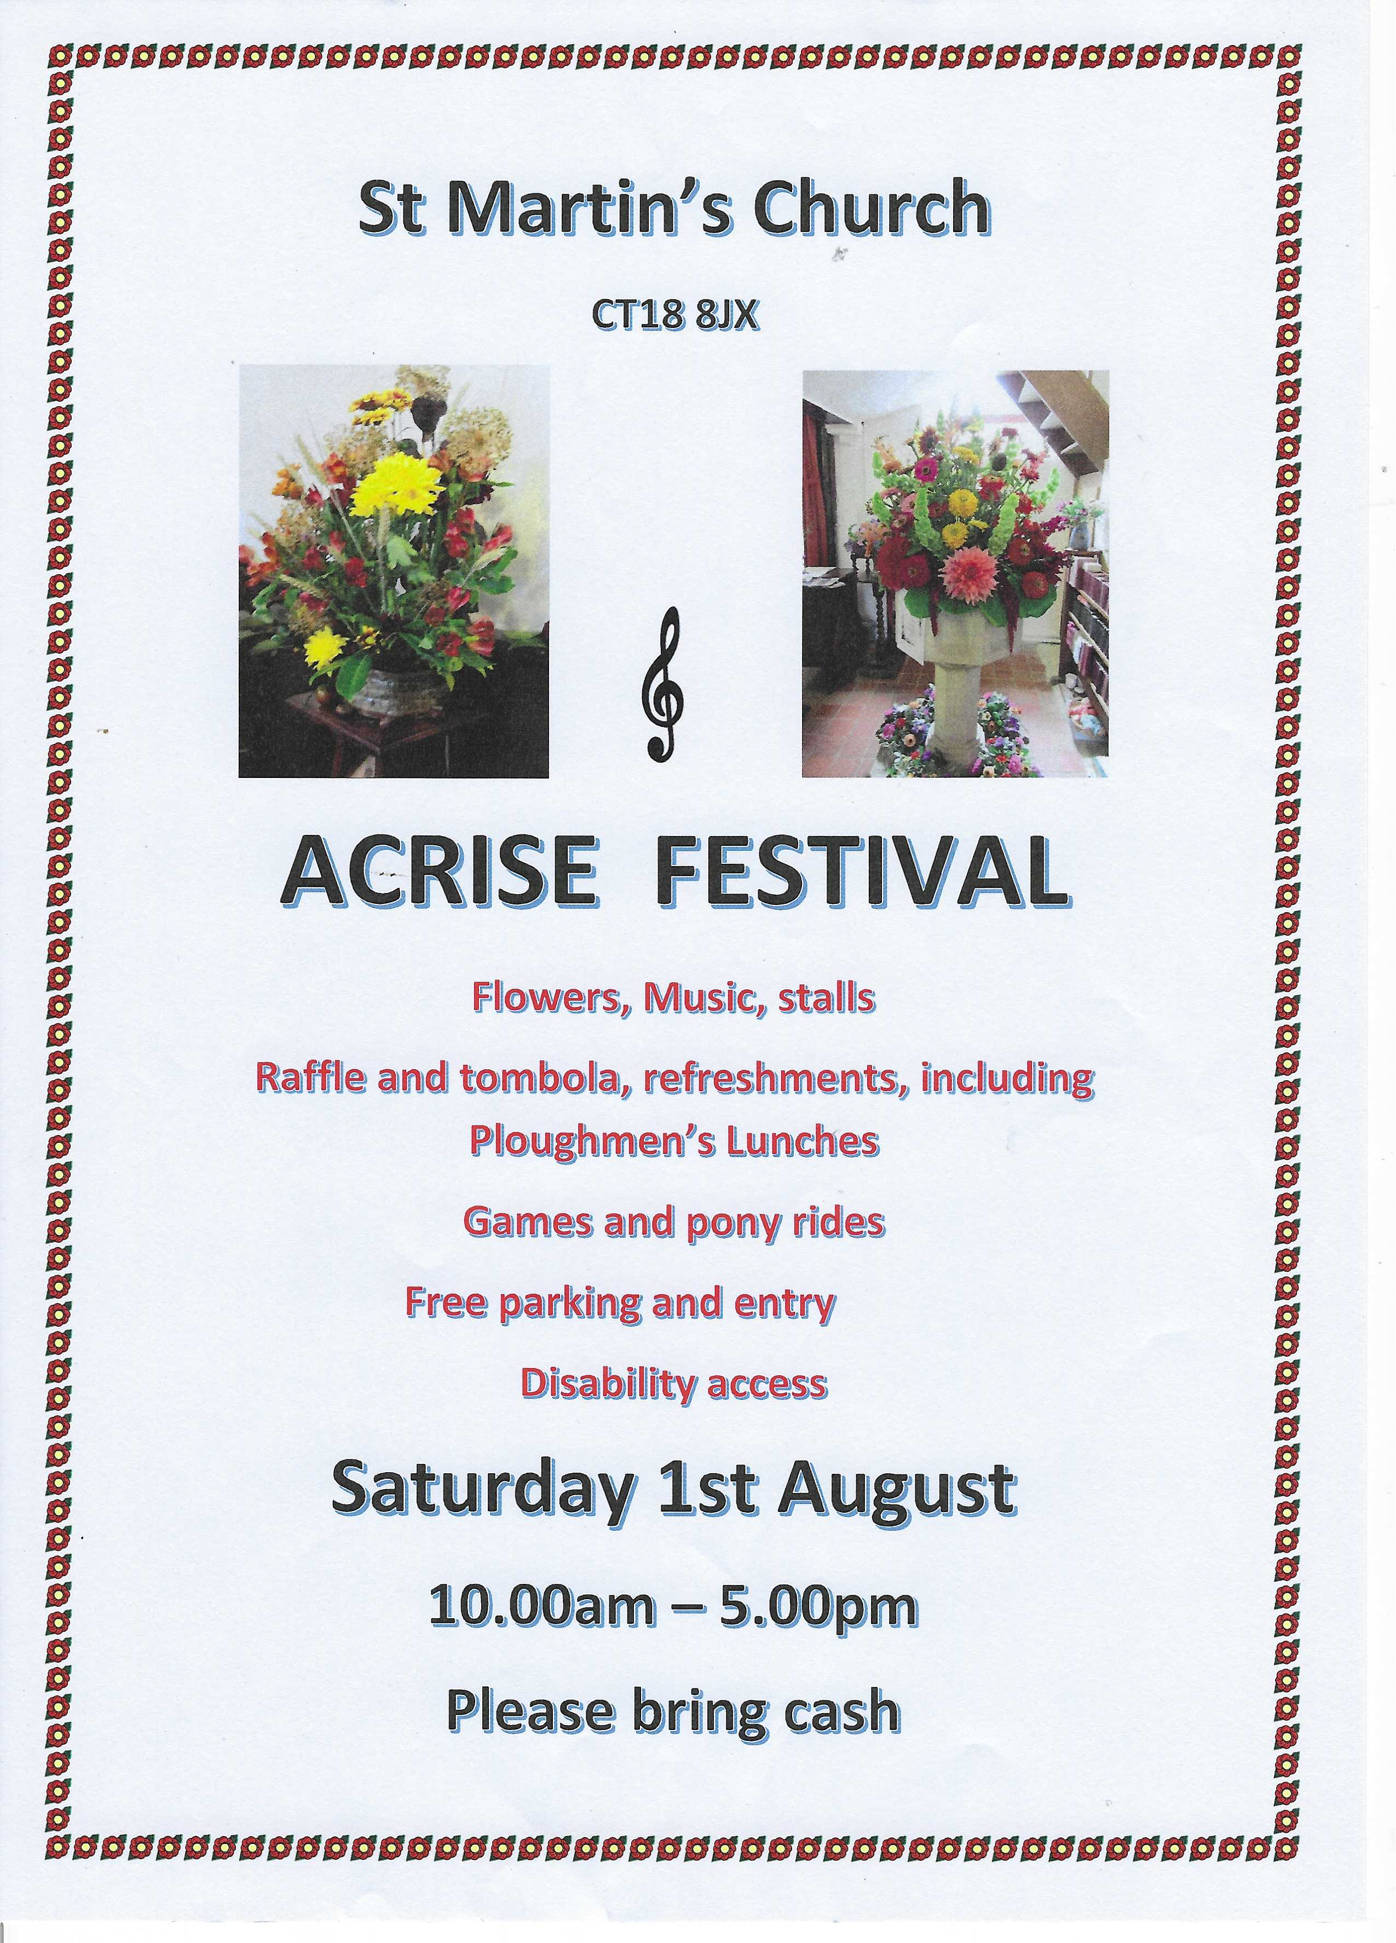
Acrise Festival
Of Flowers and Music
Saturday 1st August 10.00am – 5.00pm
Flowers in the church and music on the green. A local Dance School will also be performing for the first time. Church records will be displayed. There will be a variety of stalls, raffle, tombola, children’s games, and pony rides.
Refreshments, including ploughmen’s lunches, will be available.
Volunteers Needed
- On Tuesday 28th July from 10.00am we will be spring cleaning the church and tidying the paths, graveyard and parking area.
- On Friday 31st July from 10.00am the church will be decorated with flowers and the site will be prepared for the Saturday. Any help with site preparation will be welcome.
- On Saturday 1st August if you could help do a shift running a stall, helping with refreshments or parking, that would be much appreciated.
Donations
We would also be grateful for donations of cakes, biscuits and savouries, good quality bric a brac; any home grown produce for the produce stall.
If anyone could donate foliage or flowers from their gardens and leave them at the church on the morning of 31st July, we would be grateful.
Donations of Raffle and Tombola prizes would be a great help.
Contact
Please contact Sue on 01303844640 (sue1954prebble@gmail.com) if you could volunteer on any of the dates, could make a donation or give a raffle prize.
Jean Grieb is organising tombola prizes so please give them to her. She can be contacted on 01303892364.
Many thanks for volunteers and donations so far.

Acrise Heritage Pond Project July
Update (From Stephen Scoffham
This is a brief update with advance information about
forthcoming events.

Pond sampling
Although the Winterage Lane pond is now dry, it is still worth
sampling what is living in the mud and damp ground. I hope to
circulate the date for this later in the week (ie by 25 th July)

Archaeological talk
A reminder that a talk about the archaeology of the ponds
across the Kent Downs is timetabled for Wednesday 16
September, 7.30 at the Peggy Pike Room, Elham Village Hall.
Further details to follow.

Sargeant Drew Memorial Orchard
We have an invitation to visit the Memorial Orchard in the
walled garden behind the Landmarc Yard. This will need to be
on Friday between 10 and 2. I am thinking of arranging for
Friday 1 st October. Please let me know if you would prefer a
different date. We also have the offer of a talk about Sargent
Drew which I imagine might be best arranged later in the
autumn.
All good wishes,
Stephen

Friends of Kent Churches Ride and Stride.
This will take place on Saturday 12th September between 10.00am and 6.00pm.
We will have the church open that day with refreshments for any riders or walkers who turn up. We hope to have volunteers to be in the church for two-hour shifts from 10am until 6.00pm to welcome visitors.
Sue, Mike and Richard will be riding or striding; anyone else interested in taking part please email me (michael1946prebble@gmail.com).
Sponsor forms will be available from mid-August. Last year, despite the wet and stormy morning, the event raised £152,674. Grants were given to 37 Kent churches in 2025.

The Next Family Service will be on Sunday 27th September
Family Harvest Service at 9.30 am
There will be more details nearer the time.

