WORSHIP
SERVICES IN CHURCH
Christ Church is open for Sunday worship at 10.00 am
ONLINE SERVICES
Streamed LIVE from Christ Church Healey
on our Twitch tv channel twitch.tv/revdgill
and our Facebook page facebook.com/christchurchhealey
and to view on both after the broadcast.
Downloads of the service are available on request.
PASTORAL
If anyone needs help or support, please contact:
the Vicar on 01706 458506
or the Pastoral team on 07813 297313.
WEBSITE INFORMATION
Our websites are regularly updated and contain lots of useful information including service sheets, readings and news.
https://www.achurchnearyou.com/church/15941/
and
www.christchurchhealey.org.uk
BENEFICE MOTTO FOR 2026
“In everything by prayer and supplication… let your requests be made known to God. And the peace of God which surpasses all understanding, will guard your hearts and your minds in Christ Jesus.
Philippians 4:6-7 (NRSV)
Our Mission Statement – “To glorify God and serve our community in the name of Jesus Christ.”
PRAYERS
For the sick:
Madalen Bolton, Roger Mason, Brenda Blair, Andrew McElroy, Elliot Nightingale, Letty and children, Sue Tuffy, Jeff Ormerod.
Home members:
Jean France.
In Memoriam:
Martin Richard Hope, Barbara Anne Keate, Marian Gavin, Robert John Gould, Richard Henry MacArtney, Gordon Taylor, Eric Richard Fletcher, Winifred Layton, Brian Judge, John Lee, Cathie Brennan, Jean Margaret Young, Evelyn Storey, William Shaw.
Prayer for the week
Lord, thank You for calling me your child. Thank you for the Spirit that speaks to my heart, reminding me that I belong to you. Remind me daily that I am fully known, fully loved and fully yours and help me to walk closer to you each day.
Amen.
BIBLE READING:
Romans chapter 8 verses 14 to 17a
For all who are led by the Spirit of God are children of God. For you did not receive a spirit of slavery to fall back into fear, but you have received a spirit of adoption. When we cry, “Abba! Father!” it is that very Spirit bearing witness with our spirit that we are children of God, and if children, then heirs, heirs of God and joint heirs with Christ.

NOTICES

Mary’s Meals
Don’t forget Mary’s Meals can make the most of your spare foreign currency – collection boxes in both churches.
Mission Communities
Are being reviewed – speak to any member of the PCC so that we can forward comments on to the Area Dean and +Mark.
Schools
Pray for our schools as they work towards the end of year, especially for Y6s in their next steps
Breathe
Contemporary, reflective worship across the Mission Community will move to St George’s, Oakenrod from next month.

Lesley and family are delighted with the safe arrival of Luca James on the 10.07.26. Thank you to everyone for their love and kind thoughts.
Congratulations to all the family and thanks to God for His abundant blessings.
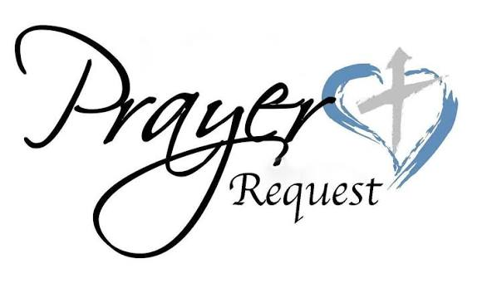
Please pray for those who cover our services over the summer holidays.

DATES FOR YOUR DIARY
St Bart’s, Whitworth
Tower open on Saturday 25th July from 11.30am until 1.30pm
Hope Community Family Fun time
In St Ann’s Hall on Saturday 25th July at 2pm. Please pray for this mission in Firgrove and Belfield.
PCC Meetings
Healey and Hamer PCC will be on Monday 27th July, 7pm at the vicarage.


