St James the Great  Wrightington with Heskin  www.stjamesthegreat.net  Facebook:  https://www.facebook.com/share/1P2dyibXWY/ |  | 92 Church Lane  Wrightington  WN6 9SP  Phone: 07769 462502  vicar@stjamesthegreat.net
12th July Sixth Sunday After Trinity
09.00am Holy Communion - David Long
10.30am Family Service
5.00pm 30@5 (last before summer break)

Parents – please ensure that you complete an Attendance Form each time you come to a service (slips are in the box on the back table). This will inform me and is essential information when the time comes for Faith References.

Returning again during the school holidays is the popular “Bikes, Brews and Boardgames”
These will run on three Wednesdays from 10.30am to 12.00noon on 29th July, 12th and 26th August. Children must be accompanied by a parent/carer and the cost remains at £2.00 per child, £1.00 per adult.

We are planning a couple of work days in the vicarage garden to tackle the weeds. Friday 24th July and Thursday 30th July. We will start from 10.30am until 4.00ish, if you can spare a couple of hours or so, we would really appreciate it – please bring gardening tools with you and trugs etc.
Great News! We now have a working Facebook page thanks to Nick Chesterton – the link is above and it is called Wrightington St James the Great – have fun.

*+*+*+*+*+*+*+*+*

Mon 13th July 2.00pm- 4.00pm Craft & Chat in the church hall
Tues 14th July 7.30pm Mothers Union Strawberry Evening with Jeff Hilton
Wed 15th July 10.30am Play & Praise Toddler Group (last before holidays)

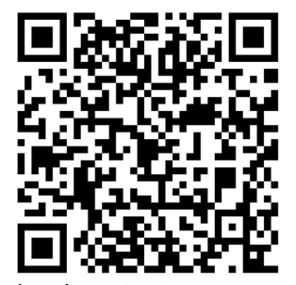
19th July The Seventh Sunday after Trinity
09.00am Holy Communion - TBC
10.30am Holy Communion – David Ward (with Baptism)

