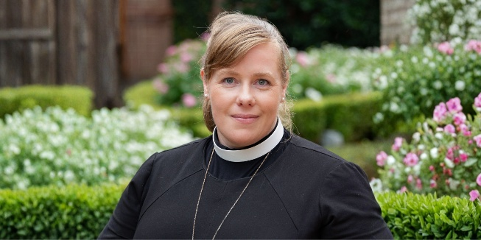
The power of friendship

Recently, I’ve been thinking a lot about friendship: what starts it, what builds it and what sustains it.
Our family moved to Hereford a little over a year ago. When we sensed a call from God to come here, we knew we would be starting again. We knew no one locally, which meant building friendships and community from the beginning.
Friendship doesn’t arrive fully formed. It grows slowly, often in what Scripture calls “the day of small things”: small conversations, small acts of kindness, small decisions to keep turning up. Like many relationships, friendship begins with connection but grows through countless small choices over time.
Even Jesus invested deeply in only a few close friendships. We cannot invest deeply in everyone, but we can choose to show up consistently for a few people: to cherish them, serve them, forgive them and remain faithful companions through life’s ups and downs.
I have often found this challenging because it means choosing to go first: starting the conversation, suggesting meeting up, offering help, buying the coffee and risking things feeling a little awkward. I have learnt from my husband, who is much more natural at including others and making space for friendship than I am. Yet, as I have been brave, I have discovered that many people are open to friendship. They are waiting, just as we are.
One of my most significant friendships began in my thirties in a very ordinary way. While volunteering, I simply said to someone, “This is a bit awkward, but I’d really like to be friends.” It sounds disarmingly simple, but it takes courage. Often all it takes is one person willing to make the first move.
There are seasons in life that carry a particular loneliness: the early years of parenting, times of transition, when friends move away, or later, when friends go to glory. Loneliness is not unusual; it is part of the human experience. Yet rather than turning on the TV, perhaps the invitation is to look up and out: to join a club, volunteer, pick up the phone or invite someone for dinner regardless of the state of our life, kitchen or garden.
Friendship is not only about reaching out; we also have to learn to receive. It can dent our pride to let it be known that we can’t manage everything. Yet some of the greatest moments of friendship in my life have come through friends offering practical help when I didn’t realise how much I needed it.
One of the great gifts the church can still offer is community: a place where people of all ages and backgrounds can gather regularly, be known and build genuine friendships. When God said to Adam, “It is not good for a person to be alone,” he knew that would apply to all of us.
So my prayer this year is to learn how to be a better friend to those I already love, and to ask God who in my life is lonely, where I could be their friend, and they mine.
I wonder if God might be asking some of you to pray this too?
The Rev'd Jane Plackett-Ferguson
Chaplain to the Bishop of Hereford

