
ST. ANN’S, BELFIELD NEWS LETTER
WORSHIP

Church open
St Ann’s is open for public worship Sundays and Wednesdays at 10.30am
Streamed LIVE on our Twitch TV channel twitch.tv/revdgill and on our Facebook page. – facebook.com/christchurchhealey
And to view on both after the broadcast Downloads on request.

Prayers for the sick
Ghislaine Glover, Cath Boon, Roger, Lilian, Letty and children.

Prayers for home members
Bob (in Mona Cliffe Care Home), Dorothy (in Braeside)

The anniversary of the dearly departed
David Johnson, Sarah Schofield, Annie Fletcher, Ronald Lord and Arthur Owen

Scan this with your phone to contribute to St Ann’s mission and ministry

Benefice Motto, 2026
“In everything by prayer and supplication… let your requests be made known to God. And the peace of God which surpasses all understanding, will guard your hearts and your minds in Christ Jesus.”

BBC Songs of Praise
Free tickets available for this event. Weds 8th July 10.30am or 4pm. See separate emailing for details how to get tickets.

All Saints’ Governors
2 diocesan appointed governors have recently retired. Please talk to Rev Gill about this amazing opportunity to serve the church and wider community.

Christ Church Summer Fayre
11am – 2pm, 4th July

Benefice Prayer Meeting
Join us to pray together as a benefice at Julie and Paull’s, 7pm Tuesday 7th July.
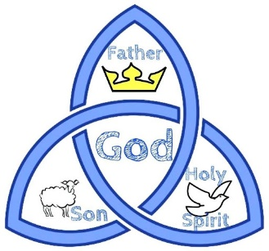

5th July 2026
Fifth Sunday after Trinity
Eucharist
Rev Debs Crossland / Rev Gill

Hymns: All NEH 440 Praise to the Lord 359 Fight the good fight 294 Just as I am 307 Sweet Sacrament divine 333 All my hope on God is founded.

NOTICES Christ Church Summer Fayre
11am – 2pm, 4th July

Fieldhouse Care Home
Worship at Field house with residents and staff, 10.30am, Thursday 9th July.

Said Communion Service
The next service of this type will be on Sunday 12th July - quiet, reflective service, Christ Church, 2pm. Let your friends know and bring them along.

Breathe
Contemporary, reflective worship across the Mission Community, 7.30pm, St Michael’s, Bamford. (New venue from next month).

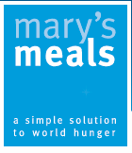
Mary’s Meals
Don’t forget Mary’s Meals can make the most of your spare foreign currency – collection boxes in both churches.

Family Baptism at St Ann’s
Join us to celebrate 6 baptisms at St Ann’s on 12th July and for a celebration in the hall after.

