Church service pattern for this month:
St. John’s:
5th July, 11:00 – Holy Communion with Sunday School
12th July, 10.30 - Joint Service
19th & 26th July, 11:00 – Holy Communion
Wednesday: 12:00 noon–Holy Communion
St. James’:
5th July, 09:30- Holy Communion with Sunday School.
12th July, 10.30 – Joint Service, St John’s with Sunday School
19th July, 9.30 – Service of the Word with Sunday School
26th July, 9.30 – Holy Communion with Sunday School

Our New Vicar
You may have already heard that we have appointed a new Vicar who will join us in the Autumn. We are delighted to welcome Rev. Emma Cooksey, who comes with her husband, John, & their son Harry, from the Isle of Wight.
A letter from her is on the reverse of this newsletter.
The Induction is expected to be on 18th October but the details will be available in September.
Men’s Breakfast
The next Men’s Breakfast will be held at St. James’ Church on Saturday, July 4th at 8.30. All welcome.
Mothers’ Union
On July 9th MU are having a trip out to Lytham Hall for Afternoon Tea so there will be no evening meeting this month.
Family Barbecue
After the Joint Service on Sunday July 12th we are holding a family Barbecue in the garden at Chapel House. Everyone is welcome so please do come along – no tickets needed, just donations to cover the cost of the food!
I’m hoping to hold a duck race down a short section of the river. Numbers will be on sale from next Sunday or on the day.
Songs of Praise
On Sunday evening 26th July at 6.30 Pilling Brass Band will lead our annual Outdoor Songs of Praise Service in the grounds of St Paul’s service to celebrate the Feast of St James.
If you would like to suggest your favourite hymn please sign up on the list at the back of the Churches. Come along and bring your chair! The view is superb and there’s no better place to praise God!
100 Club
A new 100 club is being launched this month The cost for a year is £20 and a draw will be made each month. A form to register for the draw is attached to this newsletter. You can complete it and return it to Helen with £20 or hand it in at Church.
Helpers for work with Children and Young People
We are aiming to keep Sunday School running throughout the summer on each Sunday at St John’s. If you would be available to offer some help please let us know

Olive Branch
This time of the year is the “Lean” season of the Olive Branch as people go on holiday and schools are shut. They would be grateful for any donations but this is their suggested shopping list:
- Tinned meat meals & Luncheon meat
- Tinned Fish
- Tinned tomatoes
- Tinned Veg & Fruit
- Tinned pasta & Soup
- Cereal
- Pasta Sauce jars & Pasta
- Biscuits & Crisps
- Tinned/Long-life puddings
- Coffee & Tea

Dates for your diary
12th July, 12.00 Family Barbecue
26th July, 6.30 Songs of Praise
30th August,1.30 & 3.30 - Afternoon Teas, St James’ Shireshead.

Afternoon Teas
You are warmly invited to join us for afternoon tea
on
Sunday 30th August 2026
at 1.30pm or 3.30pm
in
Shireshead St James Upper Room
Whinney Brow Lane Forton Preston, PR3 0AE
Tickets - £15 per person

To book your place call Joy 07702009421
or Ruth 07928103368/01524792306
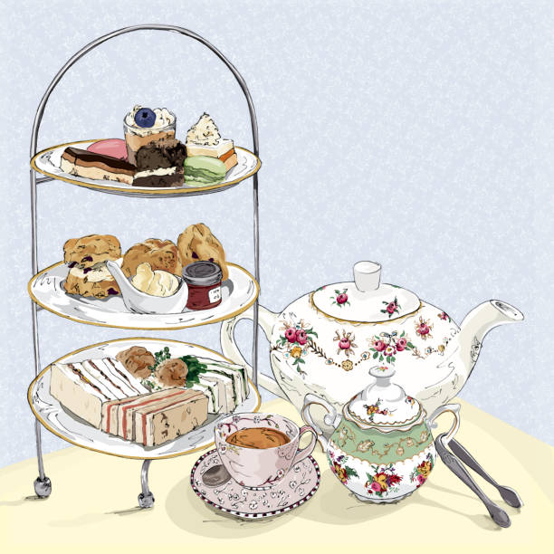
or emailing rross500@aol.com
All proceeds will go towards supporting the church
and its work in the community

Letter from Rev Emma

I am thrilled to be taking on the role of Vicar of Ellel St John the Evangelist and Shireshead St James. I am originally from Wednesbury in the West Midlands. My curacy was spent on the outskirts of Lichfield before taking up Team Vicar role in Newport, Carisbrooke and Gatcombe on the Isle of Wight. Prior to ordination, I studied at Queens Foundation Theological College part-time whilst also working as a Quality Manager in Birmingham for a company who manufacture medical devices to diagnose different types of cancer. I have a passion for children, schools and family ministry and have especially enjoyed working with the local CofE/Catholic High School and setting up a new youth group during my time on the Isle of Wight.

I will be moving to the parish with my family – my husband John, my son Harry, aged 18, and our gecko Draco! We are also hoping to get a dog once we have settled into the area. Harry is also starting University in September, so it is a big time of transition for our family. As a family we love walking and the outdoors, so we are looking forward to exploring the local area. We also have a passion for ‘treading the earth lightly’ so we like to grow veggies in our veg patch. In my spare time, I enjoy knitting, crafts, cooking, and baking. John and Harry love sport, including rugby, cricket, and darts.
I am looking forward to serving the whole parish of Ellel St John & Shireshead St James, and I am especially eager to get to know you all once I am in post in the autumn. As a family we are very happy to be moving to Galgate and we are excited about what God has in store for us in this new chapter in our lives.
Rev Emma with husband, John and son,Harry.
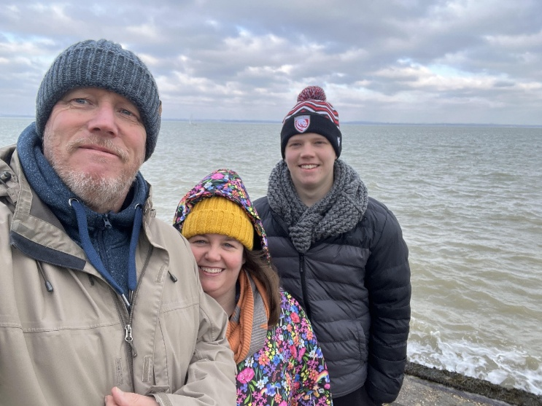

Contact Information
During the interregnum, please contact the Church wardens in the first place and they will find the right person to deal with your request.
St. John’s – Peter Harrison - 07947 385534
Steph Carter - 07952 712489
St James’ – Alex Peill - 07914 382332
Anthony Chick – 07966 898427
If you have anything for the newsletter or dates for the diary, please contact Helen Ballard, by email or What’s App.

