BENEFICE LUNCH AND BIBLE/FAITH & LIFE STUDY: All are welcome to a Benefice Lunch in St Mary’s Garsington at 12 noon on WEDNESDAY 12th August. We will begin with a lunch consisting of bread, cheese, ham, fruit juice, coffee and cake. This will be followed, around 12:45, by some discussion of Saints and social reformers whom the church remembers that week: The Blessed Virgin Mary; Clare of Assisi (Founder of the Poor Clares); Florence Nightingale (nurse and social reformer); and Octavia Hill (social reformer). We will discuss what we might learn from their lives and example, and how we might be inspired by their lives and witness.
Please let Tom know if you would be willing to research one of these figures, and give a brief summary (2-3 minutes) of their life and work.
Please also let Tom know if you hope to attend, so that he knows how much food to provide. Thank you.

STEWARDSHIP AND GENEROUS GIVING: Summer is perhaps a good time for many of us to take stock. How is our prayer life and our relationship with God? How are our relationships with others? Where do we see God at work? How is our physical health, and our mental health and well-being? How are our finances? How has God blessed us? What are we grateful for? How can we best express our gratefulness?
Christians believe that God is a generous God – a God who loves the world so much that he gave his Son; a God who gives us good gifts, and wants us to flourish and thrive. We are called to respond to God’s generosity. One way in which we can do so is through being generous with our own time, talents and gifts. Many of us are accustomed to the tradition of tithing – giving a tenth of our income to the church and / or to charities. Tithing is not as popular as it once was, but the church and other charities still depend largely upon charitable giving to resource their ministry and work, Cuddesdon and Horspath parishes have both been able to pay their parish share in full in recent years – due, largely, to generous legacies left by parishioners. Garsington was unable to pay its parish share in full in 2025 and will probably be unable to pay it in full in 2026.
I intend to prayerfully review my current finances, income, expenditure and charitable giving, and see if I can increase my giving to Garsington PCC. I wonder if I could encourage you to do the same? I recognise that not all will be able to increase their financial giving, and that some might need to decrease it. I also recognise that there are other ways of expressing generosity than merely financial giving – but our churches do rely heavily upon the generosity of church-goers and others.

If you are able to increase your giving, please speak to your PCC Treasurer, or to myself. Thank you. Revd Tom

Next week’s service: (All Welcome – why not invite a friend?)
Sunday 9th August Trinity 10
Cuddesdon, All Saint’s 9.30am Parish Communion
Garsington, St Mary’s 9.30am Parish Communion
Horspath, St Giles: 11.00am Parish Communion

Administrator and Contact details for booking baptisms, weddings, pastoral visits,
07540051798 Email gchbenefice@gmail.com

The weekly pew sheet for St Mary’s, Garsington, All Saints’, Cuddesdon and St Giles’, Horspath

Sunday 2nd August Trinty 9 (Green)
Cuddesdon, All Saints’ 8.00am Holy Communion (BCP)
9.30am Parish Communion
Garsington, St Mary’s 9.30am Parish Communion
Horspath, St Giles: 11.00am Morning Worship

Collect.
Almighty God,
who sent your Holy Spirit
to be the life and light of your Church:
open our hearts to the riches of your grace,
that we may bring forth the fruit of the Spirit
in love and joy and peace;
through Jesus Christ your Son our Lord,
who is alive and reigns with you,
in the unity of the Holy Spirit,
one God, now and for ever.
Post Communion
Holy Father,
who gathered us here around the table of your Son
to share this meal with the whole household of God:
in that new world where you reveal the fullness of your peace,
gather people of every race and language
to share in the eternal banquet of Jesus Christ our Lord.
Isaiah 55.1-5
55 Ho, everyone who thirsts,
come to the waters;
and you that have no money,
come, buy and eat!
Come, buy wine and milk
without money and without price.
² Why do you spend your money for that which is not bread,
and your labour for that which does not satisfy?
Listen carefully to me, and eat what is good,
and delight yourselves in rich food.
³ Incline your ear, and come to me;
listen, so that you may live.
I will make with you an everlasting covenant,
my steadfast, sure love for David.
⁴ See, I made him a witness to the peoples,
a leader and commander for the peoples.
⁵ See, you shall call nations that you do not know,
and nations that do not know you shall run to you,
because of the Lord your God, the Holy One of Israel,
for he has glorified you.

Romans 9.1-5
I am speaking the truth in Christ—I am not lying; my conscience confirms it by the Holy Spirit— ²I have great sorrow and unceasing anguish in my heart. ³For I could wish that I myself were accursed and cut off from Christ for the sake of my own people, my kindred according to the flesh. ⁴They are Israelites, and to them belong the adoption, the glory, the covenants, the giving of the law, the worship, and the promises; ⁵to them belong the patriarchs, and from them, according to the flesh, comes the Messiah, who is over all, God blessed for ever. Amen.

Matthew 14.13-21
13 Now when Jesus heard this, he withdrew from there in a boat to a deserted place by himself. But when the crowds heard it, they followed him on foot from the towns.¹⁴When he went ashore, he saw a great crowd; and he had compassion for them and cured their sick. ¹⁵When it was evening, the disciples came to him and said, ‘This is a deserted place, and the hour is now late; send the crowds away so that they may go into the villages and buy food for themselves.’ ¹⁶Jesus said to them, ‘They need not go away; you give them something to eat.’ ¹⁷They replied, ‘We have nothing here but five loaves and two fish.’ ¹⁸And he said, ‘Bring them here to me.’¹⁹Then he ordered the crowds to sit down on the grass. Taking the five loaves and the two fish, he looked up to heaven, and blessed and broke the loaves, and gave them to the disciples, and the disciples gave them to the crowds. ²⁰And all ate and were filled; and they took up what was left over of the broken pieces, twelve baskets full. ²¹And those who ate were about five thousand men, besides women and children.

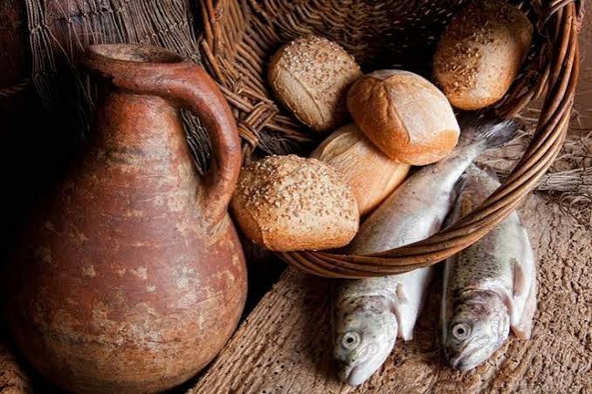

Please pray for growth in all of the churches in our Benefice God of mission, who alone brings growth to your Church, send your Holy Spirit to give vision to our planning, wisdom and love to our actions, joy to our worship, and power to our witness. Help our churches (St Mary’s, Garsington; All Saints’, Cuddesdon and St Giles’, Horspath) to grow in numbers, in spiritual commitment to you, in generous giving, and in loving service to each other and to our local communities. Amen.

Please pray for:
- The people of Venezuela, Gaza, Palestine, Iran, Israel, Lebanon, Syria; Ukraine, Yemen, Sudan and all conflict zones – for a lasting ceasefire, peace with justice, reconciliation, mercy and compassion
- For all those struggling to cope with the recent extreme heat, especially the elderly, the vulnerable and those with no home or shelter.
- For a safe harvest, for farmers struggling with drought, and for all who work to provide our food and drink.
- All refugees, asylum seekers, and those who support refugees
- Our parishes of Garsington, Cuddesdon and Horspath, our Churchwardens, Clergy, Treasurers, Secretaries and PCCs
- Our Benefice Safeguarding Officer, (Kathryn) and all that we do to keep children and vulnerable adults safe
- Story-time Church, Sunday Fun Time, Action Stations, Family Time, our all-age Eucharists, and all our work with children, young people and families
- Our Church Primary schools in Garsington and Horspath – for the Headteachers, staff and pupils and governors and for rest and refreshment during the school holidays.
- For Ripon College Cuddesdon – for the Principal the Revd Dr Harriet Harris, for all members of staff and all the community – particularly those who left those who remain, and those who will begin training in September or October
- For all those working in extreme heat and great danger to put out forest fires in Europe and in the UK.

Those who are sick, grieving, or in any kind of need, remembering especially:
Garsington:
Cuddesdon: Julie Grindod,
Horspath: Anne & Bob Adams, John Llewellyn,
For those who have died, and those who grieve for them including Sylvia Morris Ronald Griffiths, and David Ruffels from Garsington; Judith Hetherington and Shirley Woodcock from Horspath;, Christopher Efstratiou, and Alan from Cuddesdon; and John Wallis

Notices:

CONTEMPLATIVE PRAYER GROUP – ALL SAINTS, CUDDESDON – 5pm on Wednesdays
ALL WELCOME – 30 minutes of silent prayer FOLLOWED BY: Midweek Eucharist 6pm in All Saints Cuddesdon.

