St. Clements Church is, unfortunately, still closed to the public due to ongoing repairs, but the PCC and Friends of St. Clements are trying, very hard, to rectify this as quickly as possible. Although we believe it will take some time and lots more effort. We are hoping the community will help and support St. Clements and further information on this can be found elsewhere in the Oracle.

In the meantime, Tuesday coffee mornings 10.30am - 12pm are ongoing and well supported, all are welcome to drop in for a reviving cuppa and chat.

Mid week services are held in the porch on the first Tuesday of the month at 10am - 10.30am and Communion on the third Tuesday of the month also 10am - 10.30am. All are welcome.

The PCC and Friends are still baking and the cake stall is open on the first Saturday of every month from 9am - 11am. Where lots of delicious cakes are available for a reasonable cost. Refreshments are also available, so come and take a seat and partake of a cuppa and cake.

Recently St. Clements held their Strawberry Fayre, ably assisted by the PCC, Friends, Bill Smith and his music and Paul Brenchley for the use of his gazebo. We thank all and everyone for their assistance and for giving us their time for our cause. We would also like to thank the community for their support and friendliness on the day and hope the children enjoyed their scavenger hunt and games.

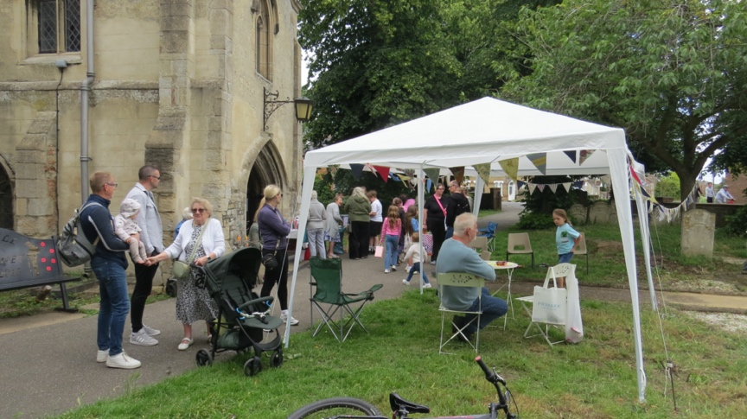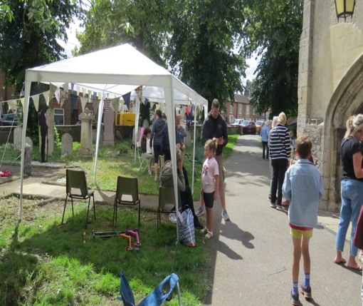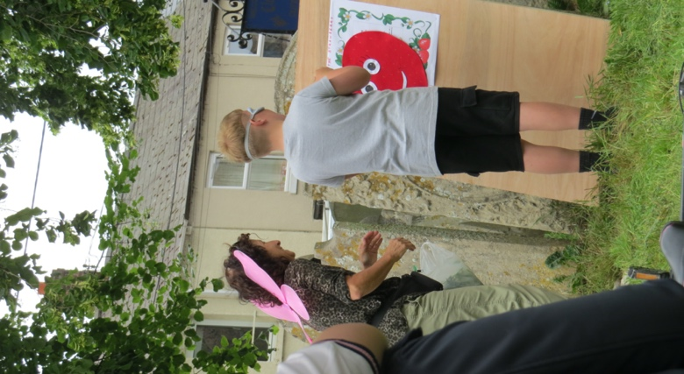 St. Clements next event will be a Harvest Festival on 17th October 2pm – 4pm. Soup and hot dogs along with a treasure hunt and games.

