All Saints’ Shiptonthorpe
9th Sunday after Trinity 2 August 2026

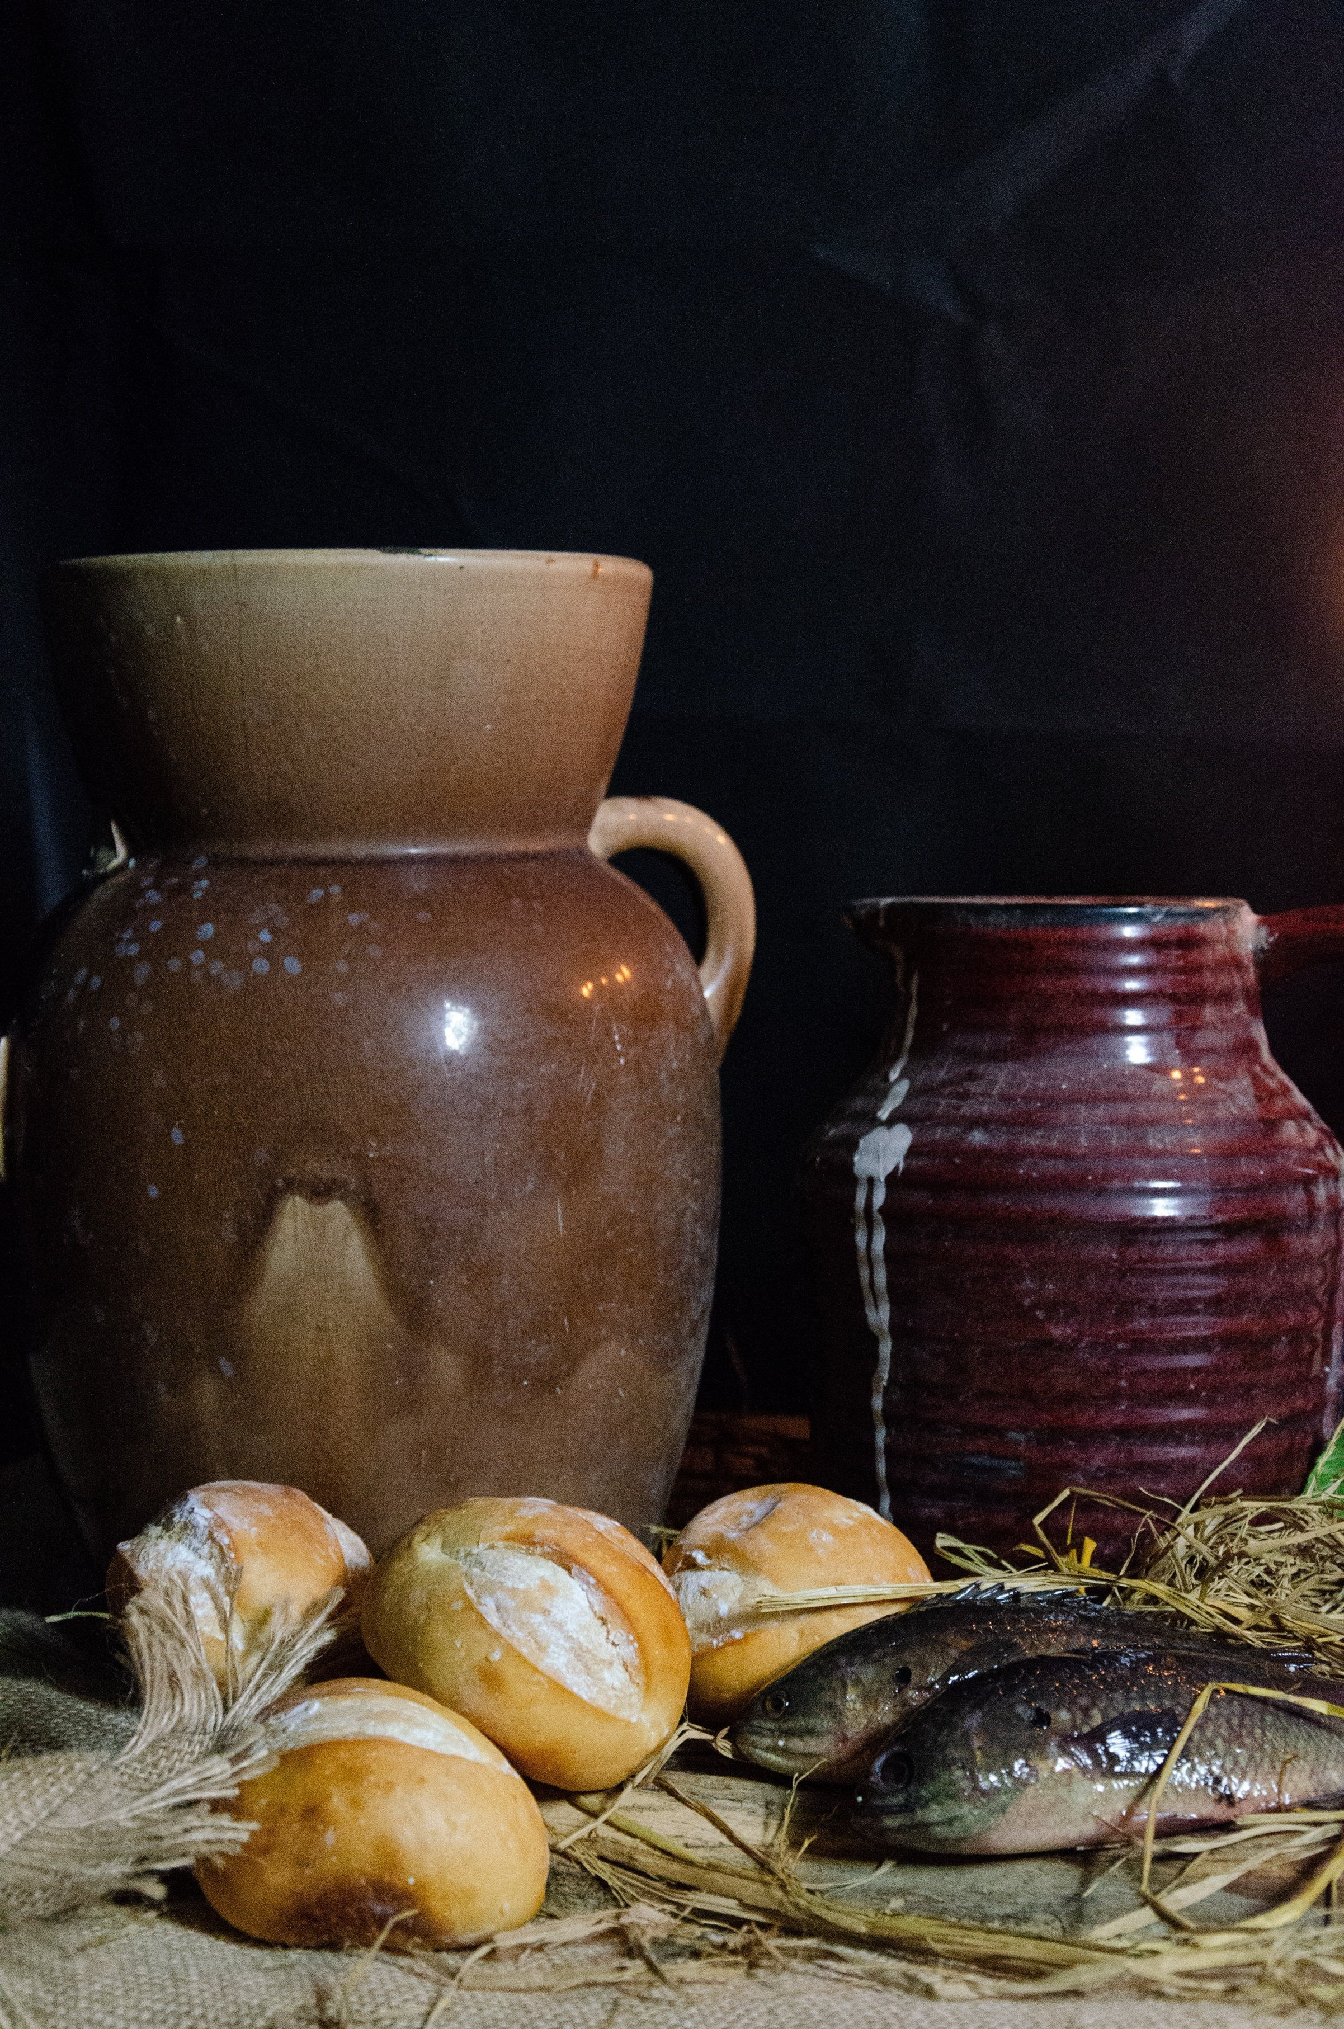
Rector:
Revd Robert Stone
07726 719 288
Church Wardens:
Freda Bailey 07818 892 777
Catherine Simpson ‬07597 876 724
Parish Safeguarding Officer
Jean Bean 07968 749 107
Collect:
9th Sunday after Trinity

Gracious Father,
revive your church in our day,
and make her holy, strung and faithful,
for your glory's sake in Jesus Christ our Lord.
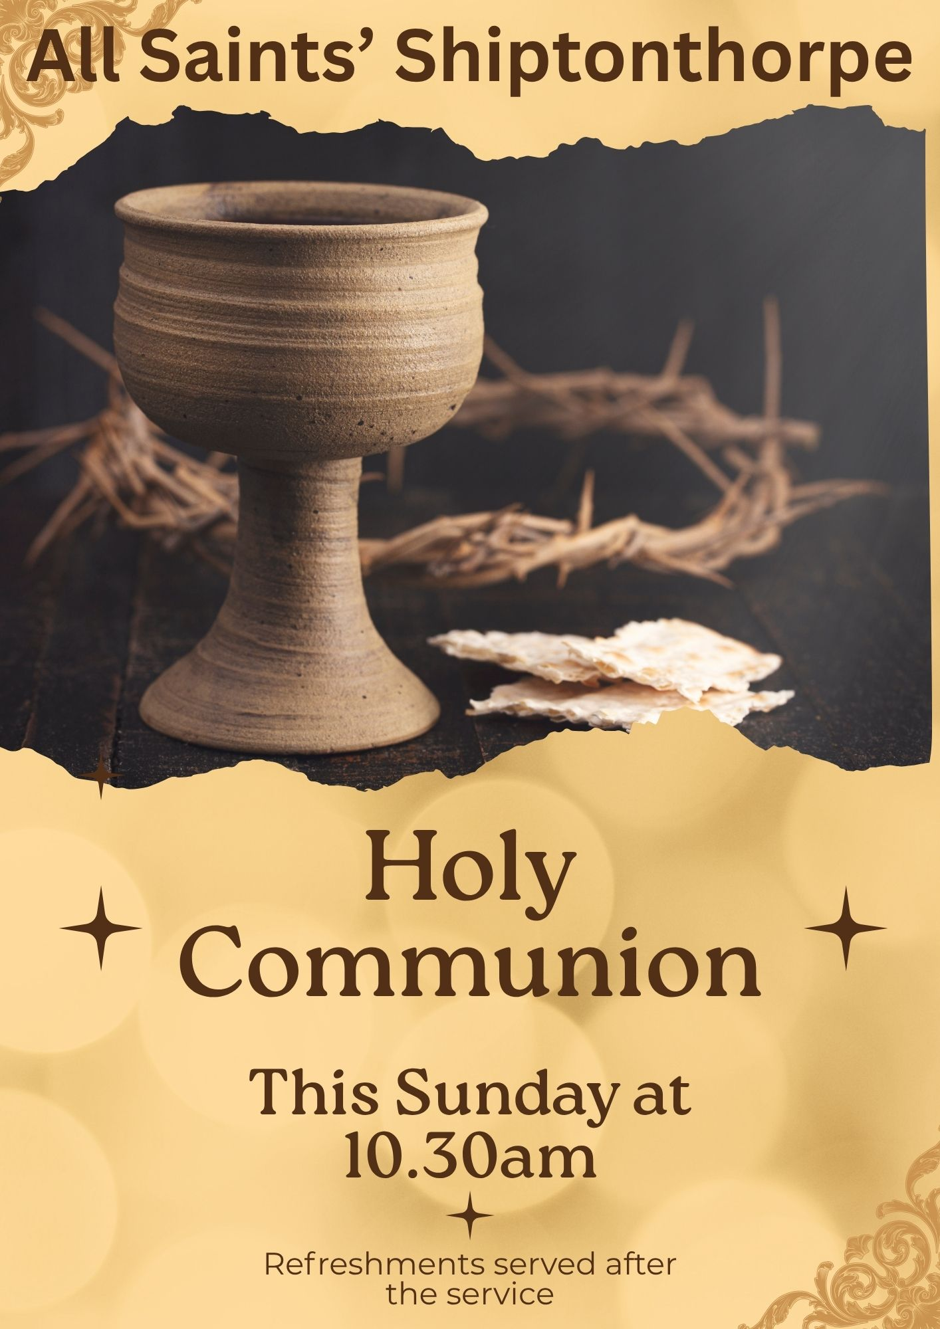
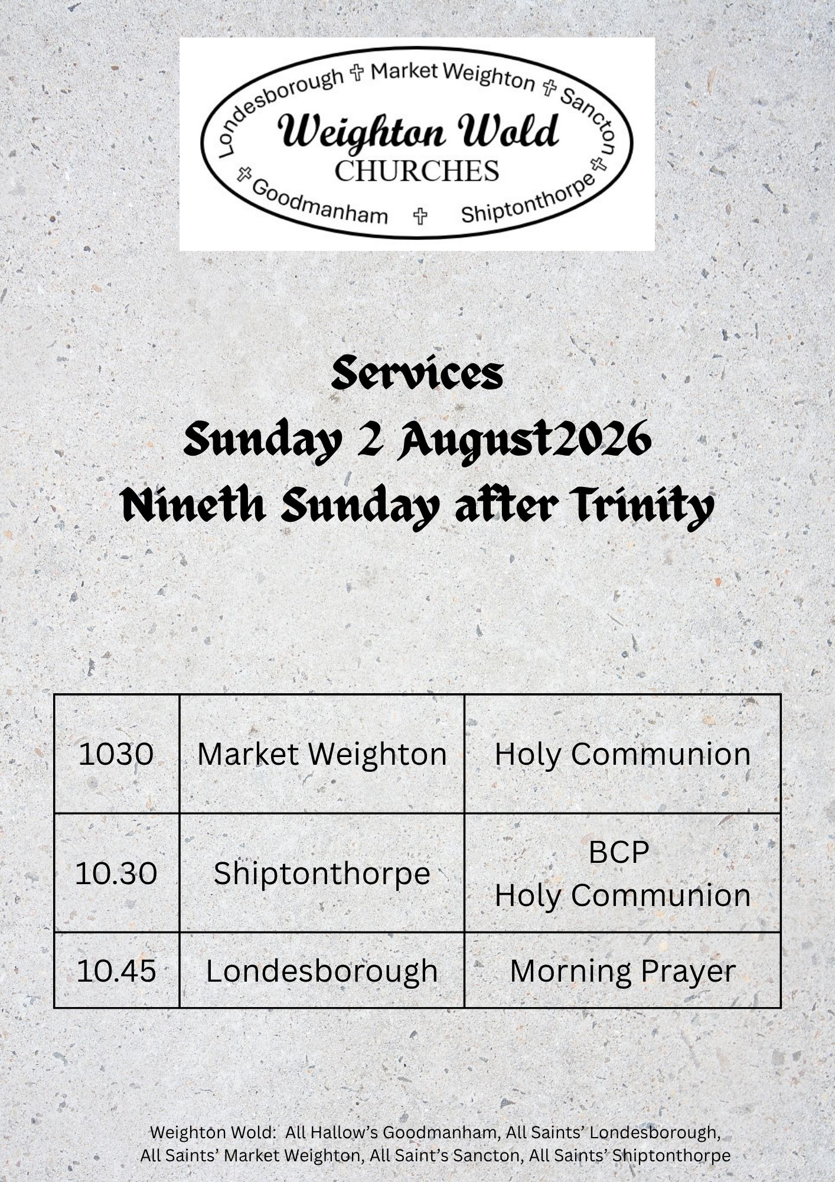

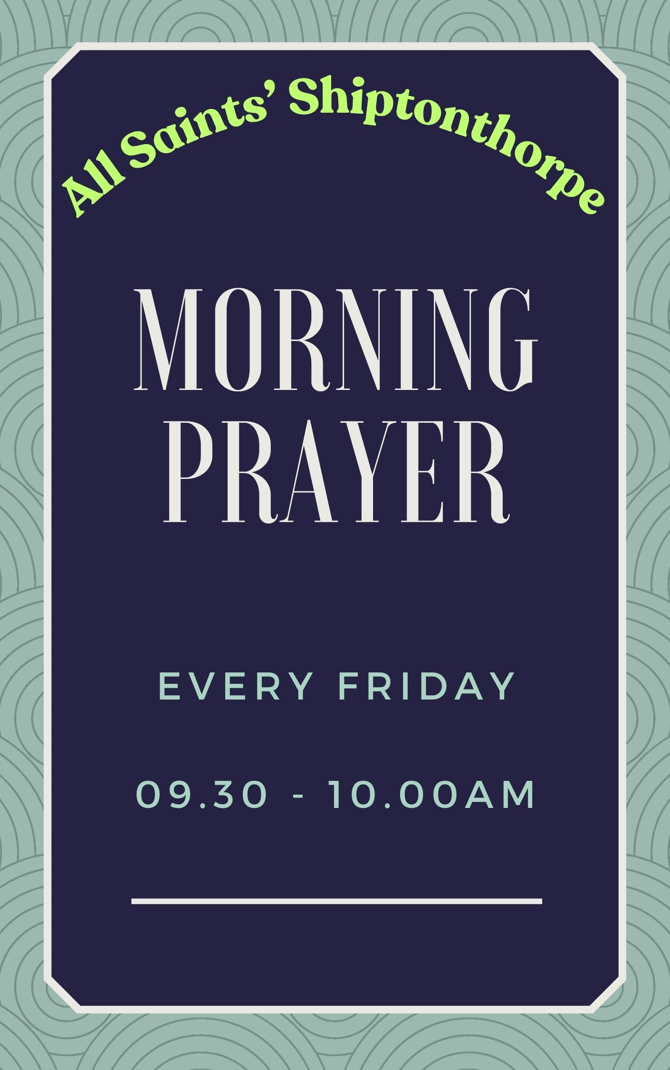
Readings
Nineth Sunday after Trinity

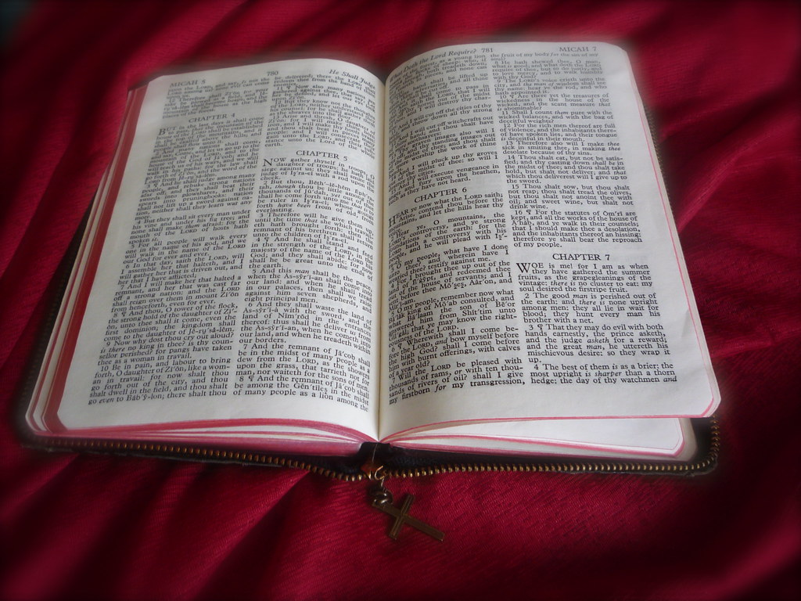 | Romans 9: 1-5  Matthew 14: 13-21

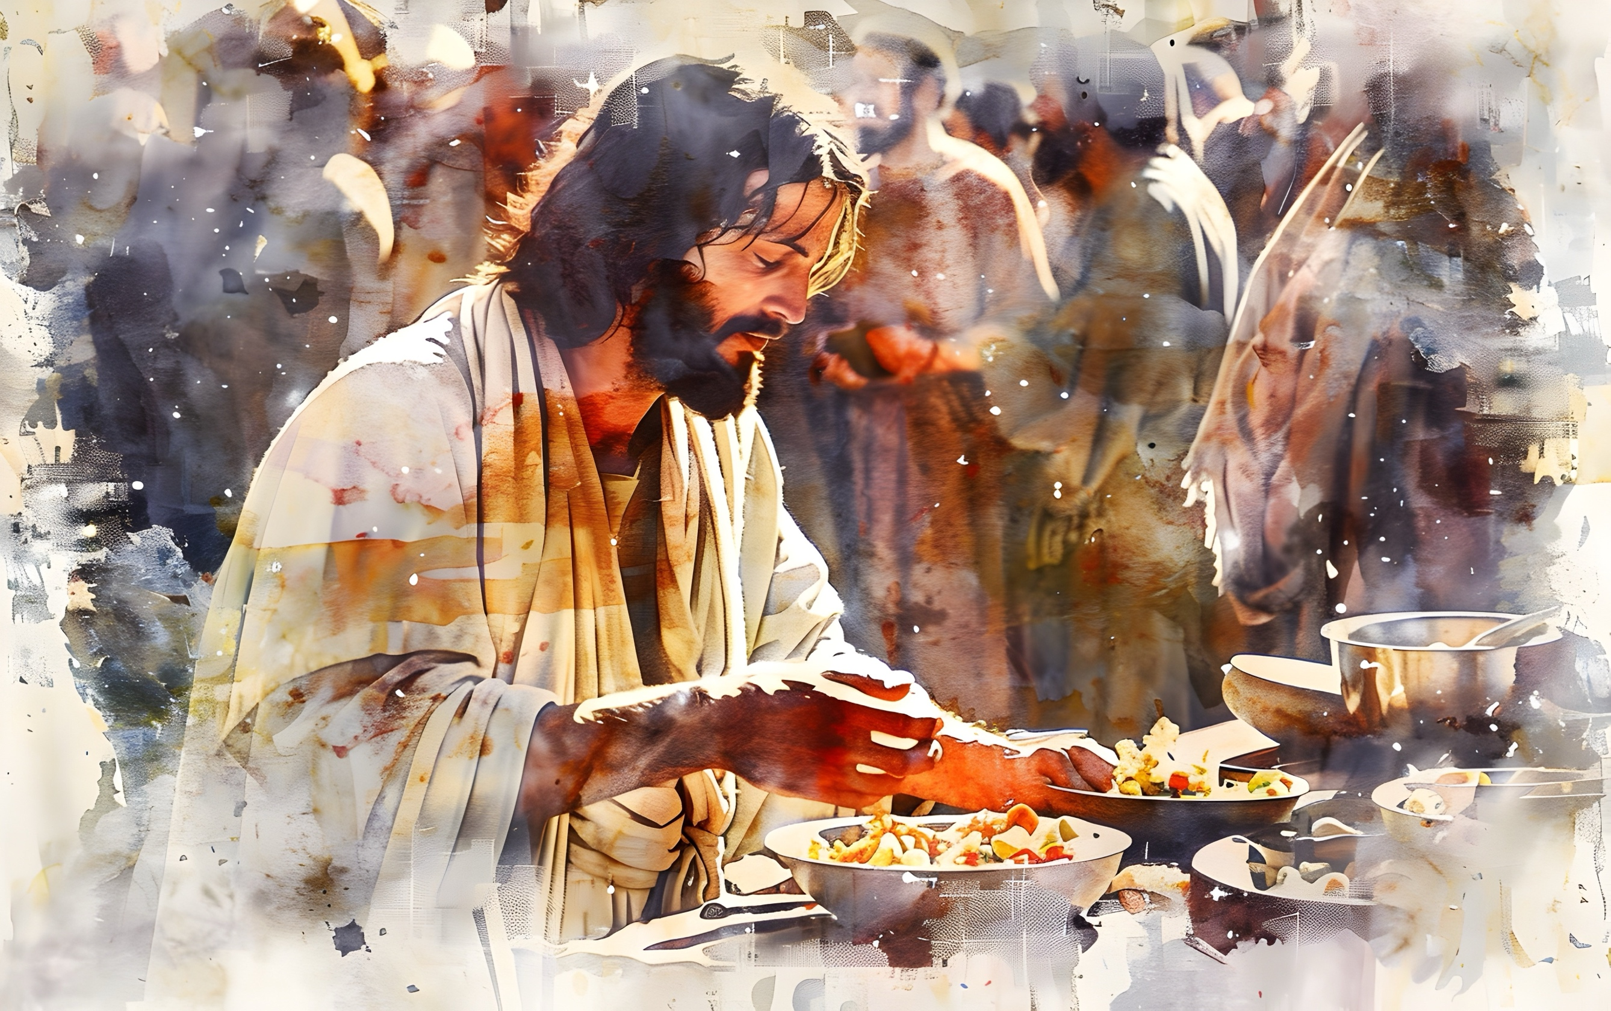



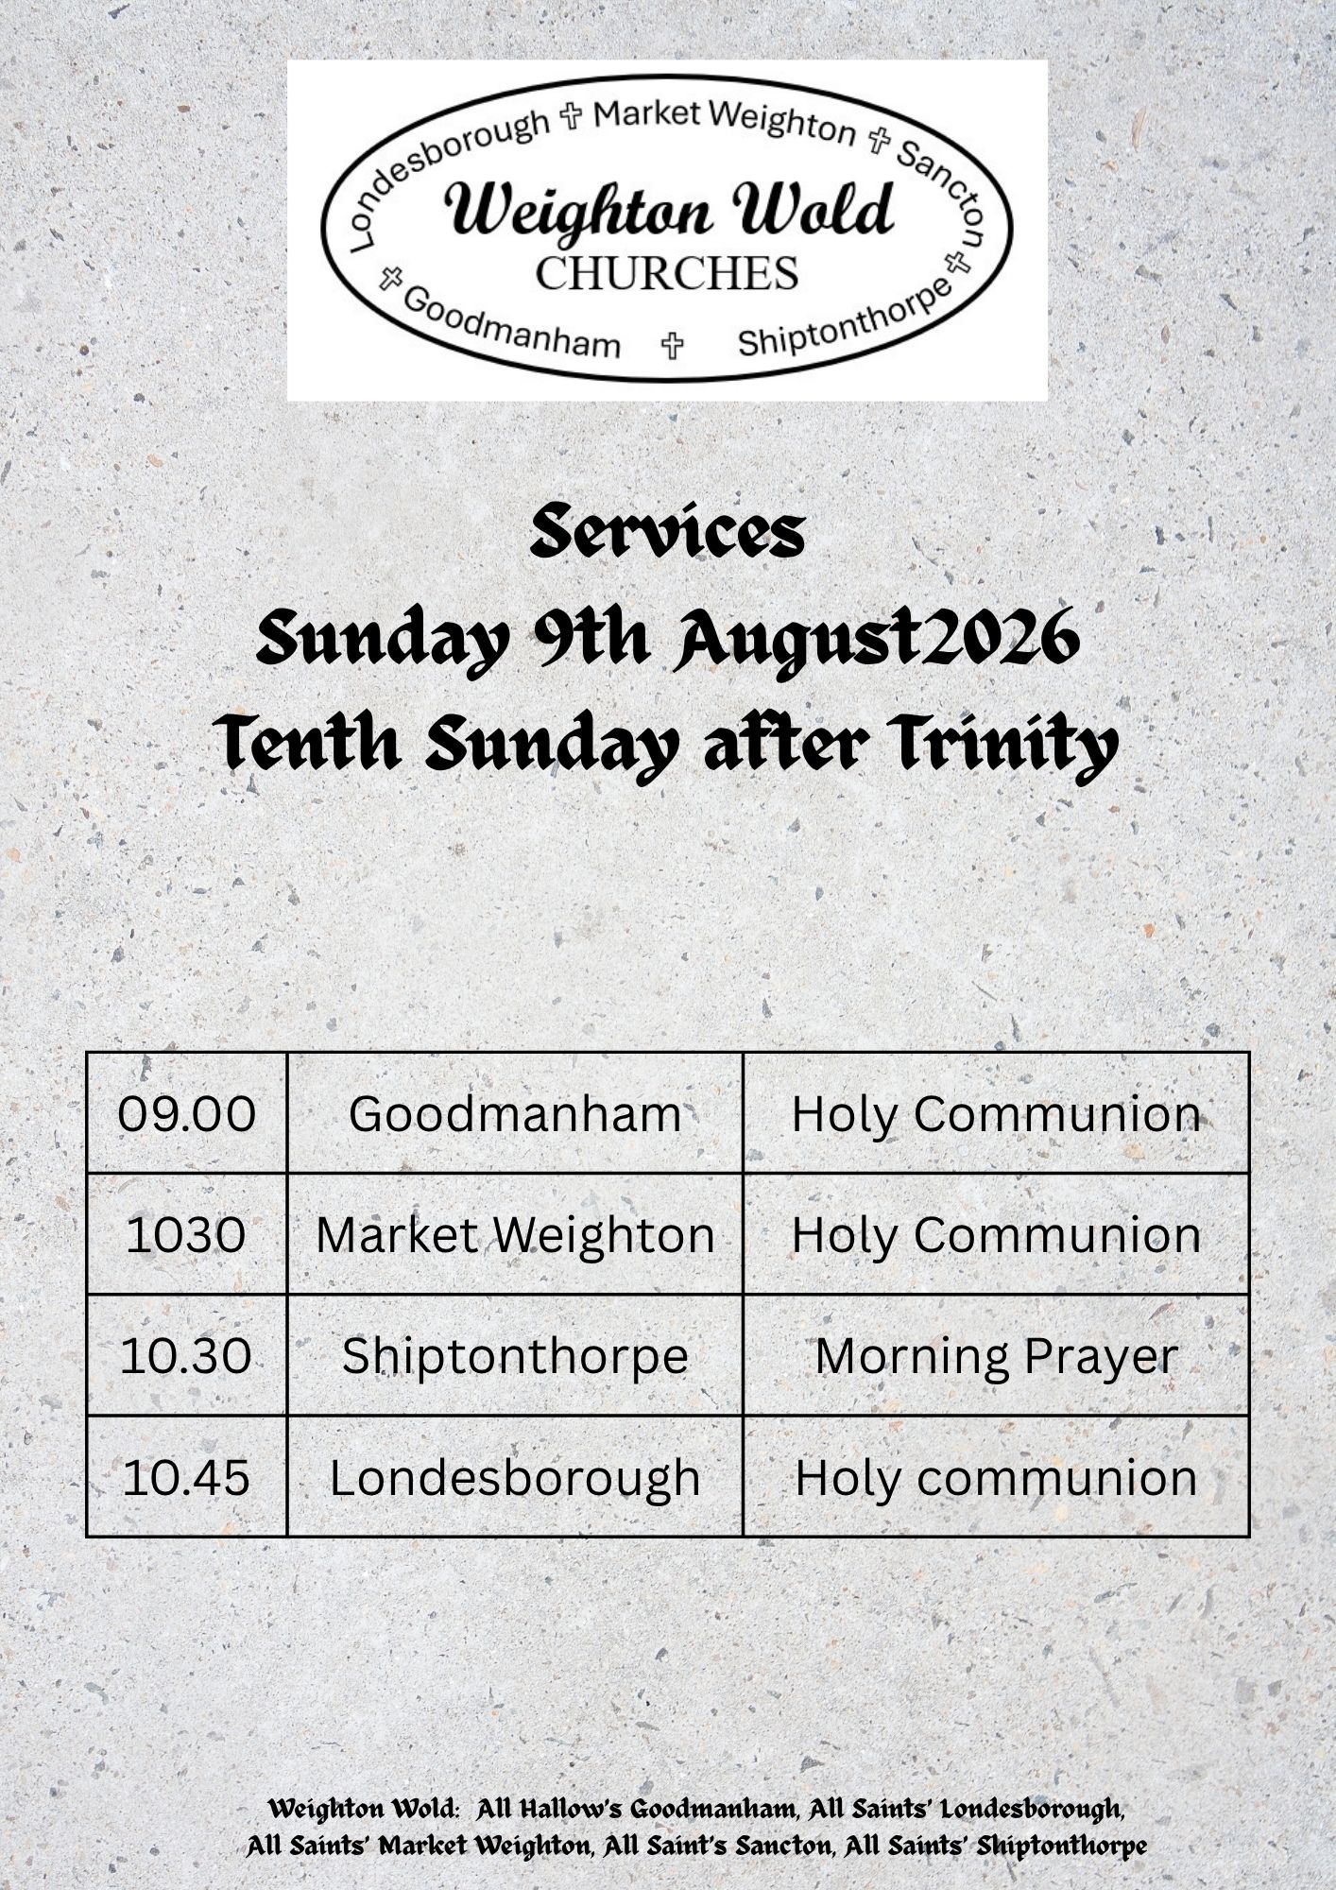



Scan the QR code for the latest news from All Saints’ Church Shiptonthorpe | 

