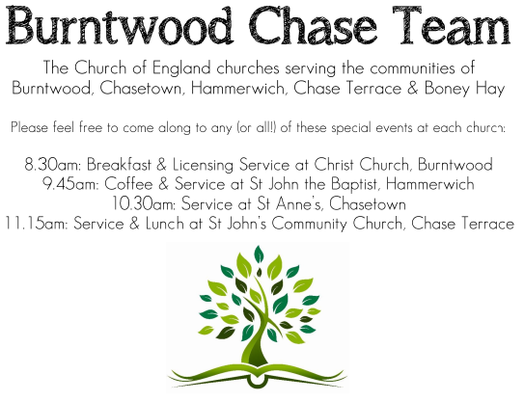
CHRIST CHURCH, BURNTWOOD
Registered Charity Nos: 1217129

SERVICE ON SUNDAY 2nd AUGUST 2026 at 10 am

HOLY COMMUNION

The 9th Sunday after Trinity

First Bible Reading - Isaiah 55: 1-5

Hear, everyone who thirsts; come to the waters; and you who have no money, come, buy and eat! Come, buy wine and milk without money and without price. ² Why do you spend your money for that which is not bread and your earnings for that which does not satisfy? Listen carefully to me, and eat what is good, and delight yourselves in rich food.
³ Incline your ear, and come to me; listen, so that you may live. I will make with you an everlasting covenant, my steadfast, sure love for David. ⁴ See, I made him a witness to the peoples, a leader and commander for the peoples. ⁵ Now you shall call nations that you do not know, and nations that do not know you shall run to you, because of the Lord your God, the Holy One of Israel, for he has glorified you.

Gospel Reading - Matthew 14: 13-21

¹³ Now when Jesus heard this, he withdrew from there in a boat to a deserted place by himself. But when the crowds heard it, they followed him on foot from the towns. ¹⁴ When he went ashore, he saw a great crowd, and he had compassion for them and cured their sick. ¹⁵ When it was evening, the disciples came to him and said, “This is a deserted place, and the hour is now late; send the crowds away so that they may go into the villages and buy food for themselves.”

¹⁶ Jesus said to them, “They need not go away; you give them something to eat.” ¹⁷ They replied, “We have nothing here but five loaves and two fish.” ¹⁸ And he said, “Bring them here to me.” ¹⁹ Then he ordered the crowds to sit down on the grass. Taking the five loaves and the two fish, he looked up to heaven and blessed and broke the loaves and gave them to the disciples, and the disciples gave them to the crowds.

²⁰ And all ate and were filled, and they took up what was left over of the broken pieces, twelve baskets full. ²¹ And those who ate were about five thousand men, besides women and children.

Collect for Today

Almighty God, who sent your Holy Spirit to be the life and light of your Church: open our hearts to the riches of your grace, that we may bring forth the fruit of the Spirit in love and joy and peace; through Jesus Christ your Son our Lord, who is alive and reigns with you, in the unity of the Holy Spirit, one God, now and for ever. Amen.

Forthcoming Services in Church

Sunday 9th August Morning Worship 10am

Wednesday 12th August Morning Prayer 9.30am

Sunday 16th August Holy Communion 10am

Future Event For Your Diary
Saturday 14th November Christmas Fayre 2-4pm

Food bank

We are continuing to support this important ministry for people in need in our local community, for which the following items are always needed: ‘Long Life Milk, Custard, Rice Pudding, Cereals. Many thanks for your support. The Food Bank is very grateful for whatever you may be able to donate.
Floodlighting
If you would like to commemorate a special occasion by floodlighting our Church, please contact Chris Brown on 01543 683862 for details.

Prayer Chain

Christ Church is blessed with a very active prayer chain. If you, or anyone you know, feel that they would like others to pray for them, please speak to Chris Brown on 01543 683862.

Home Visits and Communion

For anyone who is unable to attend church and would like a Home Visit and Communion, please contact the Vicar and he will be able to carry this out.

Vicar’s Contact Details

Rev’d Stephen Morgan - Telephone: 07305 852152

Church Wardens Contact Details

Judith Rogers - Telephone: 01543 324718
Mike Holmes - Telephone: 01543 672970

Church Office Telephone: 01543 642187 [Please leave a message and we will respond in due course]

Church Web Site:www.christchurchburntwood.org.uk
Church Email: christchurchburntwood15@gmail.com
Facebook: www.facebook.com/group/christchurchburntwood/

Next Sunday’s Service – The 10th Sunday after Trinity

Sunday 9th August – Morning Worship at 10am

Bible Readings: 1 Kings 19: 1-18 and Matthew 14: 22-33

