
SPIRE & LIGHT United Churches
United Benefice of St Keverne, St Ruan with St Grade & St.Wynwallow (The Lizard)

*If you do not wish to receive these notices, please let your Churchwarden know*

12th July 2026
SEA SUNDAY

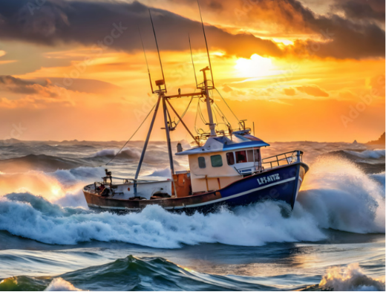
Readings
Isaiah 55:10 – 13
Psalm 65
Romans 8:1-11
Matthew 13:1-9, 18-23

9.30am – Morning Prayer - St.Peter’s, Coverack
9.30am – Holy Communion - St.Ruan, Ruan Minor
11am – St.Keverne – see poster below
11.15am – Café Church – St.Wynwallow, The Lizard
6pm – Evensong – St.Grade

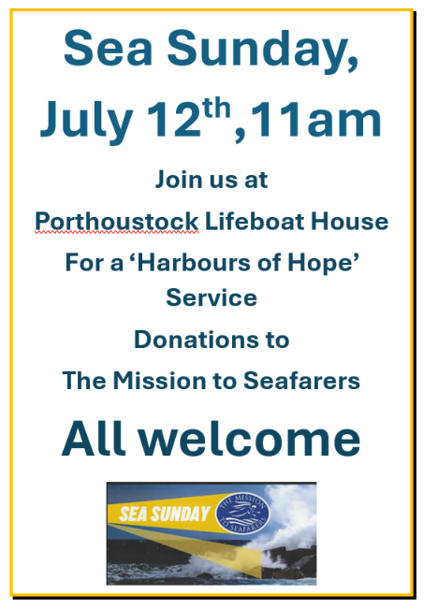

Next week – Sunday July 19th
9.30am – Holy Communion - St.Peter’s, Coverack
9.30am – Holy Communion - St.Wynwallow, The Lizard
11am – Morning Prayer – St.Keverne
11.15am – Family Service – St.Ruan, Ruan Minor

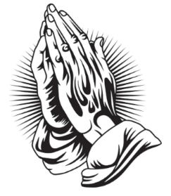
The Prayer Spot
We pray for the Deanery that we belong to and we thank you for the faithful people you have brought together here. Remind us that we have each been brought to faith by Our Saviour Jesus Christ.
Lord Jesus, we thank you for your presence in our lives and the love you give us to share with others. Keep us strong in our faith and close to you.
Help us to be always there for others in their time of need, you have given us each gifts to use to reach out to others and to give comfort to those around us.
Heavenly Father we live in a world slowly destroying itself, through greed, hatred, and with no concern for others. Remind us that we can bring love, care and understanding into the world, by reaching out into our communities and showing your love to all we meet. Loving God, be with us always. Remind us that we are brothers and sisters in Christ Jesus, that God is ever present in our lives, through his wonderful Holy Spirit that he has given to you as a free gift to us all.
Mighty God, everything you do reveals your Majesty. Open our eyes to see what you are doing in our lives. Let us marvel at your good gifts and your wise provision. Your acts are amazing Lord. We cannot comprehend the number of blessings you pour out to us from day to day. As we gather today around your name, we pray that you will fill our hearts, our minds and our souls. Transform us Lord and make us more like you. Through Jesus Christ our Lord. Amen
God bless you all. Samuel Buchanan

On the Way Prayers
Back next week!

The Diocese of Truro’s Prayer Diary for this week

