The Radcliffe Team Ministry
Parish of St Mary
and
Parish of St Thomas and St John with St Philip’s Community Centre
NOTICES THIS WEEK | Sunday 19 July 2026  Seventh Sunday after Trinity

Sunday and the week ahead

Sun 19th  Seventh Sunday after Trinity | 9:30am | Eucharist at St Mary’s. | Followed by refreshments  Envelopes will be in church to facilitate response to the UK Venezuela Appeal
Sun 19th  Seventh Sunday after Trinity | 11:00am | Eucharist at St Thomas and St John’s  - Prayerful good wishes to Sue Aspinall who reaches a milestone birthday during the week  - Deadline to notify unavailability for normally rostered duties in August to Kathleen please by phone or email (contact details at foot of page 2)
Sun 19th  Seventh Sunday after Trinity |  | The Ministry of Healing will be offered at both morning services: prayer for yourself or a loved one, with anointing and laying on of hands
Wed 22nd | 10:00am | Team mid-week Communion at St Thomas and St John’s | With refreshments
Thu 23rd | 7:30pm | The Mission Community’s Task Group Meeting will be held at St Mary’s
Fri 24th | 10:15am | (- 11:30) Following coffee, Team Friday Friends Study Group, in St Thomas and St John’s church. All welcome as we meet to study chosen Psalms in the Bible
Fri 24th | noon | Team Intercessions at St Thomas and St John’s, followed by bring-your-own-lunch if you wish, drinks provided
Fri 24th | 2:00pm | Wedding at St Thomas and St John’s of Carl James McGlynn and Lisa Jayne McLoughlin
Sat 25th | 10:30am | Saturday Café at St Thomas and St John’s, including Vestry Hour (10:30-11:30am) for baptism and wedding enquirers.  July BONUS BALL will be drawn | Until 12:30
Sun 26th  Trinity 8 | 9:30am | Eucharist at St Mary’s. | Followed by refreshments
Sun 26th  Trinity 8 | 11:00am | Eucharist at St Thomas and St John’s | Followed by refreshments
- “
Points for Prayer

Weddings | Carl James McGlynn and Lisa Jayne McLoughlin; Andrew Ede and Jocelyn Anderson-Wood
For healing | St Mary’s: Catherine, Andrew Berry, Revd Dougie Bird, Berenice Carey, Anna Cowsill, David Duckworth, Mick Dugdill, Colin Embrey, Margaret Embrey, Christine Firth, William Firth, Peter Gorman, Pauline Holt, Harry Melling, Sue Richardson, David and Jean Valentine. Ian Williams, Denis Wright, Janice Wright  St TJ and elsewhere: Marilyn Alldred, Joyce Baker, Lawson Bant, Reg Dee, Jacob Dewar, Zohreh Galati, Lyn Hill, Claire Jones, Louise Peart
Bereaved | Family and friends of Joyce Uren, Betty Boardman and Chris Hollis
Books of Remembrance | St Mary’s: Ruth Egerton (20th); Agnes Kerwin (23rd); Gill Layton (24th)  St Thomas and St John’s: Norman Howarth, John Joseph Chapman (19th); Barbara Anne Aldred, Barbara Broxap (20th); Gordon George Hannam (21st); Jack Bradshaw (23rd); Samuel John Birch (24th); Christopher Michael Dighton, Jenny Dighton (d 2.11.79) (25th)

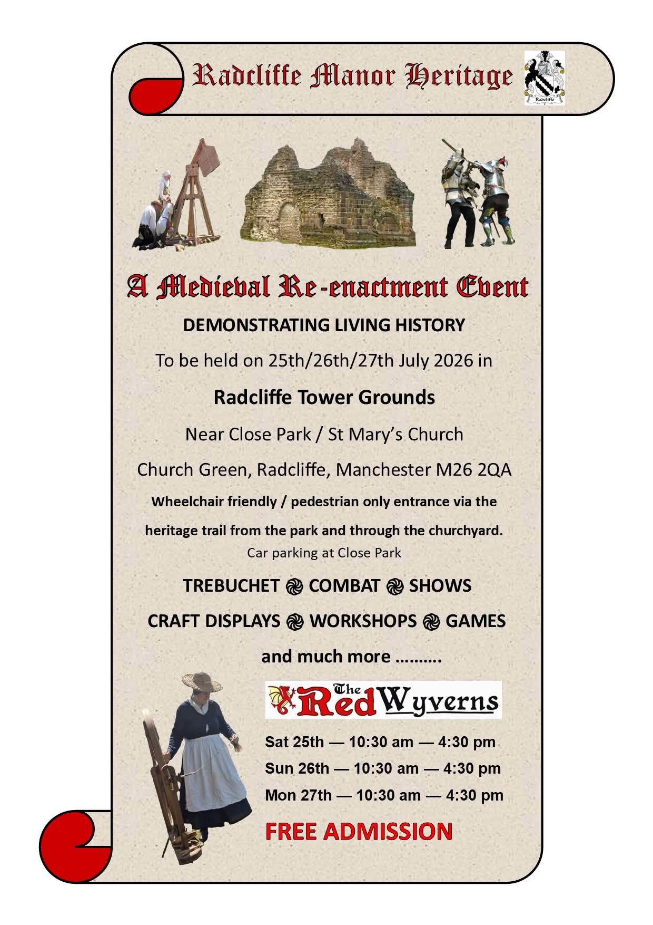

St Mary’s church will be open for refreshments during the advertised times of this event – on Sunday, from the end of morning service.

X
To be in touch with the clergy, please contact Revd Marie Pattison, Team Rector (0161 989 5785 or 07795 805767), Revd Irene Thirkell, Curate (07435 657865) or Revd Adele McKie, Associate Priest (07946 383024).

To discuss baptisms or weddings, please go to Vestry Hour from 10:30 on Saturdays at St Thomas and St John’s, or from 10:45 on Sundays at St Mary’s.

Please supply future information to lesandkathleen@btinternet.com or to 0161 724 5696.

Please follow us and “like” us on our Facebook pages: Radcliffe Parish Church of St. Mary; The Parish Church of St Thomas & St John, Radcliffe; St Philips Community Centre.

VENEZUELA EARTHQUAKE APPEAL

Key facts

4,500 people
killed in the earthquake with the death toll continuing to rise

680,000 children
in need of humanitarian assistance according to UN estimates

16,700 people
injured, with tens of thousands more missing

96,000 buildings
are believed to have been damaged or destroyed

Latest update FROM Disasters Emergency Committee: 13 July 2026

The earthquakes struck within seconds of each other. The scale of destruction is catastrophic. Hundreds of people have been killed and the death toll continues to rise.

The 7.2 and 7.5 magnitude earthquakes struck close to Venezuela’s capital city, Caracas. The second earthquake was the strongest to hit the country in more than a century. Venezuela’s authorities have declared a state of emergency.

Thousands of people are injured, and the country’s hospitals are under extreme pressure. The UN estimates that millions of people have been affected, with more than two million in the worst impacted areas.

The earthquakes caused damage to homes and businesses in Caracas and across several states, with particularly serious impact reported in the La Guaira and Greater Caracas areas. Families are sleeping in makeshift tents on the street, with little protection from the heat and rain. Power lines and roads have been destroyed, and people are cut off from essential supplies.

Christian Aid adds:

Christian Aid colleagues are already working hard with our partners to assess the needs of our neighbours in Venezuela and ensure that our emergency response is exactly what and where it needs to be.

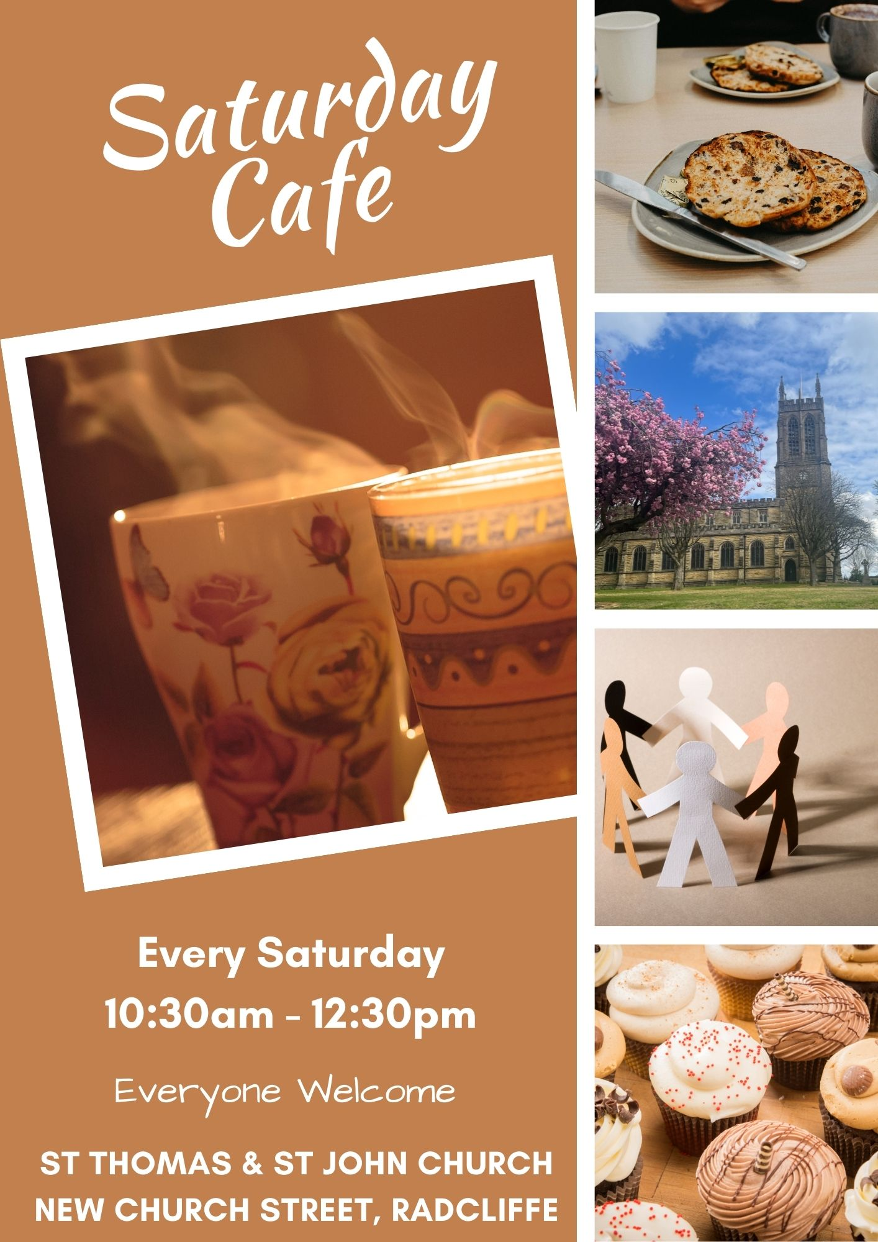

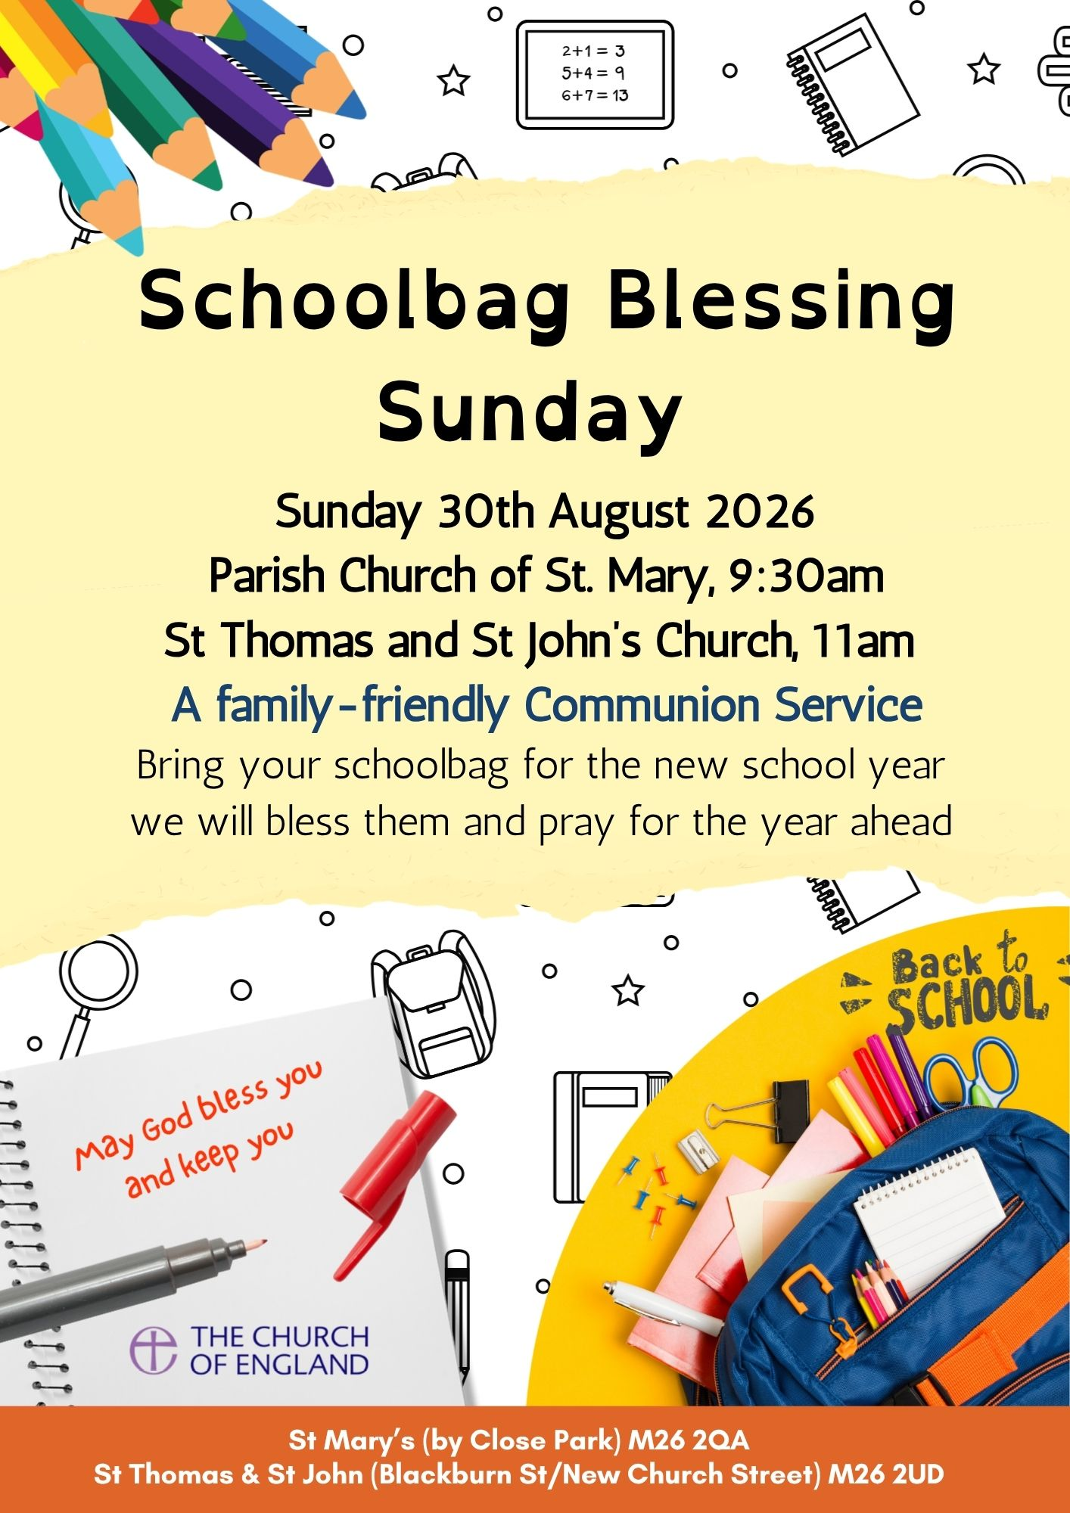

Being stewards of God’s creation and doing our bit as Christians for the planet, if you have any of the following lying around your home then please bring them to be recycled
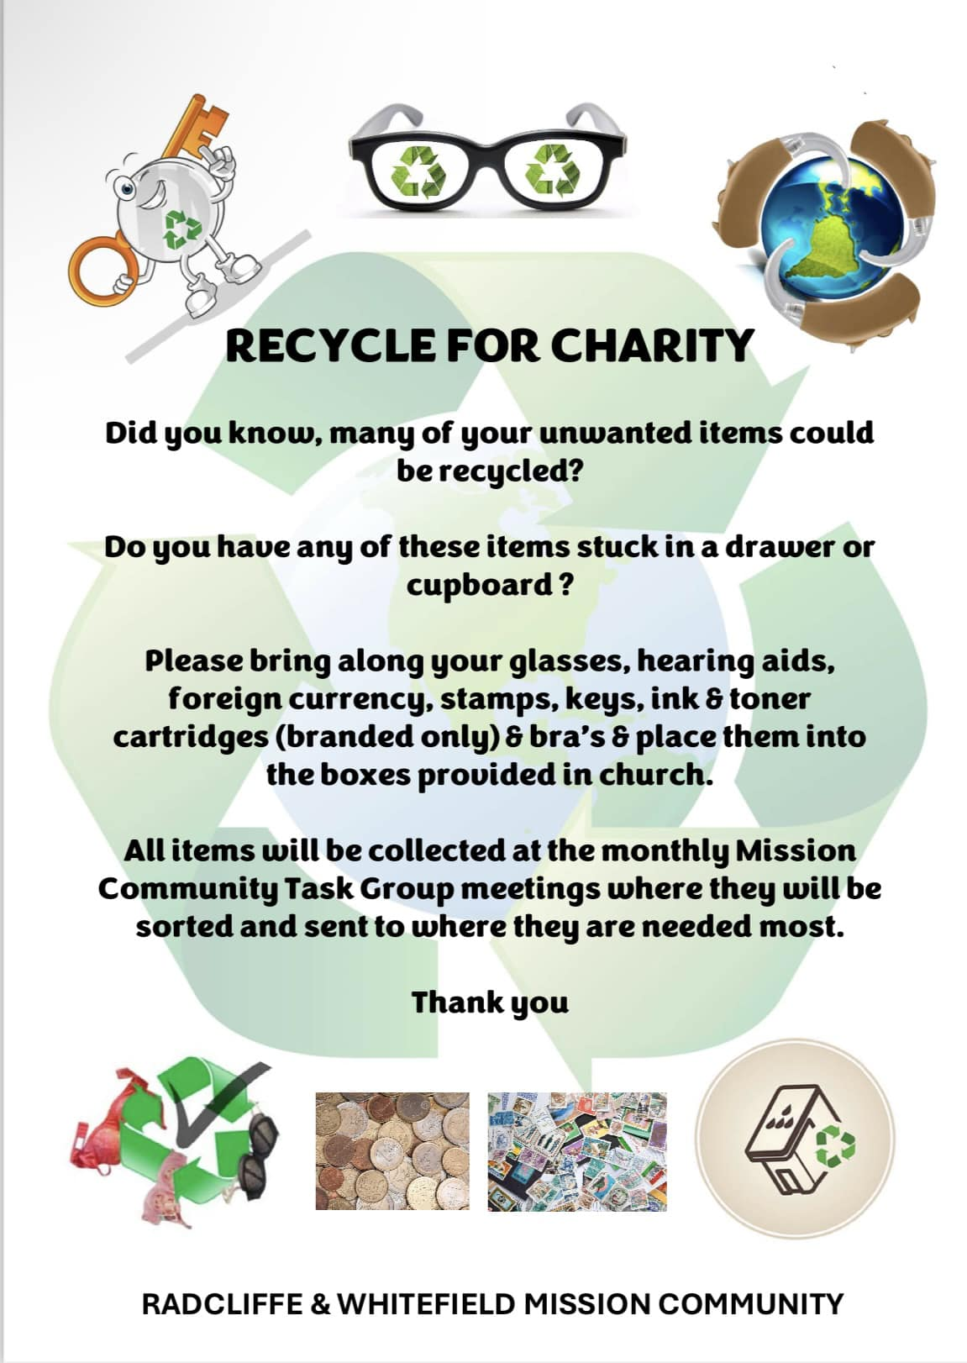

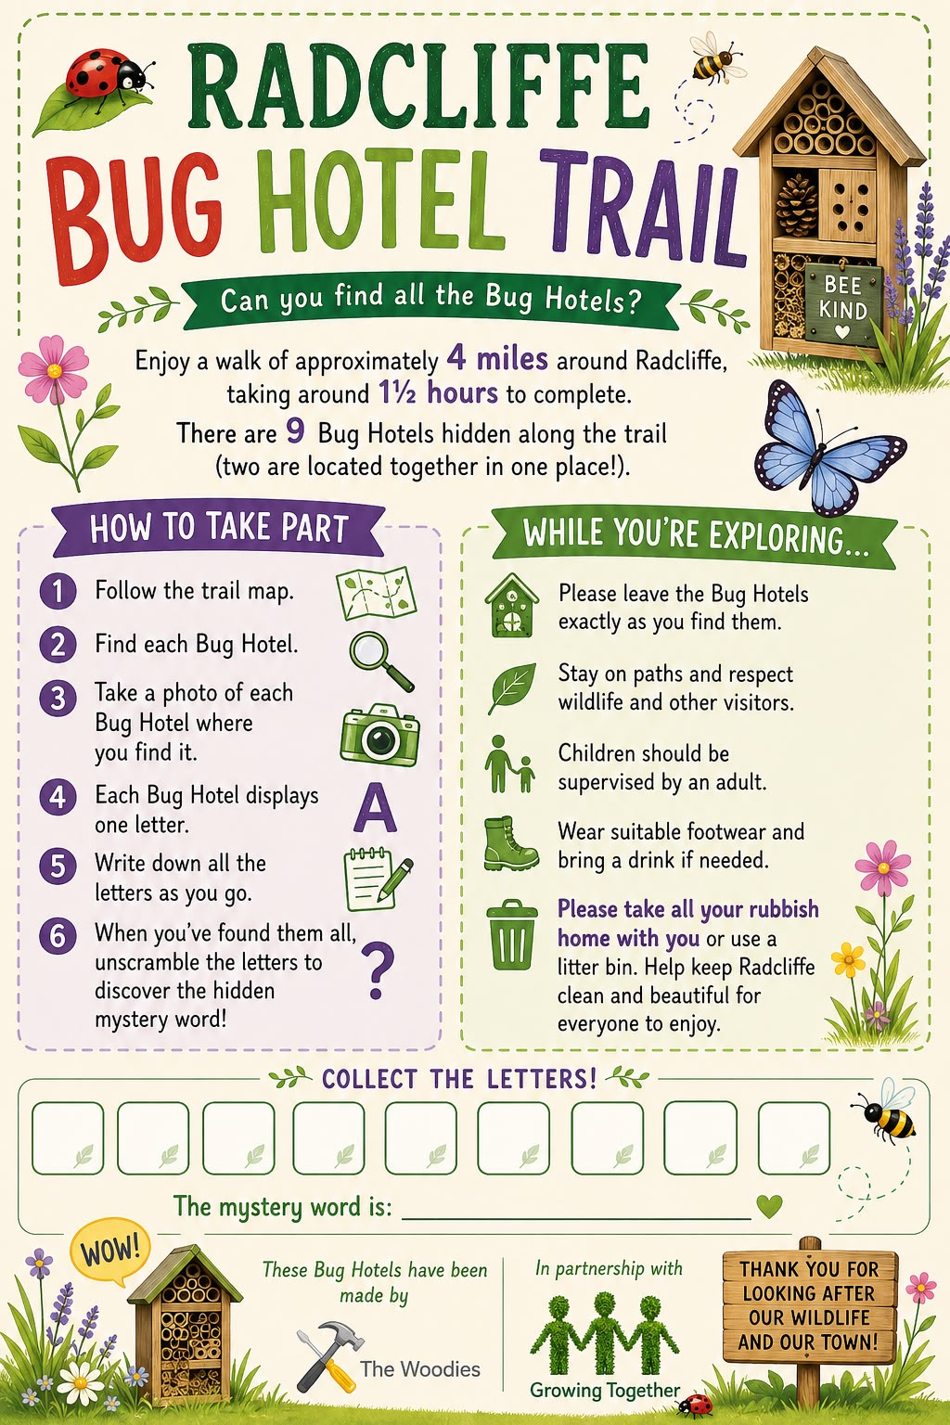
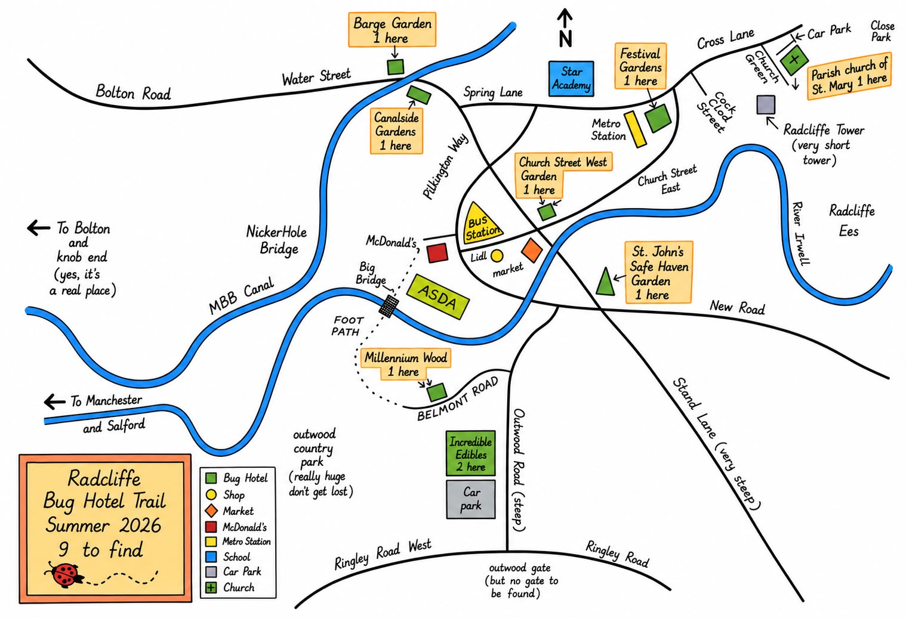

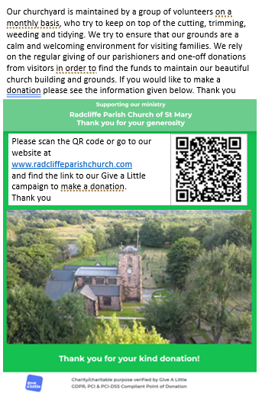
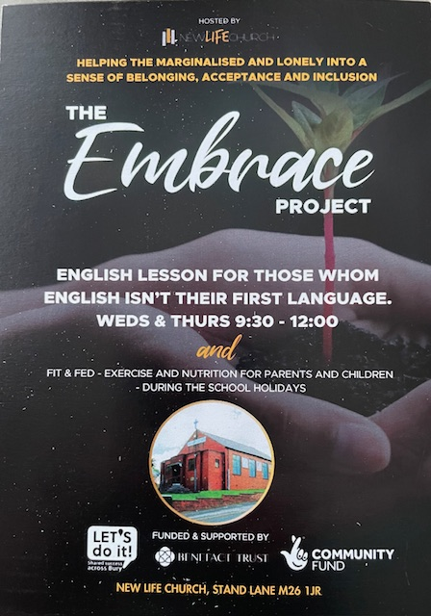
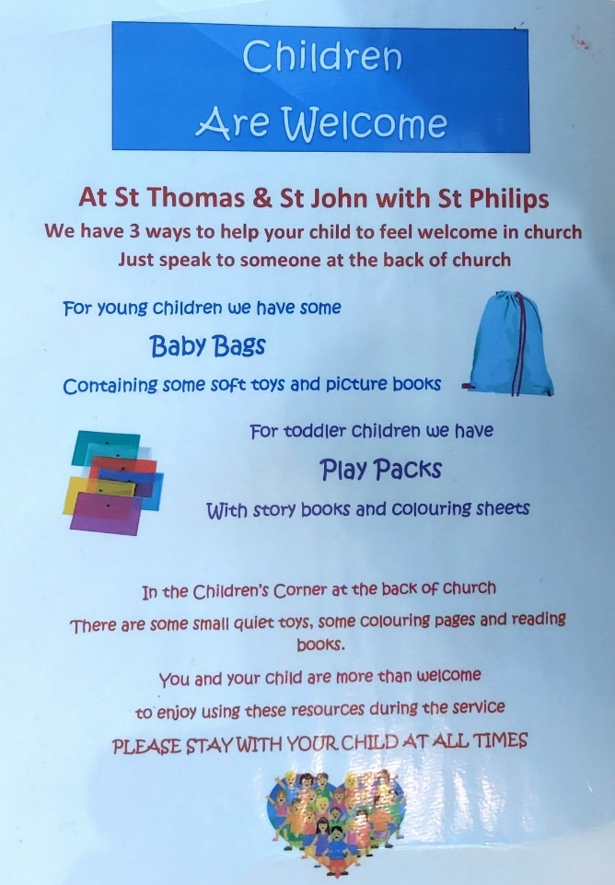

Giving to church
Our Churches depend on income from fees paid for some of our services, from fund-raising, from activities at St Philip’s Community Centre and – most particularly – from monetary gifts from worshippers and other supporters. In each of our churches, donations can be made via digital giving machines using credit or debit cards. You can use the QR codes below to give. Please speak to us for advice on gift aiding your offering, so that each £1 you give becomes £1.25 – at no extra cost to you.
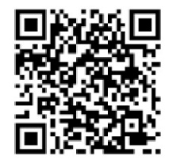

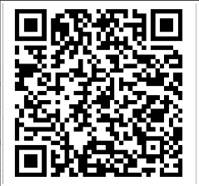
Left: St TJ’s

Right: St Mary’s

