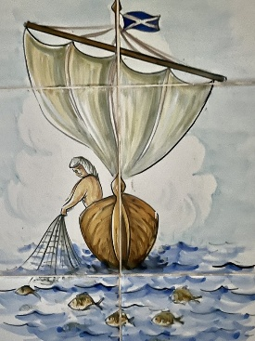
Rota St. Andrew’s Church Puerto Pollensa
August 2026
2nd August | 9th August | 16th August | 23rd August | 30th August
Nineth Sunday after Trinity  (Green)  Isaiah 55: 1-5  Romans 9:1-5  Matthew 14:13-21 | Tenth Sunday after Trinity  (Green)  1 Kings 19:9-18  Romans 10:5-15  Matthew 14:22-33 | Eleventh after Trinity  (Green)  Isaiah 56:1,6-8  Romans 11:1-2,29-32  Matthew 15:21-28 | Twelfth Sunday after Trinity  (Green)  Isaiah 51:1-6  Romans 12:1-8  Matthew 16:13-20 | Thirteenth Sunday after Trinity (Green)  Jeremiah 15:15-21  Romans 12:9-end  Matthew 16:21-end
Holy Communion  11am | Holy Communion 11am | Holy Communion  11am | Morning Prayer 11am | Holy Communion 11am
40 Years of the Anglican Church in Puerto Pollensa!
This year we will be celebrating our 40th anniversary of Anglican Worship here in Puerto Pollensa.Do you have any memories from any point in the last 40 years which you would like to share? Do let me know! Revd.Sara chaplain@standrewspuertopollensa.org

Songs of Praise!
Friday 14th August 6pm
Join us at St. Andrew’s for all your favourite hymns! Let us know what hymns you like beforehand (if possible), then come and sing loudly to raise the roof. Drinks and nibbles afterwards.

