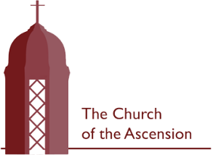
Sunday 5 July 2026
Trinity 5

A very warm welcome to church today to all regulars, visitors and newcomers.
WHAT’S ON?

Today
9am Morning Prayer
10am Holy Communion
2pm Summer Music Concert

Tuesday
There is no Morning Prayer today.
2.30pm Service at Birchwood Grange

Wednesday
9am Morning Prayer
10am Holy Communion

Thursday
7 for 7.30pm Deanery Synod at St Andrew’s,
Sudbury with focus on Modern
Slavery

Next Sunday
9am Morning Prayer
10am Holy Communion (Trinity 6)

Saturday 18 July
2-4.30pm Vicarage Garden Party in aid of Homes of Promise, Uganda

Welcome
We invite everyone to stay for refreshments after all our services. If you are new or visiting today, we would love to get to know you!

Summer Music Concert – Today 2pm
Please join us in the church for an afternoon of music from the fantastic Tracey King School of Music. All in aid of church funds!
Sermons
An audio recording of the previous week’s sermon is now available on our A Church Near You page. Just scan the QR Code and find the notice for last Sunday, then scroll to ‘More Info’ and simply click. (If you are using a mobile device, you may be asked to download Soundcloud).



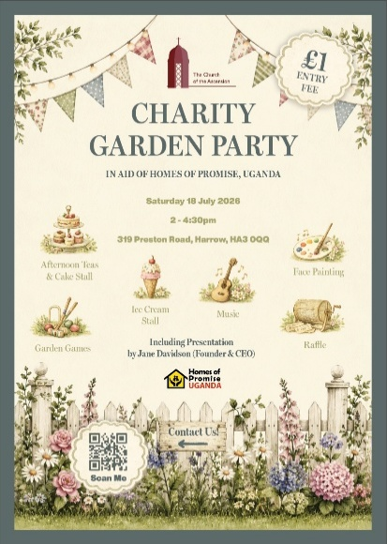

Charity Garden Party – Saturday 18 July 2-4.30pm
The Vicarage, 319 Preston Road
Please help us promote this very special event in aid of Homes of Promise, Uganda by inviting others, helping at it and coming along yourself! Our advertising boards are up and we have handsome prizes for the Grand Draw!

Collect
Almighty and everlasting God,
by whose Spirit the whole body of the Church
is governed and sanctified:
hear our prayer which we offer for all your faithful people,
that in their vocation and ministry
they may serve you in holiness and truth
to the glory of your name;
through our Lord and Saviour Jesus Christ,
who is alive and reigns with you,
in the unity of the Holy Spirit,
one God, now and for ever.

Post Communion Prayer
Grant, O Lord, we beseech you,
that the course of this world may be so peaceably ordered
by your governance,
that your Church may joyfully serve you in all godly quietness;
through Jesus Christ our Lord.

Second Reading: Romans 7.15-25
I do not understand my own actions. For I do not do what I want, but I do the very thing I hate. Now if I do what I do not want, I agree that the law is good. But in fact it is no longer I that do it, but sin that dwells within me. For I know that nothing good dwells within me, that is, in my flesh. I can will what is right, but I cannot do it. For I do not do the good I want, but the evil I do not want is what I do. Now if I do what I do not want, it is no longer I that do it, but sin that dwells within me.
So I find it to be a law that when I want to do what is good, evil lies close at hand. For I delight in the law of God in my inmost self, but I see in my members another law at war with the law of my mind, making me captive to the law of sin that dwells in my members. Wretched man that I am! Who will rescue me from this body of death? Thanks be to God through Jesus Christ our Lord!

First Reading: Genesis 24.34-38, 42-49, 58-67
So he said, ‘I am Abraham’s servant. The Lord has greatly blessed my master, and he has become wealthy; he has given him flocks and herds, silver and gold, male and female slaves, camels and donkeys. And Sarah my master’s wife bore a son to my master when she was old; and he has given him all that he has. My master made me swear, saying, “You shall not take a wife for my son from the daughters of the Canaanites, in whose land I live; but you shall go to my father’s house, to my kindred, and get a wife for my son.”
‘I came today to the spring, and said, “O Lord, the God of my master Abraham, if now you will only make successful the way I am going! I am standing here by the spring of water; let the young woman who comes out to draw, to whom I shall say, ‘Please give me a little water from your jar to drink,’ and who will say to me, ‘Drink, and I will draw for your camels also’—let her be the woman whom the Lord has appointed for my master’s son.”
‘Before I had finished speaking in my heart, there was Rebekah coming out with her water-jar on her shoulder; and she went down to the spring, and drew. I said to her, “Please let me drink.” She quickly let down her jar from her shoulder, and said, “Drink, and I will also water your camels.” So I drank, and she also watered the camels. Then I asked her, “Whose daughter are you?” She said, “The daughter of Bethuel, Nahor’s son, whom Milcah bore to him.” So I put the ring on her nose, and the bracelets on her arms. Then I bowed my head and worshipped the Lord, and blessed the Lord, the God of my master Abraham, who had led me by the right way to obtain the daughter of my master’s kinsman for his son. Now then, if you will deal loyally and truly with my master, tell me; and if not, tell me, so that I may turn either to the right hand or to the left.’
And they called Rebekah, and said to her, ‘Will you go with this man?’ She said, ‘I will.’ So they sent away their sister Rebekah and her nurse along with Abraham’s servant and his men. And they blessed Rebekah and said to her,
‘May you, our sister, become
thousands of myriads;
may your offspring gain possession
of the gates of their foes.’
Then Rebekah and her maids rose up, mounted the camels, and followed the man; thus the servant took Rebekah, and went his way.
Now Isaac had come from Beer-lahai-roi, and was settled in the Negeb. Isaac went out in the evening to walk in the field; and looking up, he saw camels coming. And Rebekah looked up, and when she saw Isaac, she slipped quickly from the camel, and said to the servant, ‘Who is the man over there, walking in the field to meet us?’ The servant said, ‘It is my master.’ So she took her veil and covered herself. And the servant told Isaac all the things that he had done. Then Isaac brought her into his mother Sarah’s tent. He took Rebekah, and she became his wife; and he loved her. So Isaac was comforted after his mother’s death.

Gospel: Matthew 11.16-19, 25-30
‘But to what will I compare this generation? It is like children sitting in the market-places and calling to one another,
“We played the flute for you, and you did not dance;
we wailed, and you did not mourn.”
For John came neither eating nor drinking, and they say, “He has a demon”; the Son of Man came eating and drinking, and they say, “Look, a glutton and a drunkard, a friend of tax-collectors and sinners!” Yet wisdom is vindicated by her deeds.’
At that time Jesus said, ‘I thank you, Father, Lord of heaven and earth, because you have hidden these things from the wise and the intelligent and have revealed them to infants; yes, Father, for such was your gracious will. All things have been handed over to me by my Father; and no one knows the Son except the Father, and no one knows the Father except the Son and anyone to whom the Son chooses to reveal him.
‘Come to me, all you that are weary and are carrying heavy burdens, and I will give you rest. Take my yoke upon you, and learn from me; for I am gentle and humble in heart, and you will find rest for your souls. For my yoke is easy, and my burden is light.’

Contact the Vicar
(Sunday through Wednesday)
nickjones.ascension@gmail.com
07515 736822

