

A very warm welcome to you, especially if you are visiting.
Please take this sheet home with you and use it as a basis for prayer.

Sunday 19th July 2026
Lowick 9.15 Holy Communion
Ford 11am Holy Communion

Sunday 26th July 2026
Lowick 9.15 Holy Communion
Ford 11am Holy Communion
Ancroft Patronal Festival 1-4pm
Pilgrimage walk from Lowick to Ancroft, 2pm
Ancroft 5pm Hymns and Pimms

Sunday 2nd August 2026
Lowick 9.15 Holy Communion
Ford 11am Holy Communion

Sunday 9th August 2026
Lowick 9.15 Holy Communion
Ford 11am Holy Communion
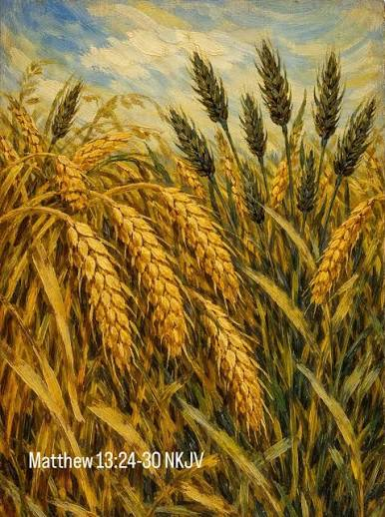
Today is the Seventh Sunday after Trinity and we are challenged by the gospel to ask who is sowing what in our lives. As we go through this week, it might help to make a journal jotting each day of what God shows us in answer to this question, and how to respond accordingly.

- Thursday 23rd July at Fordhill, 5.30pm Ford PCC

- Saturday 25th July, St Anne’s Ancroft 2.30pm Funeral of Ruth Turner
- Sunday 26th July St Anne’s Patronal Festival 1-4pm in church with teas, tower tours, music, heritage crafts
- Sunday 26th July 2pm from Lowick Church – 2 hr pilgrim walk to Ancroft – see Alex for details, to join the 5pm service of Hymns and Pimms
- Saturday 1st August, Lowick Churchyard clear up session from 1pm, refreshments available.


Saturday 19th September
9am -1pm at Etal Village Hall
Refreshments provided,
All welcome.

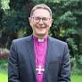
Bishop Mark will facilitate.

For our prayers

All who suffer in body, mind or spirit, especially Heather Piper, George Hall, Gail Calder, Don and Sam Quilty, Alison Murray, Alan Hughes.

We pray for those who mourn, and for all who mark anniversaries of death at this time of year: Alison Northover.

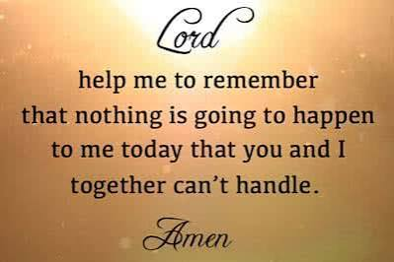

Flake Parishes Contacts

Revd Charlotte Osborn (Vicar) 01289 388591 ceosborn@mail.com 07957 367457

Revd Alex Firman (Assistant Curate) 07935 732811
alex_firman@hotmail.co.uk

Our other licensed clergy

Revd Margaret Sentamu 077871 204745, Canon Nick Sagovsky,
Revd Marion Penfold 01289 305664

Church Contacts

Ancroft Leigh Yorke 07716 116739
Etal Andrew Joicey 01890 820540
Ford Kathleen Holmes 07951 099668
Lowick John Dickson 07967 343211

Parish Administrator
Sheena Atkinson
admin@flakeparishes.org

Safeguarding Officer
Philip Greene
safeguarding@flakeparishes.org
07555 412284

