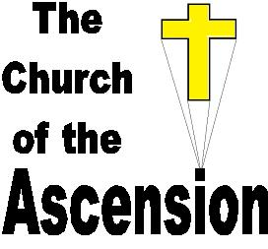
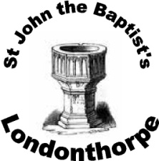
ggh
Community News


Month of July 2026

Quiz Night for Grantham Foodbank – Sat 4th July, 6.30pm. FREE entry including light refreshments, just leave a donation for the Foodbank. Contact churchoftheascension.work@gmail.com to reserve a place.

Benefice Service of Holy Communion at the Ascension – Sunday 5th July, 10am followed by refreshments. Also live-streamed. All welcome

Wellbeing Café in Ascension Church Hall –Mon 6th, 13th & 20th July, 10am-12noon. Hot drinks, cakes, crafts, table games and a listening ear. FREE with voluntary donations! CLOSED 27th July & all August.

Rising Stars Baby & Toddler Group in Ascension Church Hall – Tues 7th, 14th & 21st July, 10am-12noon. Toys, crafts, soft play, stories, songs, healthy snacks, refreshments. FREE! CLOSED for summer holidays.

Sunday Worship with Sunday Club for Children – Sunday 12th July, 10am followed by refreshments. Also live-streamed. All welcome

Baptism of Leo Lorenz at the Ascension – Sunday 12th July, 12.15pm.

Holy Communion at St John the Baptist’s Londonthorpe – Sunday 12th July, 4pm, followed by refreshments. All welcome

Ladies Fellowship, Rev. Barbara’s South African Travels, in Ascension Community Rooms – Tues 14th July, 2pm, followed by refreshments. FREE! All ladies welcome

Service at Richard House Care home – Wed 15th July, 2.30pm. All welcome

All Age Family Service at the Ascension – Sunday 19th July, 10am followed by refreshments.

Harrowby Primary End of Year Service at the Ascension – Tues 21st July, 2pm

Londonthorpe Church Coffee Morning with Celtic Morning Prayer – Thurs 23rd July, 10am-11.30am. FREE with voluntary donations. Celtic Morning Prayer will be at 9.15am. All welcome

Service of Holy Communion at the Ascension – Sunday 26th July, 10am, followed by refreshments. Also live-streamed. All welcome

Hymns of Praise at St John the Baptist’s Londonthorpe – Sunday 26th July, 4pm, followed by refreshments. All welcome

Benefice Service of Holy Communion at the Ascension – Sunday 2nd August, 10am followed by refreshments. Also live-streamed. All welcome

Morning Prayer at the Ascension from Mon-Thurs at 9am, with refreshments on Wednesday.

Ladies Fellowship Summer Fayre in Ascension Church Hall – Tues 11th August, 2pm. Mystery parcels, Puzzles & Games, Raffle, Various Stalls, delicious refreshments. FREE entry! All welcome

Happy Birthday to Sarah Horton (5th July) James Moore (25th July) & Nicky Watkinson (31st July).





f


g



Revd Samantha Parsons Tel: 01476 574145 Email: rev.samparsons@gmail.com
Facebook: https://www.facebook.com/ascensionharrowby/
Website: http://www.achurchnearyou.com/Grantham-Harrowby-Londonthorpe

