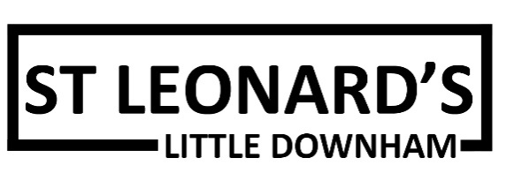

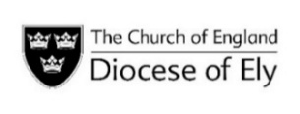

AUGUST 2026

Services are in held the church at 11am unless indicated otherwise

Everyone welcome!

2nd August Morning Praise
with Josie Gableman

9th August Holy Communion
with Revd Jeremy James

16th August Morning Praise
with Shirley Jenkins

23rd August Holy Communion
with Revd Alan Partridge

30th August Methodist Holy Communion
with Revd Mike Newell

For enquiries, please contact Shirley Jenkins (Churchwarden)
0790 4381914, Shirleyjenkins545@gmail.com

St Leonard’s is part of the Isle of Ely Villages Benefice
Team Rector: Revd Chris Hollingshurst
rector@isleofelyvillages.org

Website: https://www.achurchnearyou.com/st-leonard-little-downham
In 2009 St Leonard’s formed a Local Ecumenical Partnership (LEP) between the Church of England and the Methodist Church. Two congregations became one as a sign of unity in Christ and began sharing their resources.

In 2009 St Leonard’s formed a Local Ecumenical Partnership (LEP) between the Church of England and the Methodist Church. Two congregations became one as a sign of unity in Christ and began sharing their resources.

