The Parishes of St Anne’s Greenland’s  and St Paul’s North Shore  Week Commencing: 5th July 2026 | 
Sunday 5th July 2026  Today we welcome Fr Josh who will preside at Eucharistic services with both parishes  St Anne’s Eucharist Service at 9-30am St Paul’s Eucharist Service 11.15am (Baptism service at St Paul’s at 2-00pm)  Tuesday at St Paul’s Ecumenical Prayer meeting at 9-30am in the chapel  Wednesday 8th July 2026  Mid-week Eucharist Service at St Paul’s at 10-00am  St Anne’s Thursday Evening  Holy Communion Service at 6.00pm  Contemplative Prayer Group  Monday 20th July at 7.00pm at  5 Hetherington Place.    Sunday and Wednesday at 6-30pm At St Paul’s church Phone Jim on 07955597771 jim@libertychurchblackpool.org.uk Liberty Church is a safe inclusive church that welcomes everyone who celebrates the diversity of LGBT+ |   Please pray for:  Stephen; Joanne; Glen; Christine Elias;  Terry Williams; Father Michael Fish;  Paul Heelam; Anne Russell; Louise Jones; David Lee Fletcher; Amanda Smith; Wendy Booth; Sue Heelam; Iain Thompson Snr; Michael Eaton; Sue Simpson; Darren Marchant; Denise Murphy; Chris Waller; Marion Farrar; Margaret Crook.    In Memorium:  William Thomas Smallman; Ronald Dean; Margaret Mabel Tattersall; Ronald Rudge; Richard John Davies; John Griffiths Baker; Harold Pearson; Lily Beatrice Glover;  Harry Gregson; Joseph Parry; Lois Gorst; Harry Smith; Muriel Barlow.    Barry Key; Maureen Allen;  Doreen Waller.  In your prayers this week remember our parishes and the families in; In your prayers this week remember our parishes and the families in:  Tyrone Avenue, Valentia Road,  Washington Avenue, Washington Court,  Ormond Avenue, Finchley Road,  Redcar Road, Redvers Terrace, Northfield Avenue, Gynn Avenue.


  Low Moor Community Centre  Coffee Morning every Monday from  10am–12noon  Everyone welcome    Come along and join in Pilates at St Anne’s Church  Monday, Tuesday & Thursday mornings. For more information: Please phone Claire on 07599659154  Allsorts  Every first and third Wednesday after Mid-week Communion.  Thursday at St Paul’s Drop In Café    9-30am to 12-00noon.  Bring a friend along for a warm welcome. Come and see our very long awaited new toilet area.    St Paul’s Coffee Morning  Saturday 11th July at 10.30am – 12noon.  All welcome. | 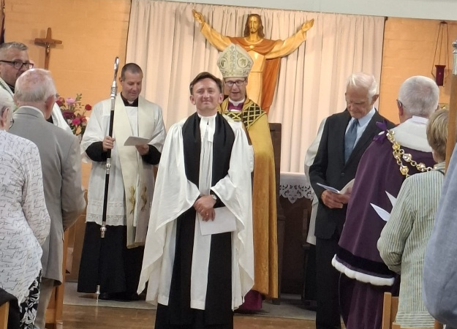  What a fantastic evening on Wednesday  Full of joy, laughter, happiness, music and …. Cake!!  A memorable night in the history of St Anne’s and St Paul’s, so many people and a lovely service. Fantastic choir.  Many thanks to everyone who helped in any way to make it a very special time.  Thursday at St Paul’s Uniformed organisations, from 6-00pm – 9-00pm. Please invite any young people who may want to join these groups to come along and meet our leaders  Bereavement Support Group  Monday 13th July at 2.00pm – 3.00pm  

