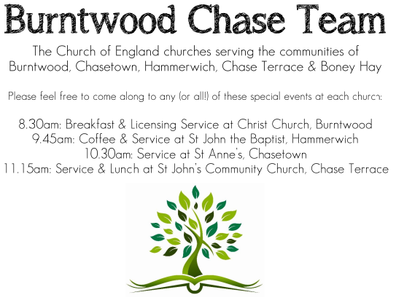
CHRIST CHURCH
Registered Charity Nos. 1217129

SERVICE ON SUNDAY 12th July 2026 at 10am

Morning Worship

6th Sunday after Trinity

Readings:
Isaiah 55: 10-13

¹⁰ For as the rain and the snow come down from heaven,
and do not return there until they have watered the earth,
making it bring forth and sprout,
giving seed to the sower and bread to the eater,
¹¹ so shall my word be that goes out from my mouth;
it shall not return to me empty,
but it shall accomplish that which I purpose,
and succeed in the thing for which I sent it.
¹² For you shall go out in joy,
and be led back in peace;
the mountains and the hills before you
shall burst into song,
and all the trees of the field shall clap their hands.
¹³ Instead of the thorn shall come up the cypress;
instead of the brier shall come up the myrtle;
and it shall be to the Lord for a memorial,
for an everlasting sign that shall not be cut off.

Matthew 13: 1-9, 18-23

That same day Jesus went out of the house and sat beside the lake. ² Such great crowds gathered around him that he got into a boat and sat there, while the whole crowd stood on the beach. ³ And he told them many things in parables, saying: ‘Listen! A sower went out to sow. ⁴ And as he sowed, some seeds fell on the path, and the birds came and ate them up. ⁵ Other seeds fell on rocky ground, where they did not have much soil, and they sprang up quickly, since they had no depth of soil. ⁶ But when the sun rose, they were scorched; and since they had no root, they withered away. ⁷ Other seeds fell among thorns, and the thorns grew up and choked them. ⁸ Other seeds fell on good soil and brought forth grain, some a hundredfold, some sixty, some thirty. ⁹ Let anyone with ears listen!’

¹⁸ ‘Hear then the parable of the sower. ¹⁹ When anyone hears the word of the kingdom and does not understand it, the evil one comes and snatches away what is sown in the heart; this is what was sown on the path. ²⁰ As for what was sown on rocky ground, this is the one who hears the word and immediately receives it with joy; ²¹ yet such a person has no root, but endures only for a while, and when trouble or persecution arises on account of the word, that person immediately falls away. ²² As for what was sown among thorns, this is the one who hears the word, but the cares of the world and the lure of wealth choke the word, and it yields nothing. ²³ But as for what was sown on good soil, this is the one who hears the word and understands it, who indeed bears fruit and yields, in one case a hundredfold, in another sixty, and in another thirty.’

COLLECT FOR TODAY
Merciful God,
you have prepared for those who love you
such good things as pass our understanding:
pour into our hearts such live toward you
that we, loving you in all things and above all things,
may obtain your promises,
which exceed all that we can desire;
through Jesus Christ your Son our Lord,
who is alive and reigns with you,
in the unity of the Holy Spirit,
one God, now and for ever.

WHAT’S GOING ON
Upcoming Services and Events
Wednesday 15th July Morning Prayer 9.30am
Sunday 19th July Holy Communion 10am
Wednesday 22nd July Morning Prayer 9.30am
Sunday 26th July Morning Worship 10am

DATES FOR YOUR DIARY
Saturday 11th July Shelfield Choir Concert 7pm
Saturday 14th November Christmas Fayre 2-4pm

Food bank
Update on the food bank, we are continuing to support this worthwhile appeal. A few of the items always needed are:
‘long life milk, custard / rice pudding, cereals’
Many thanks for your support.

Afternoon Tea
Thanks to the Social team led by Chris on raising £640.80 for church funds. It was a great, themed afternoon which all enjoyed and thanks for supporting us.

FLOODLIGHTING
If you think about commemorating a special occasion by floodlighting our Church. Please contact Chris Brown on 01543 683862 for details.

PRAYER CHAIN
Christ Church is blessed with a very active prayer chain. If you, or anyone you know, feel that they would like others to pray for them, please speak to Chris Brown on 01543 683862.

HOME COMMUNION
For anyone who is unable to attend church and would like a Home Visit and Communion, please contact the Vicar and he will be able to carry this out.

VICAR CONTACT DETAILS
Rev’d Stephen Morgan Tele: 07305 852152
CHURCH WARDENS CONTACT DETAILS
Judith Rogers Tele: 01543 324718
Mike Holmes Tele: 01543 672970
Church Office Tele: 01543 642187 [leave a message and we will respond]
Church Web Site:www.christchurchburntwood.org.uk
Church Email: christchurchburntwood15@gmail.com
Facebook: www.facebook.com/group/christchurchburntwood/

Other Contacts
Rev’d Matt Wallace St. John’s, Chase Terrace— Tele: 01543 670078

NEXT SUNDAY SERVICE
Sunday 19th July at 10am
Holy Communion
Isaiah 44: 6-8
Matthew 13: 24-30, 36-43
7th Sunday after Trinity

