The Winterbournes and Compton Valence

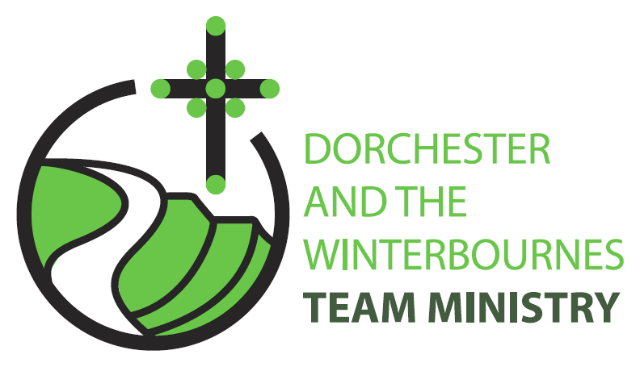

Trinity 8
26th July 2026

Welcome to this service in the Ordinary Season. This week we are encouraged to think about what we treasure and to reflect on the small things we can do to share God’s love with others. In our prayers we especially remember the plight of the people in our link Dioceses of Sudan and South Sudan who are facing an upsurge in violence and are experiencing food shortages. We continue to pray for peace processes in Iran and Israel and Ukraine. We also pray for those affected by Climate Change and extreme heat, wildfires and famine.

Collect
Lord God,
your Son left the riches of heaven
and became poor for our sake:
when we prosper save us from pride,
when we are needy save us from despair,
that we may trust in you alone;
through Jesus Christ our Lord.
All: Amen

Reading: 1 Kings 3: 5-12

⁵ At Gibeon the Lord appeared to Solomon in a dream by night; and God said, ‘Ask what I should give you.’ ⁶ And Solomon said, ‘You have shown great and steadfast love to your servant my father David, because he walked before you in faithfulness, in righteousness, and in uprightness of heart towards you; and you have kept for him this great and steadfast love, and have given him a son to sit on his throne today. ⁷ And now, O Lord my God, you have made your servant king in place of my father David, although I am only a little child; I do not know how to go out or come in. ⁸ And your servant is in the midst of the people whom you have chosen, a great people, so numerous they cannot be numbered or counted. ⁹ Give your servant therefore an understanding mind to govern your people, able to discern between good and evil; for who can govern this your great people?’
¹⁰ It pleased the Lord that Solomon had asked this. ¹¹ God said to him, ‘Because you have asked this, and have not asked for yourself long life or riches, or for the life of your enemies, but have asked for yourself understanding to discern what is right, ¹² I now do according to your word. Indeed I give you a wise and discerning mind; no one like you has been before you and no one like you shall arise after you.

This is the word of the Lord.
All: Thanks be to God.

Gospel Reading: Matthew 13: 31-33, 44-52

Hear the Gospel of our Lord Jesus Christ according to Matthew.
All: Glory to you, O Lord.

31 He put before them another parable: The kingdom of heaven is like a mustard seed that someone took and sowed in his field;
32 it is the smallest of all the seeds, but when it has grown it is the greatest of shrubs and becomes a tree, so that the birds of the air come and make nests in its branches.
33 He told them another parable: The kingdom of heaven is like yeast that a woman took and mixed in with three measures of flour until all of it was leavened.
44 The kingdom of heaven is like treasure hidden in a field, which someone found and hid; then in his joy he goes and sells all that he has and buys that field.
45 Again, the kingdom of heaven is like a merchant in search of fine pearls;
46 on finding one pearl of great value, he went and sold all that he had and bought it.
47 Again, the kingdom of heaven is like a net that was thrown into the sea and caught fish of every kind;
48 when it was full, they drew it ashore, sat down, and put the good into baskets but threw out the bad.
49 So it will be at the end of the age. The angels will come out and separate the evil from the righteous
50 and throw them into the furnace of fire, where there will be weeping and gnashing of teeth.
51 Have you understood all this? They answered, Yes.
52 And he said to them, Therefore every scribe who has been trained for the kingdom of heaven is like the master of a household who brings out of his treasure what is new and what is old.

This is the Gospel of the Lord.
All: Praise to you, O Christ.

Post Communion Prayer

Strengthen for service, Lord, the hands that have taken holy things;
may the ears which have heard your word be deaf to clamour and dispute; may the tongues which have sung your praise be free from deceit;
may the eyes which have seen the tokens of your love
shine with the light of hope;
and may the bodies which have been fed with your body be refreshed with the fullness of your life;glory to you for ever. Amen
NOTICES:
Churches Together in Dorchester & Area: Dorset County Show 2026
Saturday 5th & Sunday 6th September.
Dear Church Members.
The plans for this year’s show are going well but we need volunteers for the weekend to help run the various things that we offer. Slots are either 2hr or 2x 2hrs with break. If it’s a 2hr slot we ask that £7.50 is paid to help cover cost of ticket. 2x2 hr slot, with break in between is free.
If you would like to volunteer please email : petermjenner@outlook.com with the day and time slot you can offer. It will be great to have people from different Churches as this is Churches Together in Dorchester & Area event.

Peter Jenner – Churches Together in Dorchester & Area.

PRAYERS FOR THE WEEK

From The Diocese of Salisbury - As the war in Sudan continues, please join us in prayer:

God our Father, whose son Jesus Christ wept over your people who knew not the way of peace, and were as sheep without a shepherd, hear our prayer for the people of the Sudan’s. Turn the hearts of their leaders to reconciliation and peace. Bless their Archbishops and clergy, that they may be true shepherds of your flock. Strengthen those who heal the wounded and feed the hungry. Hasten the time when all nations will own your just and gentle rule and receive your gift of peace, in Jesus Christ our Lord.

Dear Lord, we especially remember all the children who are being impacted by this conflict and pray for your protection on them and their families.
Lord, we know that people are hurting deeply, and our thoughts are with them. You know the hearts of all involved, and we pray that you will heal their hurts - bringing about peace and reconciliation.

Loving Father, we pray for the people of Sudan who have already seen so much devastation in their country. May you comfort them in their grief. Keep the flames of hope alive we pray and restore the nation.

Dear Lord, we thank you for all the good that has been accomplished in Sudan through World Vision and others. We pray that you will be with aid workers at this time; keep them and their families safe.

"We are hard pressed on every side, but not crushed; perplexed, but not in despair... struck down, but not destroyed." 2 Corinthians 4:8-9 NIV

