Parish Magazine Article - August 2026
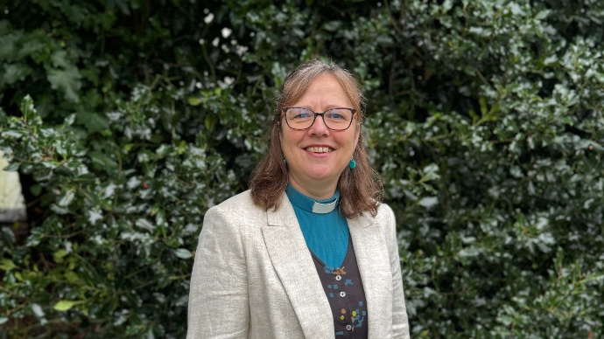
Journeys
I wonder how many journeys you have planned in your lifetime: the daily trips and the longer adventures; the familiar routes we take almost on autopilot, and the journeys we plan carefully because of where we are going, or what we hope to do and see.
There are the journeys we make every day—to work, to school, or to see a neighbour. There are the journeys we make less often, but still regularly: visiting relatives, going to church, or attending commitments. And then there are the journeys we may make only once in a lifetime. Each journey has a purpose, a beginning and an end: to see a loved one, to celebrate, to earn a living, to shop for food, to visit the doctor, to take a holiday, or to explore somewhere new.
As a family, we recently spent hours planning the route and places to stay for a road trip through Italy—from Lake Como to Naples and back. We wanted to visit the places on our “we would really like to see” list, while also making time to rest, explore and enjoy being together. The planning resulted in a wonderful holiday: we saw amazing things, experienced busyness and rest, encountered a different culture, and came home refreshed—physically, emotionally and spiritually.
Throughout the Bible there is a great deal of journeying, and often in those physical journeys we see God at work in the lives of those who travel. We see the Israelites rescued by God and formed as his people; Elijah running away and discovering that God is with him; Paul shipwrecked yet protected so that he can speak to others about Jesus; and Jesus journeying to the cross, revealing God’s ultimate love through his words and actions along the way.
At the beginning of July, I was part of two joyful services as Bishop Richard ordained our new priests and deacons. As I sat through those services, I was reminded again of journeys—not physical journeys this time, but spiritual ones: the journeys we make with God as we respond to his call and leading. As followers of Jesus, we are called by God into his service, a calling that takes many shapes and forms. Like our physical journeys, our spiritual journeys have a purpose. Paul speaks of doing whatever we do to the glory of God, and Jesus teaches that in all we do we reveal God to others—his light, his life and his love. So, as we head into a season of holiday journeys, I wonder whether we might use the opportunity of a physical journey to reflect on our spiritual one, from beginning to end.
The Venerable Sam Hustwayte
Archdeacon of Ludlow

