God’s Acre August 2026
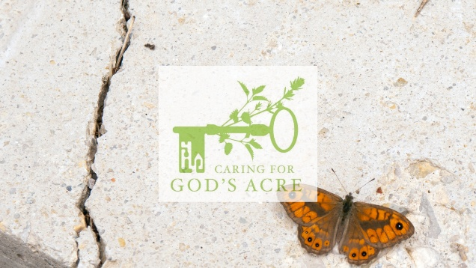
Just another butterfly on the Wall
As August rolls in, you might start to see some new wings fluttering in your local churchyard. The Wall Brown or Wall butterfly is named after its habit of basking casually on walls or rocky places. This behaviour allows the butterfly to raise its temperature enough to fly around comfortably. Perfectly camouflaged against stones, the best way to identify the species is by checking the eyespots on its wings. One large eyespot on the forewing and four smaller ones on the hindwing is a dead giveaway that you have a Wall on your hands.
The Wall’s habitat is diverse across England and Wales, spanning coastal zones, open grassland, disused quarries, railway edges, gardens, field edges and even churchyards and cemeteries. They may be found in sunny spots, basking on warm stone monuments, walls surrounding the churchyard, or the gravel of kerbed graves. Walls lay their eggs on grass tussocks and the broader leaves of coarse grasses such as Yorkshire Fog. Larvae and caterpillars will munch away on the grasses, while the butterflies rely on a variety of grassland wildflowers for nectar.
Inland Wall populations saw dramatic decreases in the 1980s, but not for the reasons you might expect. Habitat loss and degradation or abandonment of traditional farming or forestry practices didn’t fit the bill for the Wall, so researchers instead had to come up with other theories.
Belgium researchers discovered they were witnessing similar decline with their Wall populations, so decided to do some digging. They proposed that warming climates were causing the species to have a third brood late in the year, leaving little time for the caterpillars to develop before winter. This brood was then unfortunately lost, causing the downward spiral.
Though, this might not be the end for the inland populations. Many butterfly species can change their voltinism (the number of generations produced per year). This flexibility allows species to respond quickly and often unexpectedly to years with favourable conditions, producing more broods than would be typical. Based on this principle, we can expect inland Wall populations to experience strong natural selection as climates warm, eventually recovering and becoming as resilient as their coastal relatives, where temperatures are more consistent.
It’s a waiting game for the Wall, but in the meantime, we can be doing our part to support the species. Leaving coarse, grassy and sunny patches in your churchyard or garden gives them places to do their sunbathing. Creating gorgeous wildflower meadow areas gives the Wall, as well as many other pollinators and invertebrates, lots of variety for food. If you spot a Wall, be sure to record it in your iNaturalist app or send us a photo, especially if you see one in your local churchyard or burial ground. Every record builds a picture of just how important burial grounds are for wildlife.
Kaitlyn Elverson
Engagement Officer, Nature in Sacred Places Project (NiSP)

