SUNDAY
Readings Rom 7^{15-25a}, Matt 11^{16-19, 25 to end}
8am HOLY COMMUNION [BCP] Rev Mark,
11am MORNING WORSHIP [CW] Sheena

Readings 2Samuel 2^{1-11;}3¹, Luke 18³¹-19¹⁰
6:30pm EVENSONG [BCP] Rev Mark

MAYOR’S CIVIC SERVICE

at St Barnabas.
Thursday 9th July at 7:30pm
doors open at 7pm,
This year’s service has a theme of reaching out to children and families in need - noticing and responding to those who are struggling, often quietly, before they ask for help. It would mean a great deal to me, and to the Mayor, to have a good turnout from both our congregations, so please do come along and support the service if you're able.

People on our prayer list: Derek & Pam Johnson, Guy Negus, Derek Cotgrove, Sue Burton, Tessa Yates; also the families and friends of Florrie Large and Paul Haisman-Baker.

Looking Ahead

FINDING A VOICE on Weds at 1:00pm and 7:30pm
in St. Barnabas

BEAT’N’BEANS Sat. 11th July 10:30am entertainment by
Any Good Thing

CONCERT of SUMMER MUSIC by the Allegro Choir , … Sun 12th July at 3pm at St. Barnabas.
Tickets available on the door, £10 – children free.
WEDNESDAY (8th)

10:30am HOLY COMMUNION Rev Mark
Readings Hosea 10^{1-3,7-8,12}, Matthew 10¹⁻⁷

Services next week

Sun 12th 11:00am Holy Communion

Weds 15th 10:30am Holy Communion

HAVE YOU NOTICED THE SEAGULLS RECENTLY?
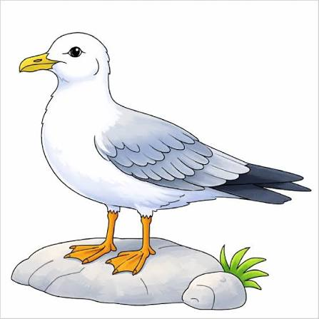

Or rather – the lack of them?

A recent survey published by the British Trust for Ornithology (BTO), found that the total number of gulls wintering in the UK has fallen from 3.9 million to just under 2.5 million over the past two decades. It is thought that the reason for the decline of gulls is due to improvements in waste management, both on our streets and in landfill. Avian flu, agricultural practices and climate change may have also played a part.

The survey found all species, apart from herring gulls, had declined. The great black-backed gull, the UK’s largest, saw a 66 per cent drop in numbers wintering in the UK. Black-headed gulls declined by almost half. Common gull numbers fell by 26 per cent, and those of lesser black-backed gulls dropped by 47 per cent.

Emma Caulfield, a BTO research ecologist and survey co-ordinator, said: “These figures are pretty alarming. Despite these smart and adaptable birds figuring out how to live alongside us, the ever-changing world appears to be moving too fast for them to keep up.”

