ST MARY THE VIRGIN BRAUGHING
Sunday 12th July 2026
Trinity 6
Welcome to our Service of Holy Communion which will be led by our Priest-in-Charge, Rev’d Lynn Hayler. Please do stay for refreshments after the service.
If you have children with you this morning, please feel free to make use of the children’s area at the front of the church. This morning’s service is a more traditional Holy Communion so they may get a bit bored but there are lots of things to keep them busy there.
Our communion celebration is open to all who know Jesus as Lord. Please indicate at the communion rail if you would like our Vicar to dip (intinct) your wafer in the wine. If you don’t wish to receive the bread and wine you are welcome to come up for a blessing. Please indicate by keeping your hands by your side
COLLECT:
Creator God,
you made us all in your image:
may we discern you in all that we see,
and serve you in all that we do;
through Jesus Christ our Lord. Amen

READING:
Matthew 13 1-9, 18-23

HYMNS:
Opening : 447 Morning has broken
Gloria : Peruvian Gloria
Gradual : 652 The Spirit lives to set us free
Offertory : 723 When God made the garden of creation
Communion : 526 Our Father (Caribbean)
Closing : 555 Praise to the Lord, the Almighty

NOTICES
Jean After over 20 years, Jean Hubbard has decided to step down from the PCC. We are very grateful to her for everything she has done for our Church over many, many years. We will miss her.
Alpha Course Would you like to explore the big questions of faith? Are you curious about Jesus? Do you want a refresher in faith? We will be starting an Alpha course in the coming months. Your opportunity to explore faith in an informal environment. If you’re interested in taking part or helping to run alpha, please speak to Lynn
Braughing Home Group Bible Study We meet on a Tuesday evening during termtime at 7.00pm. All are invited to join us as we explore God’s word together. To register your interest or get some more information, please contact: sara.holland1965@hotmail.co.uk

Choir Over the Christmas period we had a wonderful Pop-up Choir but throughout the year, we have a small Church Choir who sing at Sunday services. We are always delighted for new members to join us. Our next Choir Practice is on Thursday 30th July from 7-8pm in St Mary’s Church Braughing.

Refreshments We are delighted to be able to offer tea, coffee, squash, biscuits and sometimes even cake after our service. We don’t charge for this but are always grateful to receive a small donation (in the pot on the coffee table). This helps us to maintain our supply of drinks and snacks.

Bike ‘n Hike This year’s Bike ‘n Hike takes place on Saturday 12th September from 9-5pm. This annual event is organised by the Beds and Herts Historic Churches Trust. You are encouraged to get sponsored and cycle, walk or ride around as many churches as you can. The money raised goes half to the Trust and half to your local church (ie us!). Many churches provide refreshments for participants and most of them are open for you to wander round if you wish. There is a sponsor form at the back of the church if you would like to take part or speak to Paula.

Thank you Event We will be holding a Thank you afternoon on Saturday 12th September from 3-5pm in the Church Hall for all of those volunteers who help out at our church. Our congregation is also welcome to attend. We will be serving tea, cake and Prosecco. Offers or help on the day/cake making much appreciated. Please speak to Lynn or any member of the PCC

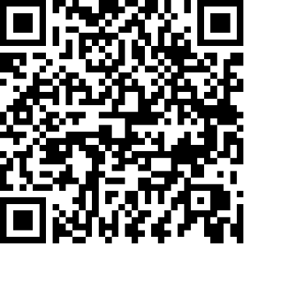
If you would like to support the work of our church but you don’t have any cash with you, we do have a “sum-up” machine which takes cards (please see the Sidesperson at the back of the church).
Alternatively you can scan the QR code opposite and make a direct donation.
Anything you can give, no matter how small, is much appreciated.

FUTURE SERVICES:

Sun 19th July CAFÉ CHURCH Furneux Pelham 9.30
Sun 26th July HOLY COMMUNION Furneux Pelham 10.30
Sun 2nd Aug ALL AGE SERVICE Braughing 10.30
Sun 9th Aug HOLY COMMUNION Braughing 10.30

Contact information for Braughing Church:
Email – churchoffice@btinternet.com Phone – 01920 823832 (please leave a message)
revlynnhayler@outlook.com 07721 637682

