
SPIRE & LIGHT United Churches
United Benefice of St Keverne, St Ruan with St Grade & St.Wynwallow (The Lizard)

*If you do not wish to receive these notices, please let your Churchwarden know*

26th July 2026


Readings
1 Kings 3:5-12
Psalm 119:129-136
Romans 8:26-39
Matthew 13:31-33, 44-52

9.30am – Morning Prayer - St.Peter’s, Coverack
9.30am – Holy Communion - St.Ruan, Ruan Minor
11am – Holy Communion - St.Keverne
11.15am – Café Church – St.Wynwallow, The Lizard
6pm – Summer Evening Praise – St.Mary’s, Cadgwith

Next week – Sunday August 2nd
9.30am – Holy Communion - St.Peter’s, Coverack
9.30am – Holy Communion (BCP) - St.Wynwallow, The Lizard
11am – Morning Prayer (BCP) – St.Keverne
11am – Treveddon Field for the Vintage Car Rally (not 11.15am Morning Prayer in St Ruan Church)


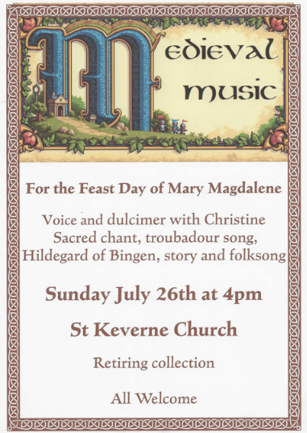
This year, Mothers' Union is 150!

To celebrate, we are having an exhibition called 'Love in Every Stitch'. It is a wonderful chance to remember all the women who have been involved in Mothers' Union in Cornwall across many generations, and to admire the hand stitched banners that they sewed with love and care to represent each branch.

The exhibition is from Tuesday 11 August - Saturday 22 August in Truro Cathedral. It is free, and can be visited during normal cathedral opening hours (10.00 - 17.00 most days). Any donations will go towards the ongoing work of Mothers' Union to help families locally and overseas.

Finally, you may also like to know that the annual free Family Fun Day for under-10s organised by Mothers' Union is on Wednesday 19th August this year - see https://www.trurocathedral.org.uk/whats-on/family-fun-day-wed-19-aug-2026-10-00-am



The Prayer Spot

We pray for the Deanery that we belong to and we thank you for the faithful people you have brought together here. Remind us that we have each been brought to faith by Our Saviour Jesus Christ.
Lord Jesus, we thank you for your presence in our lives and the love you give us to share with others. Keep us strong in our faith and close to you.
Help us to be always there for others in their time of need, you have given us each gifts to use to reach out to others and to give comfort to those around us.
Heavenly Father we live in a world slowly destroying itself, through greed, hatred, and with no concern for others. Remind us that we can bring love, care and understanding into the world, by reaching out into our communities and showing your love to all we meet. Loving God, be with us always. Remind us that we are brothers and sisters in Christ Jesus, that God is ever present in our lives, through his wonderful Holy Spirit that he has given to you as a free gift to us all.
Mighty God, everything you do reveals your Majesty. Open our eyes to see what you are doing in our lives. Let us marvel at your good gifts and your wise provision. Your acts are amazing Lord. We cannot comprehend the number of blessings you pour out to us from day to day. As we gather today around your name, we pray that you will fill our hearts, our minds and our souls. Transform us Lord and make us more like you. Through Jesus Christ our Lord. Amen
God bless you all. Samuel Buchanan

On the Way Prayers

Let us start our prayers this evening by focussing on our own congregation – bringing before God anyone who is really in need of our prayers. We pray for Heidi and Phil, as Heidi enjoys a well deserved break. Lord, please bless all our clergy and lay leaders as they continue to help keep our service patterns going. We pray for all those being married in our Deanery churches this summer. We bring before you Lord, anyone else known to us who needs the comfort of our collective prayers right now. Lord, may they feel the healing touch of your hands, now and in the days to come.

As our schools break up for the summer holiday, let us pray for all our children and young people – that they are safe in their families, safe on our beaches and safe with their friends and online. We pray too for all teachers in Cornwall – that they may find rest and relaxation this summer, so they are better able to help those in their care when they return again in September. Let us pray for all parents who have to rearrange their working schedules or organise childcare. We pray too for all grandparents who can find this holiday time quite stressful.

Let us pray for anything special we have coming up in our churches this coming week.

Lord, bless all our activities, our innovations, our experiments and above all for the fun we have in being together. Good God, be with us in every experience of life. When we neglect you, remind us of your presence. When we are frightened give us courage. When we are tempted, give us the power to resist. When we are anxious and worried, give us peace. When we are weary in service, renew our tired frame.

Now we bring before you the needs of our country as a new Prime Minister takes over. We pray for Andy Burnham and his new cabinet, that whatever they do is guided by you; that they look after the poor, clothe the naked, and look to restore faith in government.

And we pray for peace in this trouble world. The situation in the Middle East is still rumbling on, the terrible war in Ukraine has been further battered this week, and all the armed conflict that goes on in Africa, that we rarely hear anything about.

The Lord bless us and keep us; the Lord make his face shine upon us and be gracious to us; the Lord turn his face toward us and give us peace." Amen

The Diocese of Truro’s Prayer Diary for this week

