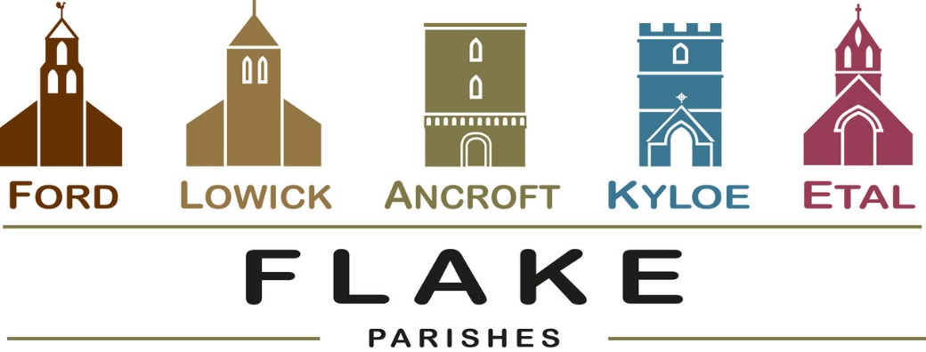
A very warm welcome to you, especially if you are visiting.
Please take this sheet home with you and use it as a basis for prayer.

Sunday June 7th 2026
Lowick 9.15 Holy Communion
Ford 11am Holy Communion
With joy we welcome Canon Nick Sagovsky to our pulpits this morning to begin our study of the Letter to the Colossians

Sunday June 14th 2026
Lowick 9.15 Holy Communion
Ford 11am Holy Communion

Sunday June 21st 2026
Lowick 9.15 Holy Communion
Ford 11am Holy Communion

Sunday June 28th 2026
Lowick 9.15 Holy Communion
Ford 11am Holy Communion

Revd Charlotte Osborn (Vicar) 01289 388591 ceosborn@mail.com 07957 367457
Revd Alex Firman (Assistant Curate) 07935 732811
alex_firman@hotmail.co.uk

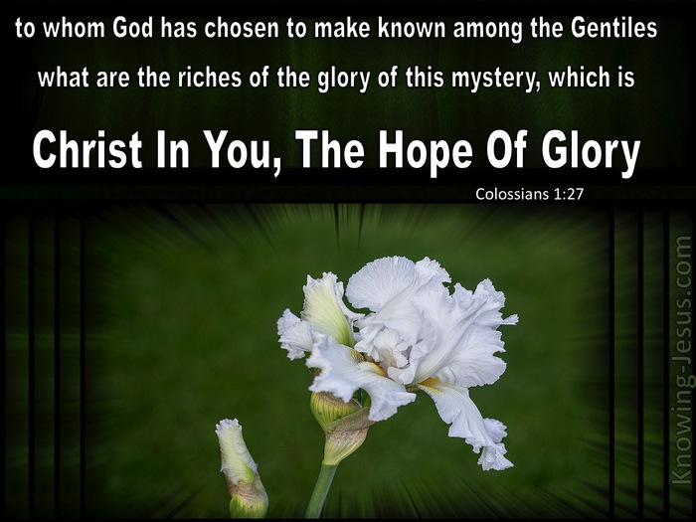

During June we depart from the lectionary readings to focus on Paul’s letter of encouragement to the church at Colossae as it wrestled as we do today with establishing the supremacy of Christ over and above all that would compete for first place in our lives.

- Sunday 7th June, Tweedmouth Church
Gareth Davis-Jones in concert -see poster

- Tuesday 9th June 1.30pm Ancroft PCC

- Wednesday 10th June 7 for 7.30pm Deanery Synod Branxton Village Hall

- Saturday 13th June
Lowick Village Fete 2-5pm


Final opportunity to come to this show….this afternoon at Wooler, tickets available on the door.

Sunday 7th June
Wooler URC 3.30pm
Tickets £10 from Dee Colam
07801 822851

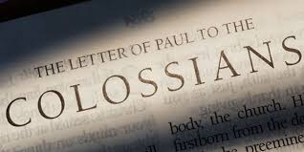
- 7pm-8.30pm Mondays 8th June/15th/22nd/29th
at Lowick Vicarage
Study and discussion of Colossians chapter by chapter – all most welcome as we learn together and encourage one another.


Rota Revisions- following our APCM’s we are updating the rotas and welcome any new readers, intercessors, flower arrangers, bellringers, welcomers, etc.
Training will be provided and if you would like to offer your services, please speak to Alex or Charlotte

For our prayers


We shall be reading the banns of marriage over the next weeks for

Annabel and John, Ancroft 20th June
Ian and Yvonne, Ford 18th July

We joyfully pray for them as they prepare not just for their wedding day, but for their married life together

Please continue to pray for all who suffer in body, mind or spirit, especially Heather Piper, George Hall, Gail Calder, Don and Sam Quilty, Alison Murray.
We remember all who have recently died. We pray for those who mourn, and for all who mark anniversaries of death at this time of year: Isobel Mitchell.

Parish Contacts

Ancroft Leigh Yorke 07716 116739
Etal Andrew Joicey 01890 820540
Ford Kathleen Holmes 07951 099668
Lowick John Dickson 07967 343211

Websites: www.achurchnearyou.com
Instagram: https://www.instagram.com/the_flake_churches/
Facebook: the_flake_churches

Our other licensed clergy
Revd Margaret Sentamu 077871 204745, Canon Nick Sagovsky,
Revd Marion Penfold 01289 305664

