
SPIRE & LIGHT United Churches
United Benefice of St Keverne, St Ruan with St Grade & St.Wynwallow (The Lizard)

*If you do not wish to receive these notices, please let your Churchwarden know*

21st June 2026
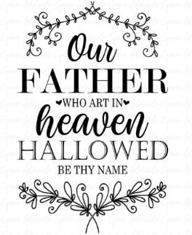
Readings
Jeremiah 20:7 – 13
Psalm 69:8-11,18-20
Romans 6:1b-11
Matthew 10:24 – 39

9.30am – Holy Communion - St.Peter’s, Coverack
9.30am – Morning Prayer - St.Wynwallow, The Lizard
11am – Morning Prayer – St.Keverne
11.15am – Family Service – St.Ruan, Ruan Minor

Next week – Sunday June 28th
9.30am – Morning Prayer - St.Peter’s, Coverack (with St.Keverne)
9.30am – Holy Communion - St.Ruan, Ruan Minor
11.15am – Café Church – St.Wynwallow, The Lizard


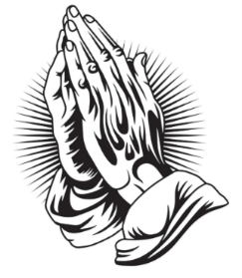
The Prayer Spot
We pray for the Deanery that we belong to and we thank you for the faithful people you have brought together here. Remind us that we have each been brought to faith by Our Saviour Jesus Christ.
Lord Jesus, we thank you for your presence in our lives and the love you give us to share with others. Keep us strong in our faith and close to you.
Help us to be always there for others in their time of need, you have given us each gifts to use to reach out to others and to give comfort to those around us.
Heavenly Father we live in a world slowly destroying itself, through greed, hatred, and with no concern for others. Remind us that we can bring love, care and understanding into the world, by reaching out into our communities and showing your love to all we meet. Loving God, be with us always. Remind us that we are brothers and sisters in Christ Jesus, that God is ever present in our lives, through his wonderful Holy Spirit that he has given to you as a free gift to us all.
Mighty God, everything you do reveals your Majesty. Open our eyes to see what you are doing in our lives. Let us marvel at your good gifts and your wise provision. Your acts are amazing Lord. We cannot comprehend the number of blessings you pour out to us from day to day. As we gather today around your name, we pray that you will fill our hearts, our minds and our souls. Transform us Lord and make us more like you. Through Jesus Christ our Lord. Amen
God bless you all. Samuel Buchanan
The Diocese of Truro’s Prayer Diary for this week

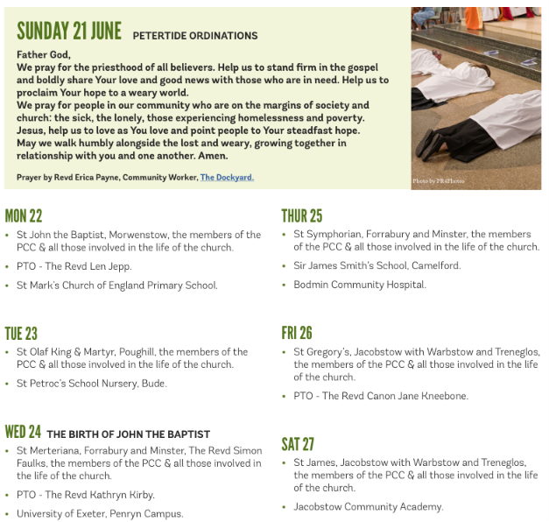
On the Way Prayers

Our Father, who art in heaven, hallowed be thy name. Dear God we pray for your church, that your kingdom will come and your will be done, on this earth as it is in heaven. Today we particularly pray for our Deanery, for Heidi and Susie and for anyone being called to come and join our ministry team. We pray for those lay people who are being recommissioned in the Cathedral this coming Sunday and we thank you for their work in our midst.

This coming Sunday is Fathers’ Day. The shops are full of merchandise, with many offers promoting the idea that we thank our fathers. Let us all, in a moment of silence, remember our own father, giving thanks for the good things that we have inherited from them. We pray for family life, and we particularly pray for all those about to become fathers, may they all realise the responsibility that they are taking on, to nurture and care for all those in their care. Let’s pray too for all stepparents who take on the responsibility of fathering or mothering someone else’s offspring. It isn’t always an easy relationship, so let us pray for wisdom, empathy and tolerance. Lord, we give thanks for Joseph who followed God’s call, in really tricky circumstances, to be your earthly father, who nurtured you and gave you a home and a trade – the carpenter from Nazareth who is always seeking joiners!

We pray for anything special that we might be doing in our churches this weekend, for anything that we’re doing as a family to celebrate our Fathers. On the whole, in our churches these days, men tend to be in the minority. Help us, as a Deanery, to find imaginative ways to attract men into our congregations and for them to learn of the love and support that you, dear Lord, can bring them. In this anniversary year for the Mothers’ Union we give thanks for all the work they do to promote family life.

Father, we place into your hands the things that we can’t do - the peace we can’t bring, the healing we can’t bring, the solace that we don’t even know is needed. Help us to remember that the one thing we can do is pray. So, let us pray for any situation or anyone who needs your help and intervention right now. Father, we place into your hands the things that we can’t do, confident that you can bring peace, you can heal and you know all those who need your help right now.

Many of us are finding solace, excitement and entertainment in all the sport that is going on around the world – the football, tennis, cricket and Formula 1. We pray that this sport will bring unity and understand between nations; that all rivalry will be just enhancing the fun, rather than destroying it and we pray for all those who lose as well as those who win. Our schools will be holding their sports days so let us pray for all those who teach our young people sport and PE.

Finally we pray for all those of us in this prayer group, wherever we may be. As our lives become busier during the summer, help us to find the time to pray together, to believe that our prayers for our Deanery’s future are being heard and that you will show us the way. Amen.

