St Thomas’ Church and Community Project
“A Place for You”
July Newsletter

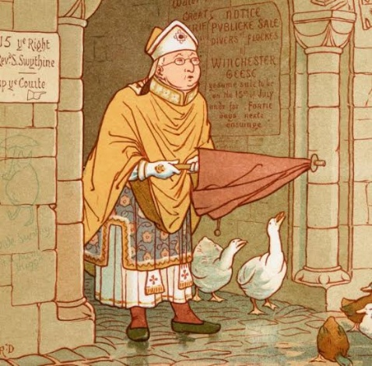

You might have heard the rhyme:

"St. Swithin's day if thou dost rain, for forty days it will remain. St. Swithin's day if thou be fair, for forty days 'twill rain nae mair."

St Swithun’s day falls on 15th July, and the legend tells us that if it rains on that day it will rain for the next 40 days. If it is dry, it will not rain. I can tell you this is not true, but we might ask where this rhyme comes from.

Swithun (sometimes spelled Swithin), was born in Winchester, within the Anglo-Saxon kingdom of Wessex. Thought to have been born around 800 AD during the rein of King Egbert, he lived most of his life in the Wessex region never travelling very far.

He was educated at the Old Minster in Winchester, where he was later ordained as a priest. He served as a chaplain to King Egbert and acted as a tutor and trusted advisor to Egbert's son, King Ethelwulf. In 852 AD he was consecrated as the Bishop of Winchester where he served until death. He died on July 2, 862 AD

Throughout his life and ministry he was known for his humility, charitable giving and bridge-building. Unlike many of his contemporaries he travelled around his local area on foot so that he could talk to more people, building and repairing church buildings without anyone knowing of his involvement. He famously built a stone bridge over the river Itchen to allow the poor to cross and sell their wares in an area with greater prosperity.

Before his death Swithun requested to be buried in the humble churchyard outside the Minster where the rain would fall on his grave and where people would walk over him. In death as in life no better than those he served. However, 100 years later church elders thought otherwise and moved his remains to an elaborate, and out of character, indoor shrine. That date was 15th July 971, and a massive and prolonged storm broke which the people attributed to the saint’s annoyance at being moved. Hence the legend.

A legend, however, does not make a person a saint. So, what does? Most protestant and Church of England traditions generally do not have an official canonisation process. Instead, we refer to the biblical definition found in the New Testament, where "saint" often describes any living believer, follower of Christ, or dedicated member of the church. We honour saints for their exemplary faith and teachings but do not pray to them or attribute miracles to them.

If we were to attribute a miracle to Swithun, it would be just the one. A local woman was crossing his bridge when workmen maliciously smashed her basket of eggs. Hearing her weeping, Swithun picked up the broken pieces and miraculously restored the eggs to their original, unbroken state.

St Swithun does give us a lovely example of how to live out our faith. He encourages our faith through his powerful example of radical humility, his actions, and charitable service to the poor. His life inspires believers to ground their spiritual journeys in everyday, down-to-earth acts of kindness rather than seeking earthly glory. He left us an amazing legacy of compassion, service to the marginalised, and radical humility.
Rev Sue Round
Confirmation
It is wonderful that we have a number of people wanting to confirm their faith in the Church of England before the Bishop. But what is Confirmation? Confirmation does not stand alone; it builds on something that must already be in place. That foundation is baptism. Baptism is the entry into the Body of Christ. It is where we are received into the Church, united with Christ and where we become part of the Christian family. Before anything else baptism comes first. Confirmation is the strengthening and affirmation of that baptismal faith.
It is a public declaration of faith, a personal ownership of what has begun in Baptism and a moment where the bishop lays hands on us and prays for the grace of the Holy Spirit.
If you are interested in being baptised or confirmed please contact Rev Sue Round sue.round@st-toms.com. This will be for next year now.
Each session takes the form of a short introductory video and discussion in a safe space. Having begun on Sunday 26th April after morning worship at 11.45am each session will last between just over an hour.

Sessions continue on 28th June 12th July. There will be some catch-up sessions for those who have been unable to join us.

The Confirmation Service will be held at St Thomas on Sunday 13th September 4pm.

June church services
If you want to discover more, come and join us any Sunday morning or at any of our community activities throughout the week.
Sunday 7th June 10am service with Holy Communion.
Sunday 14th June 10am morning prayer followed by our 4th Confirmation Session
Sunday 21st June 10am service with Holy Communion
Sunday 28th 10am – service with Holy Communion

Children are always welcome and there is usually the opportunity for them to leave the main service for their own age-appropriate activities in Connect Group. And don’t worry if you arrive a bit late or need to leave before the end.

If you are on the rota to read during July please assume that you will be reading the gospel. These may be subject to change. The readings are listed here in case you want to practice:

Sunday 5th | Matt 11 vv 16-19,25-end
Sunday 12th | Matt 13 vv 1-9, 18-23
Sunday 19th | Matt 13 vv 24-30,36-43
Sunday 26th | Matt 13 vv 31-33, 44-52

MIDWEEK WORSHIP
Now that Citizens’ Advice have moved on the monthly Midweek service will revert to the 3rd Thursday in the month.
The next service will be Thursday 16th July 1pm.

Christian Outreach

Worship, prayer, teaching and Christian fellowship doesn’t just happen in church on Sunday mornings, the church is active out in the community throughout the week.

- Stay and Play group for babies and toddlers on Monday (last session is 6th July when Bluey is coming to the party!)

- Children’s club with fun and games, crafts, cooking, activities, challenges and bible stories on Mondays from 4.00 till 5.30 and youth club 5.45 till 7.15

- Young Adults discipleship group – Monday evenings from 7.30 till 8.30

- A church service Heartlands Care home happens twice monthly

- Pastoral visits at West Hall Court every other Thursday morning and at Heartlands Care Home on Friday afternoons.

- Godly Play at Oasis Blakenhale Juniors on alternate Tuesdays – Christian teaching with classes from years 3 and 4

- The Open the Book team make monthly visits to the school assembly at Oasis Blakenhale Infants School.

- Activities for those over 50 on Thursday and Friday

Foodbank Update
The foodbank is open on Wednesday mornings from 10.00 till 11.00 p.m. and we have a wonderful team of volunteers from the church and community. We are very busy serving on average 25 people a week with food to feed around 60 people. With high demand all donations are very welcome; if you can provide occasional tins of beans, spaghetti, soup, vegetables etc please leave them in the collection tray at the back of the church or in the hall entrance. We now also provide fresh fruit and vegetables and there are usually some left after our Foodbank session so please help yourselves rather than letting them go waste. A small donation is welcome.
If you have any spare shopping bags, we will be very grateful for them and we are happy to re-use plastic carrier bags you may have. Please leave them in the donation boxes.
Thank you to everyone.

Website update
Our website is being updated to reflect everything that happens in church on Sundays, including other acts of worship and study groups, as well as what happens during the week, all in the name of St Thomas. Please have a look if you are able. If you have any comments, observations of additional thoughts, please contact Rev Sue. In future all our newsletters will also be available on the website so don’t worry if you lose it. If you would like your own copy emailed to you, again, please contact Rev Sue.

Our web address is www.st-toms.com

If you use Facebook please like and follow us on St Thomas Church & Community Project.


An afternoon of tea and a buffet will be held to raise money for Breast Cancer research.
Admission will be £5 to include hot drinks and food from the buffet. There will also be a raffle!
There will be opportunity to buy any cakes to take home. Please let Carol Malone or Sue Round know if you intend to come.
Tickets will be available in advance on Thursdays afternoons / Sunday mornings or you can pay on the door.
Friday 10th July 2pm-4pm at St Thomas Church

Prayer Requests and Prayer Pointers

Prayer means putting ourselves into a communicating relationship with the divine God. Prayer is often used to build a relationship with God, offering thanksgiving, asking for help, and seeking forgiveness. It is described as a means to express gratitude and find comfort and strength. It is a gift for our own sense of identity as children of God, and for our own sense of purpose. It is often helpful to end or begin our prayer time with the prayer Jesus taught us:
Our Father in heaven,
hallowed be your name,
your kingdom come,
your will be done,
on earth as in heaven.
Give us today our daily bread.
Forgive us our sins
as we forgive those who sin against us.
Lead us not into temptation
but deliver us from evil.
For the kingdom, the power, and the glory are yours
now and for ever.
Amen.
In your prayers this month please consider including these pointers:
- Pray for all those who are currently unwell, receiving treatment, recovering from illness or surgery and those in residential care. Please include Ray receiving treatment for an eye condition, Ann Barnes in Heartland’s Care Home, Lijino from Church of South India recovering from emergency open heart surgery
- Please remember Rev Susan Larkin. Pray for all those who will surround her with skill, care and compassion and ask the Holy Spirit to send rapid and effective healing.
- For Amber, a young teenager facing surgery and gruelling treatment for cancer.
- For Caroline, David and Pauline
- For those who work in nursing and caring roles in hospitals, residential homes and at home. For social workers and those who work in prisons.
- For those who are recently bereaved, continuing to remember the Twelftree family.
- For those with families affected by the troubles in the Middle East.
- For world leaders striving to negotiate peace.
- For our congregation to continue to grow in faith and numbers.
- For our work in local care homes and at Oasis Blakenhale School.
- For those preparing to be confirmed in September, especially those from our own fellowship.
- For the family of Ivy Cheshire as they mourn her passing. Ivy was much-loved and longstanding member of St Richard’s church.
- For yourself, and your own family and friends.

Church Wardens Admissions

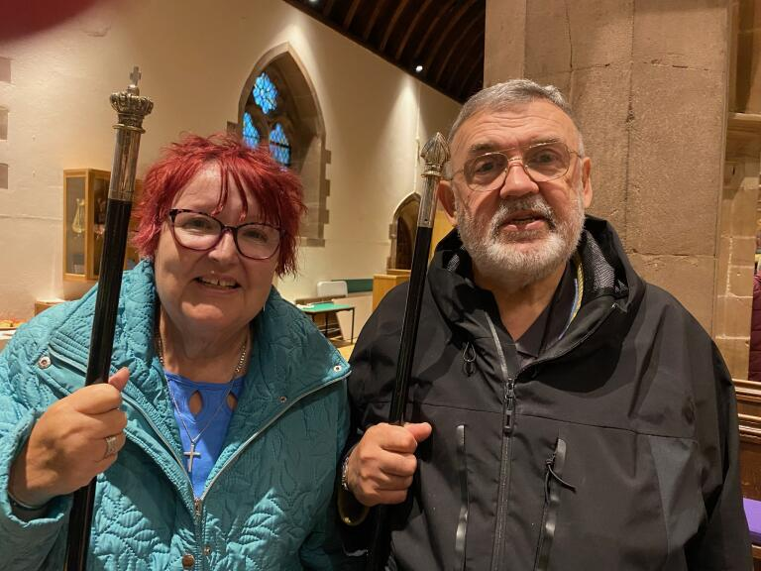
Church wardens are elected by the church congregation at the Annual Parochial Church Meeting and have key responsibilities with regard to the fabric of the building, maintenance, collections and record keeping and they play an important role in supporting the clergy; for example, ensuring the building is open and prepared for worship and people are welcomed.
Our church wardens Mark Dixon and Carol Malone were admitted to this position by the Archdeacon at a special service on Thursday 11th June at Colehill Parish Church. Here’s a photo from the service! Congratulation to you both and thank you for commitment to St Thomas and the witness you give as Christians.

WORK EXPERIENCE
From Monday 29th June to Friday 3rd July, you are likely to bump into Faye Hogan as she joins us for her year 10 school's work experience. This is a one-week placement for students aged 14-15 to spend time with an employer learning about working life. During the week, Faye will shadow some of our leaders and volunteers, assist with basic tasks and observe activities to introduce her to work in a church and community environment helping her to explore potential career interests.
The week will help Faye to build transferable skills such as communication, teamwork, problem solving and assist her in making decisions, for example; about A levels, college subjects or future career paths; building confidence and strengthen her CV writing and applications for future education or work.
So, if you see her around do say hello and ask how she is getting on.

SHANNON IS PAYING US A VISIT!!
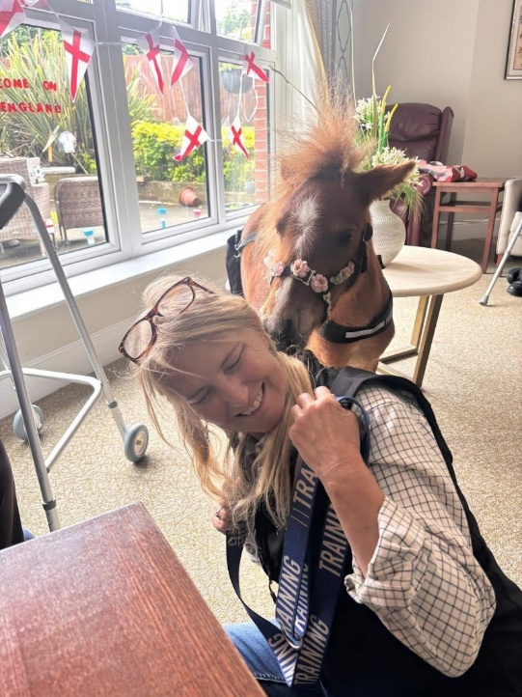
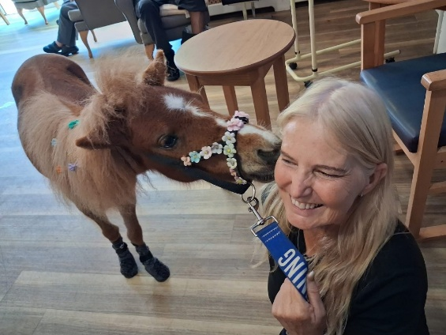
Shannon is a gorgeous miniature pony looked after by Janice who drives her where she needs to go. Her hooves don’t reach the pedals! Shannon likes to visit care homes, and other places where people meet. She loves social interaction and fun. Shannon is skilled in bringing joy, relieving stress, and boosting wellbeing. She also has very pretty face. So why not come along to Thursday Club on 16th July at 12.30 for a cuddle, create a memory and have your photo taken with her.

She’s also clearly an England fan!

Volunteers to follow behind with a mop and bucket??


As I write this, a red extreme heat warning has been issued for central, southern and south-east England and parts of south Wales, with temperatures expected to reach 39ºC in the next day or two. Just a few weeks ago, we saw temperatures reach 34ºC in what was late spring. This is early summer. I worry about what temperatures we might have to endure over the next two to three months.
East Surrey Hospital has already declared a critical incident due to high levels of demand on its emergency care services, exacerbated by high temperatures, while South East Water is asking customers to use water for "essential purposes only". The forecast has also prompted calls for caution around the water, remembering the many deaths by drowning we saw in the last heatwave.
Last month’s newsletter contained details of an upcoming community event. This new heatwave prompts me to remind you about it. We are meeting in the church on Wednesday 10th July, doors open at 5.30pm and we will be showing a film from 6.00pm, which will be followed by time for a short discussion. The film was compiled from a presentation to MPs at Westminster Hall last November where several experts on the climate, science, health and the economy talked about the impact that climate change will have on people’s lives in the future. This is a community event, not a church event. There is no charge and there will be light refreshments available. If you are going to join us, please let Sue Round know: sue.round@st-toms.com
The hotter summers and milder winters are affecting plants and shrubs in this country. I have noticed recently the number of palm trees growing in Birmingham. I know that hardy varieties can be grown in the south and south-west but they would have struggled in central England not so many years ago. As the climate continues to change we will need to look for climate-resilient plants that can handle erratic weather – able to survive both wet, waterlogged winters and hot, dry summers. Top choices include Mediterranean-style drought lovers and robust perennials with deep roots, such as Lavender, Agapanthus, Yarrow, and Hardy Geraniums.
The same applies to crops we grow for food. Climate change is already severely impacting UK agriculture, causing major yield losses in staple crops like wheat, barley, and potatoes due to extreme rainfall, flooding, and heatwaves. However, thankfully, the UK is responding to this and diversifying its agriculture. Farmers and scientists are shifting toward drought-tolerant, heat-loving, and deep-rooting varieties to cope with a changing climate. These include: chickpeas, grapes (the warming climate has drastically boosted British wine production. There are now over 1,000 vineyards across the country successfully growing grape varieties previously restricted to Mediterranean climates), lentils & soybeans, resistant varieties of wheat and black oats, and quinoa.
Fortunately for us, as a wealthy country, we can afford to pay for research and innovation to help us to adapt as the climate changes. Spare a thought, though, for the poorer countries who don’t have the resources that we have.
Linda Nugent (Parish Environment Champion)

You are invited to attend a screening of
The People's Eco-Emergency Briefing

Showing at St Thomas Church
Wednesday 10th July Doors open 5.30pm (6pm start)
Light refreshments are provided after the film.
Admission is free! Bring a friend..


An eye-opening film featuring nine leading UK scientists and experts updating us on the latest in the climate and nature crisis and its impacts on everyday national life.

Including: extreme weather, food security, health, cost of living. We’ve all felt the effect of global warming this week with the hottest day in May on record!

Based on the National Emergency Briefing in Westminster, as covered by ITV, C4, and the Times.

Followed by a short open discussion about what we can do and what it means locally.

Featuring Chris Packham, Deborah Meaden, surprise guests, and a wide range of Brits.

This event is open to the whole deanery, our ecumenical parters and the local community including elected officials. St Thomas Church needs your support in this. Please come and see how you can make a difference and understand what is being done nationally.

If you want to know more about this event or to confirm your attendance, please speak to Linda Nugent (Parish Environmental Champion) or Rev Sue Round.

Hosting this event is a big step forward towards our silver eco-church award. However, this is an event for the whole community and is not targeted especially for Christians. All are welcome.

Our little courtyard garden is starting to look quite summery and flourishing well thanks to the help from our willing volunteers under the guidance of Sam Ellgood our 50+ leader and a generous donation of bedding plants. Come and have a look and enjoy a cuppa out there.



END OF TERM PARTY

Our last session is on Monday 6th July 9.00 till 11.00; we will have a fun time tinged with sadness as we say bye-bye to children who are starting school in September. Bluey is a loveable, adventurous animated puppy who will be visiting us. We will also have Bluey themed soft play and party treats. Tickets will be issues to all our regular families over the next couple of weeks.

Little Angels will re-open in September so if you know families with pre-school children invite them along; it’s a great opportunity for children with their parents and carers to make new friends and play together.


Rochelle Dance Academy are a small friendly Dance Academy, where every student is allowed to learn and shine at their own pace. Affiliated to the International Dance Teachers Association they follow the IDTA theatre dance syllabus of Ballet, Tap, Acrobatics, Theatre Craft, Lyrical, Contemporary and Modern Jazz, in which all ages of Children are able to take examinations.
New Starters are welcome from ages 2.5yrs and above and both experienced or new to dance. We have classes to suit all ages and abilities. Classes are in age, so that they make friends, express feelings through dance, learn discipline and promote good self-esteem.
They meet at St Thomas Church, Tuesday, Thursday and Friday evenings and Saturday’s.
Contact for lesson times and prices: Principal Debbie Green 07957460968 or you can find us on Instagram and facebook.
RDA have their summer show at the Dovehouse Theatre in Solihull - Saturday 18th July 1pm and 4pm and Sunday 19th July 3pm. Tickets available on the Dovehouse Theatre website:
Box Office: 0333 666 3366
or Email: info@dovehousetheatre.co.uk

Rev Susan Larkin is having knee surgery 13th July and will be unavailable throughout the summer. Please respect her need for time and space to recover. I’m sure that she will welcome visitors and phone calls in due course but not problems, requests for help or stress. Please direct those to Rev Paul or Rev Sue (contact details at the end).
Please remember her in your prayers.

For a quiet moment


Faith is not believing that life will always be easy.
Faith is not waking up every morning with all the answers.
Faith is not pretending that the storms don't exist.
Real faith begins when the sky grows dark, the winds grow strong, and you choose to trust God anyway.
There are seasons in life when we desperately pray for the storm to stop.
We ask God to remove the pain.
To fix the problem.
To heal the heartbreak.
To calm the fear.
To change the situation.
And sometimes He does.
But sometimes, instead of removing the storm, He gives us the strength to walk through it.
Sometimes He doesn't calm the waves around us. He calms the panic within us.
Sometimes He doesn't move the mountain immediately. He teaches us how to climb it.
Sometimes He doesn't open the door right away.He teaches us patience while we wait.
That is faith.
Trusting God when you cannot see the whole path.
Trusting God when the answer is delayed.
Trusting God when your heart is tired and your prayers feel heavy.
Trusting God when nothing around you makes sense.
Because faith isn't about knowing how everything will work out.
It's about knowing Who is walking beside you while it does.
Looking back on my life, I realize the hardest seasons were often the ones that brought me closest to God.
The moments that nearly broke me became the moments that strengthened me.
The tears I cried in private became prayers that God never ignored.
The storms I wanted removed became the testimony that reminded me how faithful He truly is.
If you're walking through a difficult season right now, don't give up.
God sees every tear.
He hears every prayer.
He knows every fear hidden inside your heart.
And even when you cannot feel His hand, He is still holding yours.
The storm may not last forever.
But God's love will.
His grace will.
His presence will.
So keep praying.
Keep believing.
Keep trusting.
Not because the storm is small...
But because your God is greater than the storm.
And no matter what you're facing today, you do not face it alone.
God is walking through it with you, one step at a time.
Sometimes the greatest miracle is not that God calms the storm...
It's that He carries us safely through it.
Amen.

Bible One-Liners
Q: Why couldn't Noah go fishing on the Ark?
A: He only had two worms!
Q: How do angels greet each other?
A: They say “halo”

Timmy didn’t want to put his money in the offering plate Sunday morning, so his mother decided to use some hurried creative reasoning with him.
“You don’t want that money, honey,” she whispered in his ear. “Quick! Drop it in the plate. It’s tainted!”
Horrified, the little boy obeyed.
After a few seconds he whispered, “But, mommy, why was the money tainted? Was it dirty?
“Oh, no dear,” she replied. “It’s not really dirty. It just ‘taint yours, and it ‘taint mine,” she replied. “It’s God’s.”

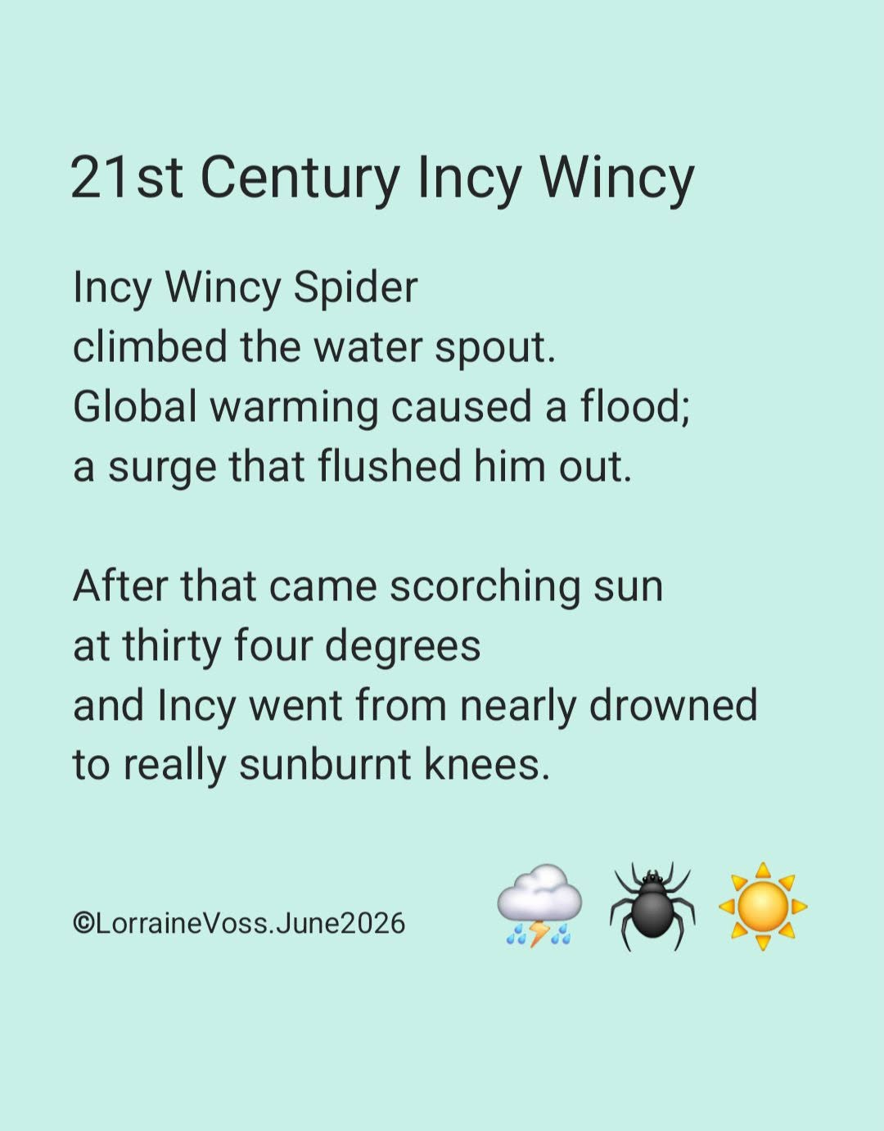



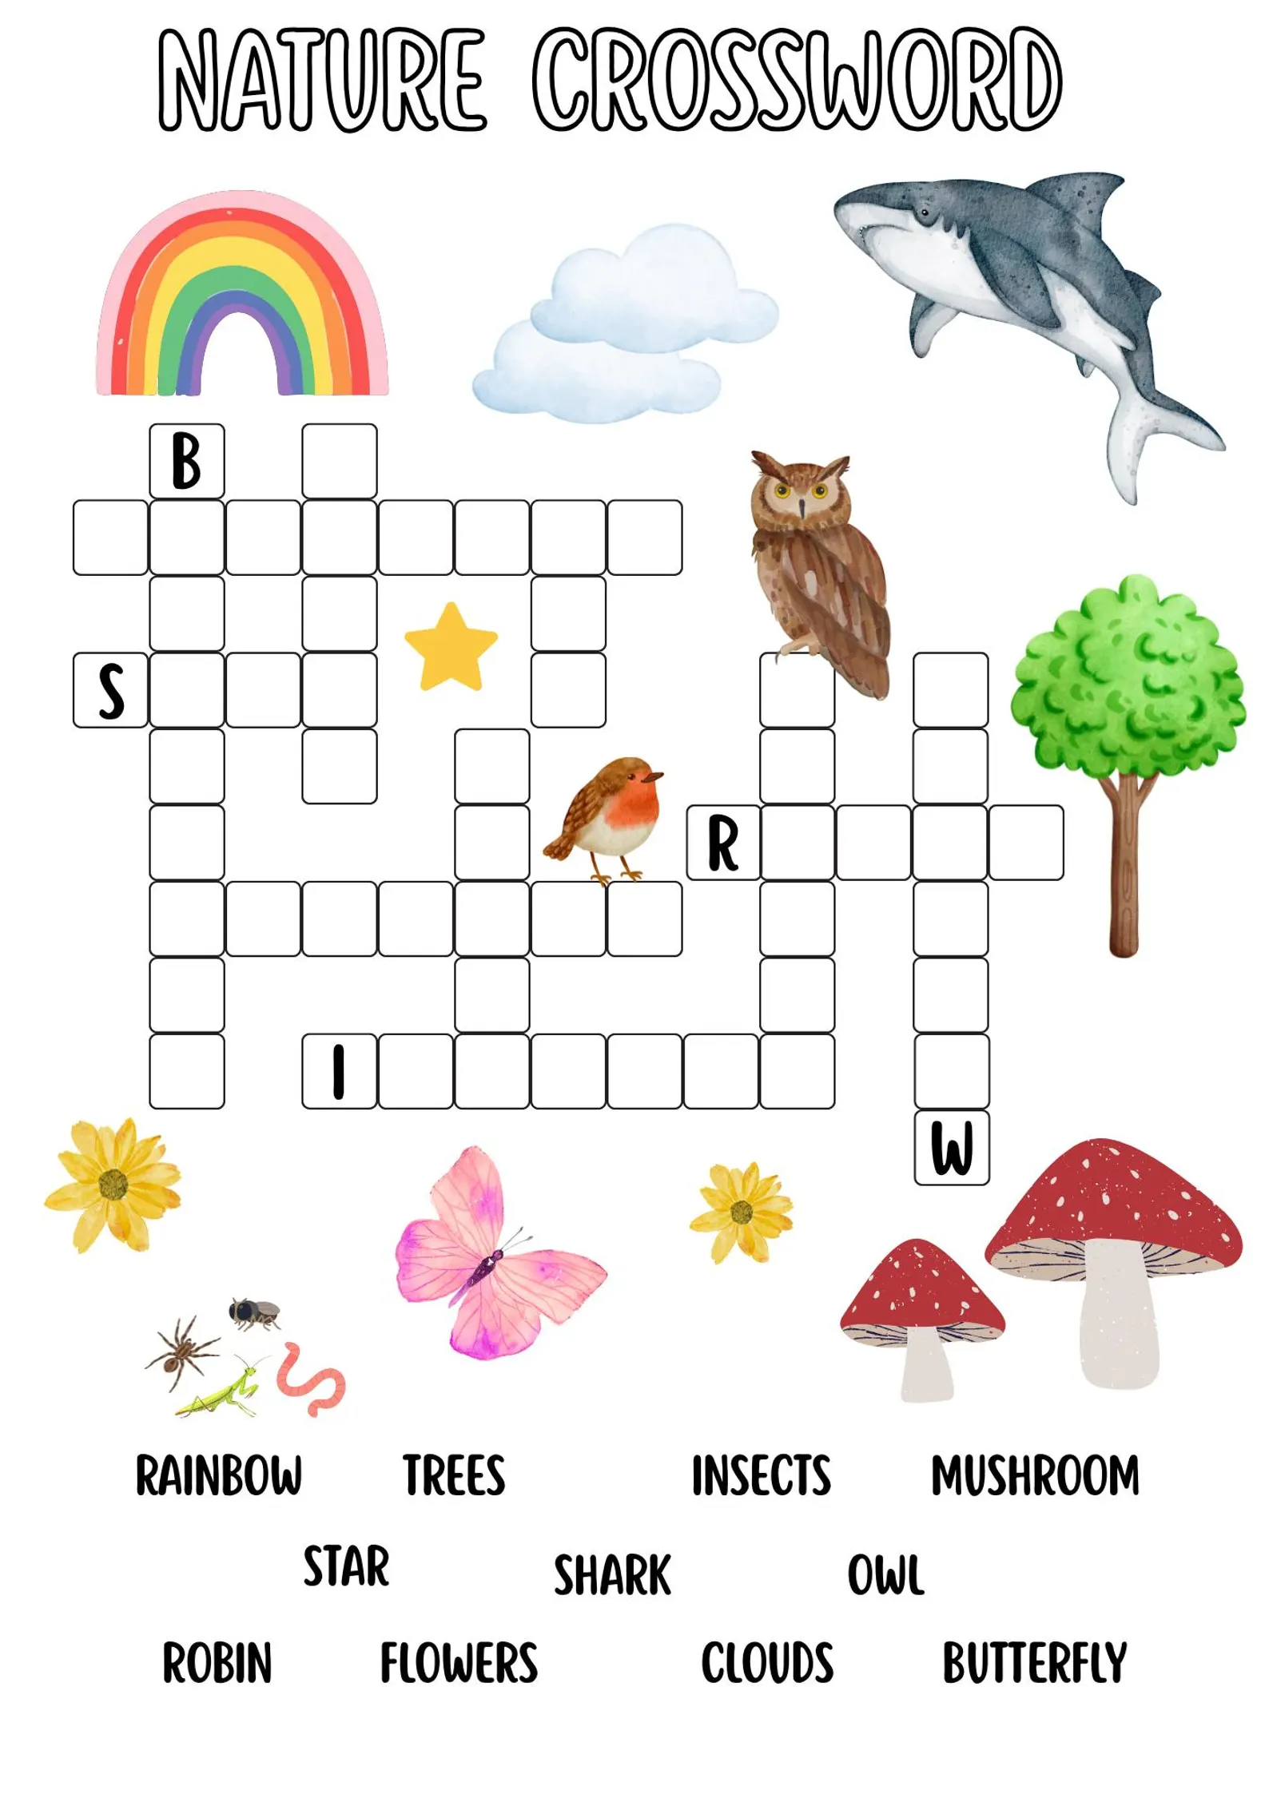

Items and articles for this newsletter are always welcome.

For the August Newsletter please send your articles and items of interest to
Revd Sue Round
Sue.Round@st-toms.com
Contact details: Rev Paul Bracher 0121-783 2319 paul.bracher@saintrichards.org.uk
Rev Susan Larkin – not available during the summer.
Rev Sue Round 0777 343 1028 sue.round@st-toms.com

