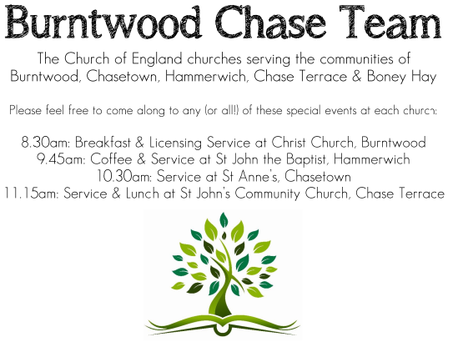
CHRIST CHURCH
Registered Charity Nos. 1217129

SERVICE ON SUNDAY 28th June 2026 at 10am

Holy Communion

4th Sunday after Trinity

Readings:
Romans 6: 12-23

¹² Therefore, do not let sin exercise dominion in your mortal bodies, to make you obey their passions. ¹³ No longer present your members to sin as instruments of wickedness, but present yourselves to God as those who have been brought from death to life, and present your members to God as instruments of righteousness. ¹⁴ For sin will have no dominion over you, since you are not under law but under grace.
¹⁵ What then? Should we sin because we are not under law but under grace? By no means! ¹⁶ Do you not know that if you present yourselves to anyone as obedient slaves, you are slaves of the one whom you obey, either of sin, which leads to death, or of obedience, which leads to righteousness? ¹⁷ But thanks be to God that you, having once been slaves of sin, have become obedient from the heart to the form of teaching to which you were entrusted, ¹⁸ and that you, having been set free from sin, have become slaves of righteousness. ¹⁹ I am speaking in human terms because of your natural limitations. For just as you once presented your members as slaves to impurity and to greater and greater iniquity, so now present your members as slaves to righteousness for sanctification.
²⁰ When you were slaves of sin, you were free in regard to righteousness. ²¹ So what advantage did you then get from the things of which you now are ashamed? The end of those things is death. ²² But now that you have been freed from sin and enslaved to God, the advantage you get is sanctification. The end is eternal life. ²³ For the wages of sin is death, but the free gift of God is eternal life in Christ Jesus our Lord.
Matthew 10: 40-42

⁴⁰ ‘Whoever welcomes you welcomes me, and whoever welcomes me welcomes the one who sent me. ⁴¹ Whoever welcomes a prophet in the name of a prophet will receive a prophet’s reward; and whoever welcomes a righteous person in the name of a righteous person will receive the reward of the righteous; ⁴² and whoever gives even a cup of cold water to one of these little ones in the name of a disciple—truly I tell you, none of these will lose their reward.’

COLLECT FOR TODAY
O God, the protector of all who trust in you,
without whom nothing is strong, nothing is holy:
increase and multiply upon us your mercy;
that with you as our ruler and guide
we may so pass through things temporal
that we lose not our hold on things eternal;
grant this, heavenly Father,
for our Lord Jesus Christ’s sake,
who is alive and reigns with you,
in the unity of the Holy Spirit,
one God, now and for ever.

WHAT’S GOING ON
Upcoming Services and Events

Saturday 4th July Art Cafe 3-5pm
Sunday 5th July Holy Communion 10am
Monday 6th July Cameo Cafe 10-12noon
Sunday 12th July Morning Worship 10am

DATES FOR YOUR DIARY
Saturday 11th July Shelfield Choir Concert 7pm
Saturday 14th November Christmas Fayre 2-4pm

Cameo Cafe
Cameo Cafe with be open on Monday 6th July.
All welcome to join us for a cuppa and biscuit or two.

FLOODLIGHTING
If you think about commemorating a special occasion by floodlighting our Church. Please contact Chris Brown on 01543 683862 for details.

PRAYER CHAIN
Christ Church is blessed with a very active prayer chain. If you, or anyone you know, feel that they would like others to pray for them, please speak to Chris Brown on 01543 683862.

HOME COMMUNION
For anyone who is unable to attend church and would like a Home Visit and Communion, please contact the Vicar and he will be able to carry this out.

VICAR CONTACT DETAILS
Rev’d Stephen Morgan Tele: 07305 852152
CHURCH WARDENS CONTACT DETAILS
Judith Rogers Tele: 01543 324718
Mike Holmes Tele: 01543 672970
Church Office Tele: 01543 642187 [leave a message and we will respond]
Church Web Site:www.christchurchburntwood.org.uk
Church Email: christchurchburntwood15@gmail.com
Facebook: www.facebook.com/group/christchurchburntwood/

Other Contacts
Rev’d Matt Wallace St. John’s, Chase Terrace— Tele: 01543 670078

NEXT SUNDAY SERVICE
Sunday 5th July at 10am
Holy Communion
Zechariah 9:9-12
Matthew 11: 16-19, 25-30
5th Sunday after Trinity

