
Notices: 28th June 2026
Priest David Oakden – Revdavid@parishofchilworth.org.uk - 01483 534293 (day off Friday)
Do let me know of anybody or anything that you would like to be prayed for.
www.parishofchilworth.org.uk and find us on https://www.achurchnearyou.com

***Psalm 16:8, 9 & 11 (NRSVA)***
I keep the Lord always before me;
because he is at my right hand, I shall not be moved.
Therefore my heart is glad, and my soul rejoices; my body also rests secure.
You show me the path of life.
In your presence there is fullness of joy;
in your right hand are pleasures for evermore.
**********************

Opportunites to Pray Together
Ecumenical Prayer Breakfast 1st Saturday of the month at the Vicarage, from 9am, prayer, coffee and croissant. Next is 4th July – Thursday evening at St Thomas at 6:00 pm for an hour every other week. 2nd & 16th July 2026.

This Sunday Services: 28th June
11:00 Old Saxon Church - Patronal Service
11:15 St Martha’s Mattins

Next Sunday Services: 5th July
09:30 St. Thomas' Holy Communion.
11:15 St Martha’s Mattins.
Donations at St Martha’s during services can now be made electronically via our Card Reader.

Looking Further Ahead
Tots and Toddlers: St Thomas' Monday 9:15am
Children's Trail: St Martha's, 28th June 2-5 pm
Bishops Gathering: 29th June in Cranleigh
St Thomas' Patronal Service: 5th July
Benefice Congregational Vacancy Meeting: 7th July 7.30pm Shere
Music at St Martha's in Aid of Royal Marsden: 12th July 1-2pm

This Sunday: Old Saxon Church Patronal Service
28th June marks the Old Saxon Church in Albury's Patronal Service combined with Midsummer - all welcome! The Friends of the Old Saxon will provide refreshments after the service.

Food and Hygiene Bank
The Foodbank Larder box is located in the porch of St Thomas Church.
Please help! We are currently very low on funds and struggling to keep up with demand.
Donations of LL milk, tinned meat, fish, veg & beans, pasta, pasta sauces, sachets rice, toiletries and cleaning products always needed. We also supply 6 families, 4 single households with monthly deliveries of fresh food at a cost £400-£500 a month.
Donations can be made at: treasurer@parishofchilworth.org.uk or scanning Foodbank QR code. Thank you



Chilworth Tinies and Toddler Group
Mondays from 9:15 -10:30am meet in St Thomas', play chat, pray and support.

Children’s Trail
The Children’s Trail around St Martha’s launches on 28th June between 2pm & 5pm. There will be drinks, cakes and even Ice Cream available. Why not come and join in the fun.



5th July St Thomas' Patronal Service
St Thomas' Patronal Service will be held on 5th July. There is no bring and share this year but do join us after the service for some fizz (alcoholic & non-alcoholic) and nibbles. All invited to come and share together.

Bishop Gathering 29th June 7:30-9pm
Bishop Paul invites you to a special gathering at St Nicholas Church, Cranleigh on 26th June, where we will meet, pray and worship together as a deanery. Put it into your diaries now.

Rector Update - Benefice Congregational Vacancy Meeting
Following Rector Tim Heaney’s announcement of this retirement in the autumn this year, he has kindly agreed that some of the Vacancy process can begin before October.
On Tuesday 7 July the Congregational Meeting will take place at 7.30pm in St James’, Shere. This is open to everyone in the Benefice. Archdeacon Catharine Mabuza will lead this meeting laying out what will take place over the coming months. Parking is limited around the church but the Village Car park GU5 9HE is free after 6pm

Children’s work update
I have been attending some Diocesan training and am praying that we will launch an after school group, please pray for help and inspiration as we look at all the options open to us.

Music at St Martha's - 12th July 1-2pm

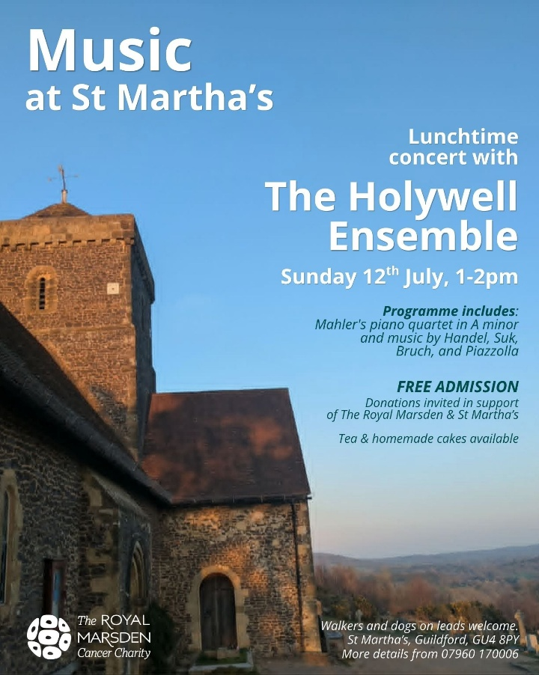

Broad Horizons Book Group
Our informal book continues on June 30th when we will be discussing "There are rivers in the sky" (Elif Shafak). See below for further details:

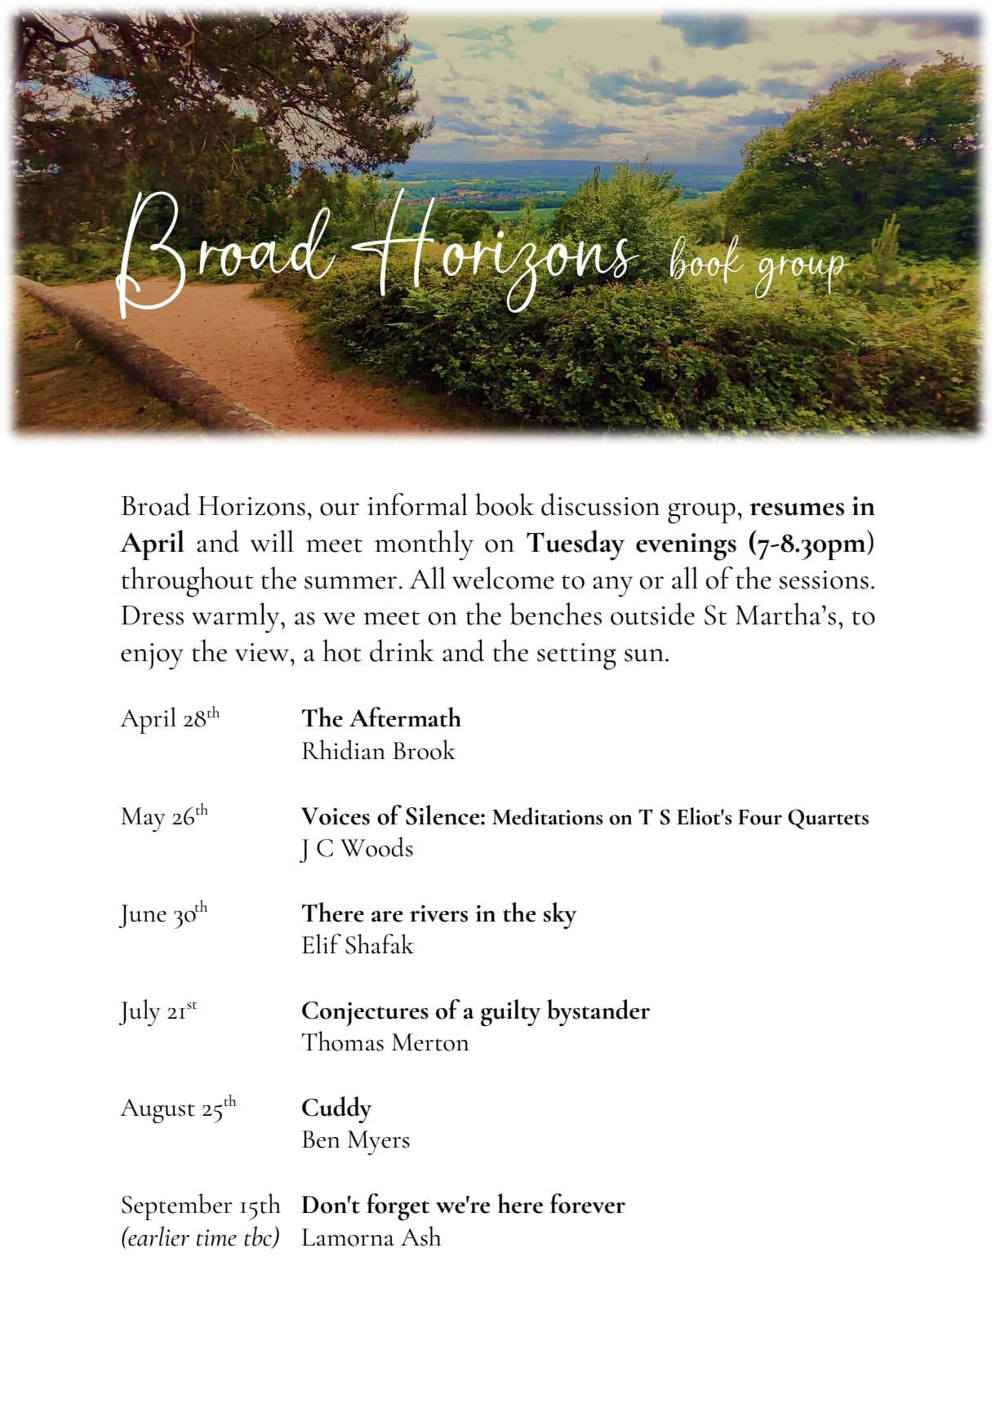

Book Stall at Albury Produce Show
Albury are running their usual book stall at Albury’s Produce Show on Saturday 18 July and are looking for books! Do you have any books you no longer need? They would love them!! Collection points are in the Churches of Albury, Shere, Peaslake and Chilworth or on the morning of the Show at the stall itself.

They are also looking for some volunteers to help sort the books in the morning and to sell the books in the afternoon. Please contact Albury’s Churchwardens if you can spare an hour or so!!

PCC & APCM Minutes and Documents
Redacted versions of these can now be found at https://www.parishofchilworth.org.uk/pcc/ on the Parish Website and will be uploaded when available.

Used Stamps for Oxfam
Please place used stamps in the box at the back of St Thomas' which will stay there all year and be emptied as and when it gets full.

1st CHRONICLES 28:20-21

If you need us
If you need any help with anything or have any questions please click on the names below to email a request:
For general admin matters our Administrator Yvonne
For local pastoral issues our Minister David

admin@parishofchilworth.org.uk
The Vicarage, Brook Road, Chilworth, Guildford, United Kingdom
 | 

