NEWSLETTER NUMBER 327
TOMORROW, SATURDAY 27TH JUNE 2026 WILL SEE OUR ANNUAL STRAWBERRY AND PROSECCO EVENT – YOU WILL NOT WANT TO MISS IT, SO GET ALONG TO THE CHURCH BETWEEEN 2.00 P.M. – 5.00 P.M.

OUR SERVICE ON SUNDAY 28TH JUNE 2026 – 4TH SUNDAY AFTER TRINITY
The next service at All Saints Church will be a Sung Eucharist starting at 10.30 a.m. on Sunday 28th June 2026. The celebrant will be the vicar, Rev Andy Barton. There will be refreshments served after the service so please stay and chat. Later, on the same day, there will be Families@4, a service aimed at families with primary school aged children.

RABSON’S RAMBLE
Celebrity connections with All Saints’ Church!
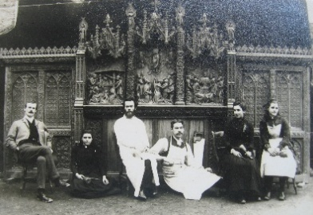
On Saturday I turned on my TV to set my video for a programme I wanted to see later that night. The TV turned on to a ‘Celebrity Antiques Road Trip’ repeat, where celebrities were seeking items in Devon. My ears pricked up when they mentioned three sisters that had started a woodcarving business in Ermington. I knew they were going to talk about the Pinwell sisters, but did you know there is a connection with our church? Mr W. J. Giles of Wellington carved our Hamdon stone font and pulpit. His work was excellent and he was well known in the SW area amongst architects for his craftmanship and reliability. By1884, Rev Edmund Pinwell, Rector of SS Peter and Paul Church, Ermington had started a scheme of restoration, drawn up under the patronage of architect Edmund H. Sedding, who was the nephew of the great Arts and Crafts architect, Mr J. D. Sedding. Edmund Sedding commissioned Mr Giles for the work. Mr Giles also taught Mary, Ethel and Violet, three of the Rector’s seven daughters how to do wood carving. Wood carving was considered a suitable pastime for girls/ women but what is unusual is that they set up a business. Their company, Rashleigh, Pinwell & Co Ecclesiastical Carvers, received many commissions to do work for other churches. The company flourished, moved to Plymouth and set up in the same building as Edmund Sedding but, by 1903, Violet was left as the sole proprietor following the departure of her older sisters, one of which went to Hampshire and set up her own business. Ermington is lucky that they possess several pieces of her work from the beginning to the end of her career e.g. stalls, bench ends, reredos etc. Violet died on 1/1/1957 but she left works in over 180 churches in Devon and Cornwall and some 20 other churches in the country. The very small photo shows the three sisters, their father and the seated figure in white is Mr Giles – it is presumed that the man on the floor came with Mr Giles as an assistant.

ROTA FOR SUNDAY 28/6/2026 – 4TH SUNDAY AFTER TRINITY
Sidesmen:- Jacquie Hockaday and Corinne Mead
Reader:- Sioned Barton
Coffee:- Corinne Mead and her sister
Flowers:- Melodie Lane

READINGS FOR SUNDAY
Collect:- O God, the protector of all who trust in you, without whom nothing is strong, nothing is holy: increase and multiply upon us your mercy; that with you as our ruler and guide we may so pass through things temporal that we lose not our hold on things eternal; grant this, heavenly Father, for our Lord Jesus Christ’s sake, who is alive and reigns with you, in the unity of the Holy Spirit, one God, now and for ever. Amen

Readings:-
Jeremiah Chapter 28, vv 5 – 9
Romans Chapter 6, vv 12 – end
Matthew Chapter 10, vv 40 - end

PRAYER LIST
Elizabeth Miles
Eunice Durrance
Hazel Ware
Ian Sansom
John Wilkie
Mike Toogood
Pam Wilkie
Paul Tatnall
Stephen Daley
YEARS MIND FOR JUNE/JULY
JUNE
29TH Kenneth Walter Troake
JULY
1ST William (Bill) Ash
2ND Ralph Nuttall
2ND Mary Cope
3rd Tony Lomas

OUTREACH GROUPS
Knit, Sew and Natter
The next meeting will be on Thursday, 2ND July 2026 at 2.00 p.m. It will be the usual meeting with lots of chat and refreshments.

Recycled Teenagers
The next meeting will take place on Tuesday, 28TH July 2026 at 2.30 p.m. Come along and enjoy cups of tea plus sandwiches and cakes along with some conversation.

Soup ‘n’ a Bite
This will be on Saturday 11TH July 2026 at 12.00 noon. It will be the normal fare of soup, bread, cheese and fruit combined with lots of conversation!

Churchyard Group
If you are willing to help, the next meeting will be at 10.00 a.m. on Tuesday 14th July 2026 if anyone is free. We wonder if anyone has any of the following plants they would be willing to donate:- White aubretia, white mini periwinkle, white iberis, white omphaloides, small green/yellow or green/white hostas and small ferns. We are very grateful to have received money enabling us to buy the bulbs wanted for next spring.

Shanty Singing
The group is not meeting in July.

OUR NEXT SERVICE
The next service at All Saints Church will be a Sung Eucharist starting at 10.30 a.m. on Sunday 5th July 2026. The celebrant will be Rev Stephen Bowen. There will be refreshments served after the service so please stay and chat.

FORTHCOMING EVENTS
Fund Raising Committee Events
1) Saturday 27/6/2026 Strawberry Special with Prosecco, 2 – 5 p.m.
This is our annual afternoon event offering all things strawberry i.e. strawberries and cream, strawberry flans, scones and strawberries etc with some extra stalls, books, bottles and a raffle on offer as well. Come and join us for a while to eat, drink and be merry. If you have items suitable for a raffle prize or items for the bottle stall, please bring them as early as possible so they can be labelled and be available to view.

2) Saturday 18/7/2026 Church BBQ and picnic, 5 – 8 p.m.
This will take place in the church grounds. Further details will come next week but you need to put the date in your diaries now.
OTHER INFORMATION
Hymns for services
A book has been placed on the sidesman’s table for you to complete with your favourite hymns. Alternatively, you can give me a list of titles/hymn numbers so I can collate them on my computer. As and when they become appropriate i.e. Christmas carols in August will not be an acceptable option, then they will be included.

From Rev Andy Barton to all those who helped with refreshments, welcome etc
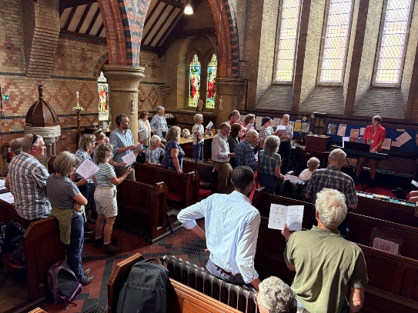
It cheered our souls to complete the first leg of Walk West Tone with the bells ringing and plenty of refreshments on offer in All Saints. You coped well with the increased numbers this year, I hope you could enjoy the Shanty Singing amidst your efforts. You have a busy church life with weekly services, monthly outreach groups and regular fundraising events. I do not take for granted the additional effort required to support the benefice walk. So a big thank you from me and all the walk team. I have attached a photo for you, more to come on our website soon.
From Rev Andrew Norris
The “Home Service” is a weekly programme which brings Christian worship into your front room which is broadcast on 105.3 FM on Wednesdays at 11.00am and repeated Sunday at 10.00 am. It is also available via the internet at any time on www.10radio.org . This week: With a very apt theme given the current climate, Andrew Kelly from the Community church in Wiveliscombe leads in an act of worship focussing on "God's sunshine" If you have prayer or song requests or want others to know about what is happening in your church, contact revandrew@10Radio.org

FUN CORNER
More items from “Lost in Translation”
MEDICINE
1) On a Chinese Medicine bottle - Known to cure itching, colds, stomachs, brains, and other diseases
2) On a Japanese medicine bottle – Adults 1 tablet 3 times a day until passing away
3) From a Japanese health questionnaire – Are you haunted by horribles? Do you ever run after your nose? Does your nose choke? Does your head, or face or shoulder ever limp? Has any part of your body suddenly grown uncontrollable?

There is nothing like an old joke to raise a smile!

