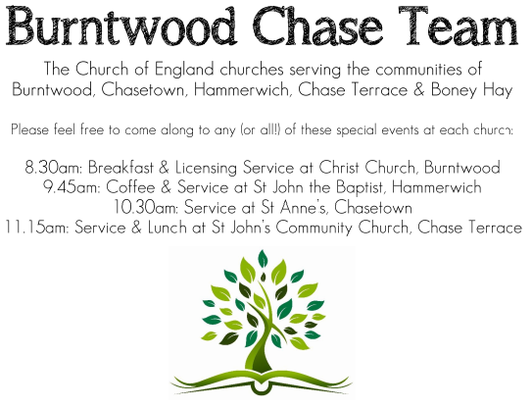
CHRIST CHURCH
Registered Charity Nos. 1217129

SERVICE ON SUNDAY 5th July 2026 at 10am

Holy Communion

5th Sunday after Trinity

Readings:
Zechariah 9: 9-12

Rejoice greatly, O daughter Zion!
Shout aloud, O daughter Jerusalem!
Lo, your king comes to you;
triumphant and victorious is he,
humble and riding on a donkey,
on a colt, the foal of a donkey.
¹⁰ He will cut off the chariot from Ephraim
and the warhorse from Jerusalem;
and the battle-bow shall be cut off,
and he shall command peace to the nations;
his dominion shall be from sea to sea,
and from the River to the ends of the earth.
¹¹ As for you also, because of the blood of my covenant with you,
I will set your prisoners free from the waterless pit.
¹² Return to your stronghold, O prisoners of hope;
today I declare that I will restore to you double.

Matthew 11: 16-19, 25-30
¹⁶ ‘But to what will I compare this generation? It is like children sitting in the market-places and calling to one another,
¹⁷ “We played the flute for you, and you did not dance;
we wailed, and you did not mourn.”
¹⁸ For John came neither eating nor drinking, and they say, “He has a demon”; ¹⁹ the Son of Man came eating and drinking, and they say, “Look, a glutton and a drunkard, a friend of tax-collectors and sinners!” Yet wisdom is vindicated by her deeds.’
²⁵ At that time Jesus said, ‘I thank you, Father, Lord of heaven and earth, because you have hidden these things from the wise and the intelligent and have revealed them to infants; ²⁶ yes, Father, for such was your gracious will. ²⁷ All things have been handed over to me by my Father; and no one knows the Son except the Father, and no one knows the Father except the Son and anyone to whom the Son chooses to reveal him.
²⁸ ‘Come to me, all you that are weary and are carrying heavy burdens, and I will give you rest. ²⁹ Take my yoke upon you, and learn from me; for I am gentle and humble in heart, and you will find rest for your souls. ³⁰ For my yoke is easy, and my burden is light.’

COLLECT FOR TODAY
Almighty and everlasting God,
by whose Spirit the whole body of the Church is
governed and sanctified:
hear our prayer which we offer for all your
faithful people,
that in their vocation and ministry
they may serve you in holiness and truth
to the glory of your name;
through our Lord and Saviour Jesus Christ,
who is alive and reigns with you,
in the unity of the Holy Spirit,
one God, now and for ever.

WHAT’S GOING ON
Upcoming Services and Events
Monday 6th July Cameo Cafe 10-12noon
Wednesday 8th July Morning Prayer 9.30am
Sunday 12th July Morning Worship 10am
Wednesday 15th July Morning Prayer 9.30am

DATES FOR YOUR DIARY
Saturday 11th July Shelfield Choir Concert 7pm
Saturday 14th November Christmas Fayre 2-4pm

Cameo Cafe
Cameo Cafe with be open on Monday 6th July.
All welcome to join us for a cuppa and biscuit or two.

Food bank
Update on the food bank, we are continuing to support this worthwhile appeal. A few of the items always needed are:
‘long life milk, custard / rice pudding, cereals’
Many thanks for your support.

FLOODLIGHTING
If you think about commemorating a special occasion by floodlighting our Church. Please contact Chris Brown on 01543 683862 for details.

PRAYER CHAIN
Christ Church is blessed with a very active prayer chain. If you, or anyone you know, feel that they would like others to pray for them, please speak to Chris Brown on 01543 683862.

HOME COMMUNION
For anyone who is unable to attend church and would like a Home Visit and Communion, please contact the Vicar and he will be able to carry this out.

VICAR CONTACT DETAILS
Rev’d Stephen Morgan Tele: 07305 852152
CHURCH WARDENS CONTACT DETAILS
Judith Rogers Tele: 01543 324718
Mike Holmes Tele: 01543 672970
Church Office Tele: 01543 642187 [leave a message and we will respond]
Church Web Site:www.christchurchburntwood.org.uk
Church Email: christchurchburntwood15@gmail.com
Facebook: www.facebook.com/group/christchurchburntwood/

Other Contacts
Rev’d Matt Wallace St. John’s, Chase Terrace— Tele: 01543 670078

NEXT SUNDAY SERVICE
Sunday 12th July at 10am
Morning Worship
Isaiah 55: 10-13
Matthew 13: 1-9, 18-23
6th Sunday after Trinity

