Welcome to Wombridge, The Church in the Park
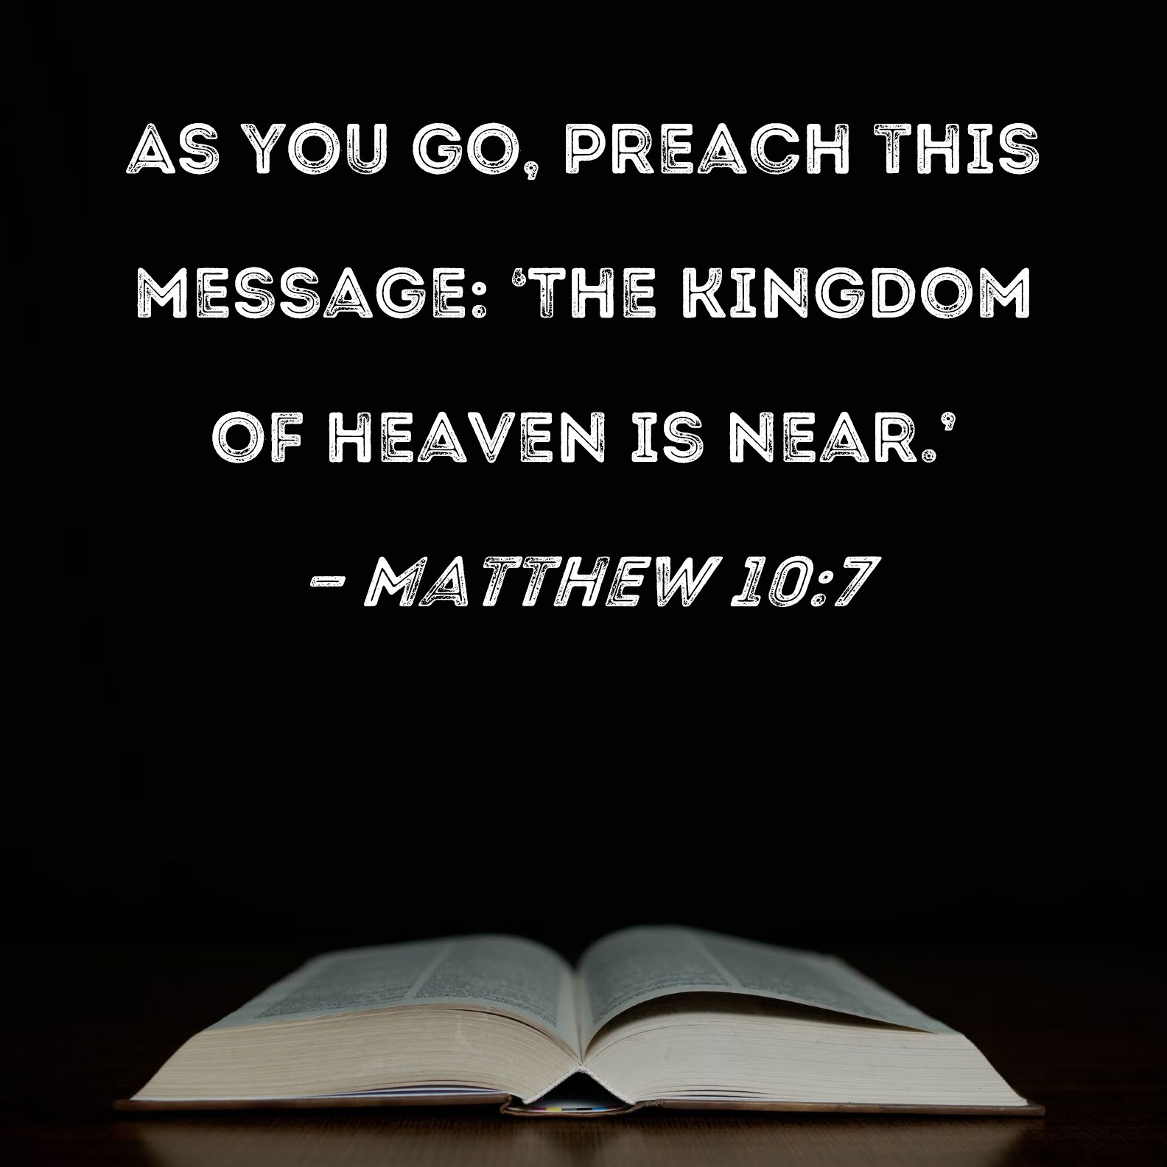
Sunday 14 June 2026
2nd Sunday after Trinity
11.00am Family Service
Lectionary Readings for today:
Genesis 18: 1-15
Romans 5: 1-8
Matthew 9: 35-10:8
Psalm 116: 1, 10-17

Collect for the Second Sunday after Trinity
Lord, you have taught us that all our doings without love are nothing worth: send your Holy Spirit and pour into our hearts that most excellent gift of love, the true bond of peace and of all virtues, without which whoever lives is counted dead before you. Grant this for your only Son Jesus Christ's sake, who is alive and reigns with you, in the unity of the Holy Spirit, one God, now and for ever. Amen.

This week we ask for your prayers for those living and working in
Bridge Close, Pool Close, Elm Way, Ercall Close, Trench Close.
Please contact Margaret Afford, Tel 01952 419826 9.30am – 12 noon, or email wombridgeparishchurch@outlook.com with any personal prayer requests.

June Services
14th: 11.00am Family Service
21st: 11.00am Holy Communion
28th: 11.00am Family Service

July Services
5th: 11.00am Holy Baptism 4.00pm Holy Communion
12th: 11.00am Family Service
19th: 11.00am Holy Communion
26th: 11.00am Family Service

There is also a short service of Morning Prayer on Wednesdays at 9.15am.

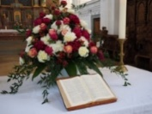
The altar flowers this week are sponsored by Nick & Chris Griffiths
In loving memory of Nick's mum and dad, Frank and Toni Griffiths.

The Ronnies Summer Concert - Saturday 11th July 2pm to 4pm
The Ronnies are returning to Wombridge for a summer concert 🙂. Tickets are £10 which includes refreshments of jam and cream scone and tea or coffee. Tickets are available from Malcolm and Evelyn Gough and Chris Griffiths. You can sure of a wonderful afternoon of entertainment, as this wonderful quartet sing songs from across the decades. Social and Outreach Team

Thank you ... following the recent APCM/AGM, the PCC wanted to thank people for their financial support to this church. Faithful and generous giving enables us to carry out the mission and ministry God has entrusted to us here in Wombridge, with every gift playing an important part in the work God is doing through His church. The Bible reminds us in 2 Corinthians 9:7 that "God loves a cheerful giver." We are thankful not only for your giving but for the spirit in which it is offered.

We know that giving is in itself an act of worship and trust, and we thank you for your faithful generosity, as we work together, through God’s grace and in His strength, acknowledging the privilege it is to serve him in this place. Thank you - Wombridge PCC

Rev Richard Walker-Hill Many of you will be aware that Richard was admitted to hospital last week. He is back home now but has to recover his strength before undergoing surgery. This will also mean a long period of convalescence. Our thoughts and prayers are with Richard at this time and I am sure you will all join in wishing him a swift return to health.

Arrangements for Clergy Cover The Benefice now has only one member of clergy, Rev Tom, covering the six churches. Following discussion between the PCC and Rev Tom, it has been agreed that from Sunday 2nd August, the evening service of Holy Communion will move from 4.00pm to 3.00pm. This will ease pressure on Rev Tom and any other clergy members who are able to provide cover for Richard until he is well enough to return. St Peter's Priorslee have already trialled having the evening service at this earlier time and it has had a favourable reception. We hope you will understand and support this change. Wombridge PCC.

Safeguarding
Please be aware that there is now a dedicated email address for reporting safeguarding concerns. wombridge.safeguarding@easttelfordbenefice.co.uk

The Newsletter for the East Telford Benefice can be found at easttelfordbenefice.co.uk, then click on the links near the top of the page. There is always plenty to read about and lots of useful information.
Find us at: www.acny.org.uk/wombridgechurch and on Facebook 

