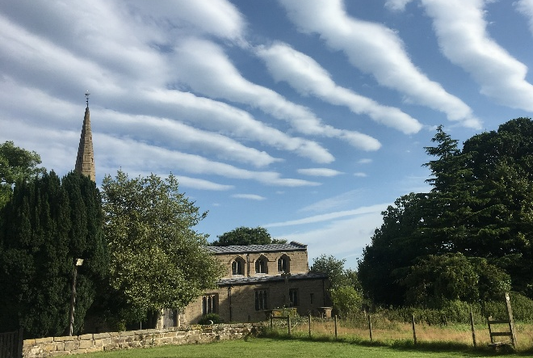
ST MICHAEL AND ALL ANGELS
HAMSTALL RIDWARE

In the United Benefice of King’s Bromley,
the Ridwares and Yoxall

June 14th 2026
Trinity 2

PARISH NOTICES

UNITED BENEFICE SERVICE ROTA
 | Hamstall Ridware  St Michael and All Angels | Yoxall  St Peter | King’s Bromley  All Saints |  | Mavesyn Ridware  St Nicholas
June 14th  Trinity 2 | 5.00 pm  Holy Communion |  | 10.30 am  Holy Communion
June 21st  Trinity 3 | 10.30 am  Holy Communion | 5.00 pm  Holy Communion | 9.00 am  Holy Communion |  | 10.30 am  Holy Communion
June 28th  Trinity 4 | 10.30 am  Yoxall Patronal Festival Holy Communion – United Benefice Service
July 5th  Trinity 5 | 9.00 am  Holy Communion | 10.30 am  Holy Communion |  | 5.00 pm  Holy Communion | 10.30 am  Morning Prayer
July 12th  Trinity 6 |  | 10.30 am  Holy Communion |  | 10.30 am  Fellowship Group

Please note that services of Holy Communion at 9 am follow the Book of Common Prayer and are said. Services at 10.30 will include hymns and other singing.
There are services of Holy Communion at 10.00 every Wednesday at St Peter’s, Yoxall
and on the first Thursday of each month at All Saints, King’s Bromley.
*******************
Rugeley Food Bank. Please do remember those who depend on Food Banks. They are needed now just as ever. If you wish to donate directly to Rugeley Foodbank at Rugeley Community Centre the Centre is open everyday to receive contributions. Alternatively, the Rugeley Food Bank welcomes financial contributions – see https://rugeley.foodbank.org.uk. Gifts can also be brought to St Michael’s and left in the box at the back of church near the font. If that is not convenient please contact Liz Carter on 07751 068181.
****************
Contact details: If you wish to contact the Rector, Jeremy Brading you can do so on revd@kbhmy.co.uk and Glenis Turner, the PCC Secretary and Benefice Administrator is on admin@kbhmy.co.uk. Our churchwarden is John Ferguson clan.member1954@gmail.com Information about events at church can be found at our webpages at https://www.achurchnearyou.com/church/4451/ and https://kbhmy.co.uk/hamstall/
St Michael’s will continue to be open everyday (weather permitting) between 10.00 am until 6.00 pm. We will revert to shutting the church at 4.00 pm on October 25th 2026
Safeguarding of children and vulnerable adults. If you have any concerns please speak in complete confidence to the Parish Safeguarding Officer, Dr Paul Carter on 01889 504347 or the Diocesan Safeguarding Officer, Neil Spiring on 01543 306030.
PLEASE REMEMBER IN YOUR PRAYERS:
Those who are sick: Mary Mycock, Angela Perkin, Doug, David and Barbara Rudge, May Windley, Pam Payne, Frank and Margaret Finch, Chris Poole, Les Wood, Pat Lomax, Alison Scott and any known personally to you.
For the departed especially Albert Barlow (better known as Boo) – and pray for his family.
For those recently married in St Michael’s: Lucy Hoskins and Harry Turner
Using the Archbishops’ prayer for Ukraine at this time let us remember the people of that war-torn land:
God of peace and justice, we pray for the people of Ukraine today. We pray for peace and the laying down of weapons. We pray for all those who fear for tomorrow, that your Spirit of comfort would draw near to them. We pray for those with power over war or peace, for wisdom, discernment and compassion to guide their decisions. Above all, we pray for all your precious children, at risk and in fear, that you would hold and protect them. We pray in the name of Jesus, the Prince of Peace. Amen
As the situation in the Middle East continues to see military action remember all those in all the countries affected by it – whether nationals or visitors, whether in those countries or elsewhere and concerned for loved ones. Pray for wisdom on the part of the leaders of the nations involved and that hostilities and suffering may come to an end soon. Please pray also for seafarers and their families caught up in a conflict not of their choosing.
From the Diocesan Prayer Diary:
Tuesday 16th: (Richard, Bishop of Chichester, 1253. Joseph Butler, Bishop of Durham, Philosopher, 1752)
We pray for this morning's Ecumenical Safeguarding Webinar on understanding the role of the Staffordshire LADO (Local Authority Designated Officer). Lord, we pray for those with particular responsibilities in respect to safeguarding across our diocese and ask for wisdom in undertaking these roles. We too pray that you guide each and every one of us as we play our part in making sure that safeguarding is everyone’s responsibility.
Thursday 18th: (Bernard Mizeki, Apostle of the MaShona, Martyr, 1896)
Lord, we again join today in Praying for the 34,000, that many more people may find the joy of starting their walk with you. Please help us to be ready, willing, and able to help people along that walk whenever and however they may come through our doors. We pray for the Risk and Audit Committee as they meet today, for sound judgement in everything they are looking at. Finally Lord, we pray for the Tea and Cake session at St Chad's House in Leek, for good fellowship for all those there, and for the wardens Jaime and Gary as they seek to take the house forward.
Saturday 20th:
Lord, we lift before you those people being ordained as Priests today. At Lichfield Cathedral we pray for each of Jules Smith, Laura Edwards, and Laura MacFarlane; at Stoke Minster we pray for James Butter and Katie Delamere. Lord, please bless each of these people at this important stage of their journeys, and continue to guide them as they move forward.

THE FÊTE – Saturday June 20th
YES! It is only a few days away from this very important day in the life of not just St Michael’s but the whole village. Help will be needed not just on the day but beforehand with selling Grand Draw tickets, getting bric-à-brac to the right people, providing Tombola prizes, bottles etc etc! All offers of help very gratefully received! Once again Val Richards is the Fête supremo and she is waiting to hear from you at rarebitrichards92@sky.com

St Michael’s encourages donations by means of this QR code and it will appear (all being well) on all our publications as an invitation to contribute to the important work of the church both
as a place of worship and a community asset where all can share in the wonderful place we have
inherited and wish to pass on to those who come after us.

