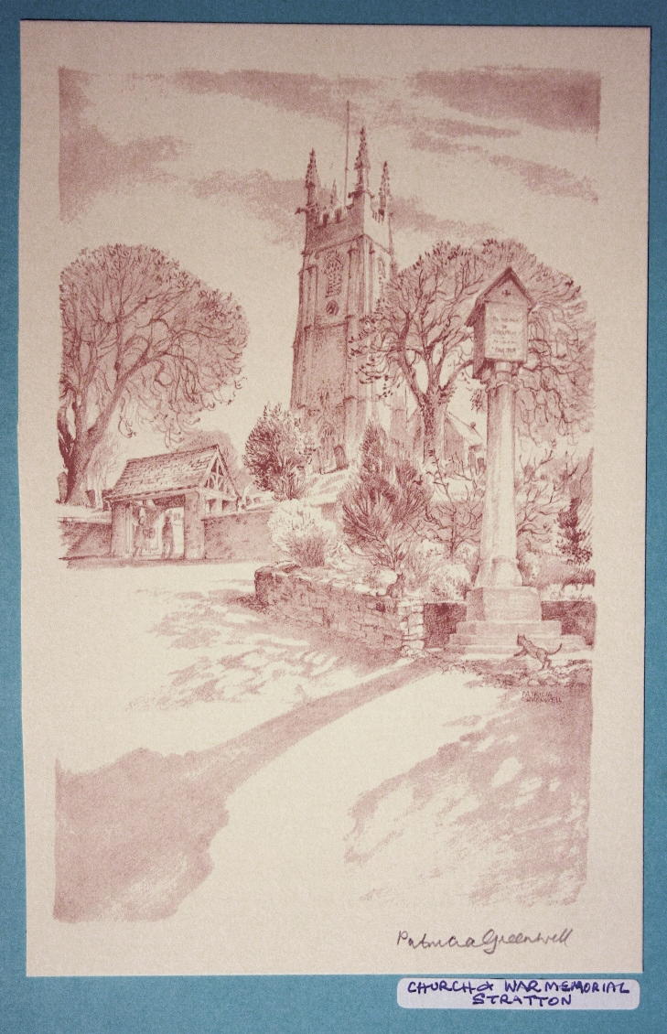 | The Parish Church  of St Andrew, Stratton  Priest in Charge  The Revd Teresa Folland  Tel: 01288 352599  e-mail: revteresa.folland@gmail.com  Churchwarden  Mrs Diana Ohlson  Tel: 01288 354441  e-mail: dohlson24@gmail.com
June 2026

Prayer of the Month

Lord of all, anchor our lives in your love, your word, your will, so that we may be able to resist the trials life throws at us. Nurture our faith and strengthen our commitment, so that, whatever turmoil we face, whatever testing we endure, when all has done its worst, we may still stand tall – unbowed, unbroken.
Amen

Nick Fawcett

Services at St Andrew’s June 2026

Wed  3rd  Sun  7th | Christian Meditation 9.30am  Midweek Mass Wed. 10.30am – Officiant: Rev Teresa Folland  1st Sunday after Trinity  Readings: Hosea 5:15-6:6; Psalm 50:7-15; Romans 4:13-end; Matthew 9:9-13, 18-26  Morning Worship 9.30am – LWLs  Evensong 6pm:Officiant Rev Teresa  Psalm:39:1-15 or Psalm:41:1-13  Readings: 1 Samuel 18:1-16; Luke 8:41-end Reader: Dafydd Thomas
Wed  10th | Christian Meditation 9.30am  Midweek Mass Wed. 10.30am – Officiant: Rev Doug Adams
Sun  14th | 2nd Sunday after Trinity  Readings: Exodus 19:2-8a; Psalm 100; Romans 5:1-8; Matthew 9:35 – 10:8 [9-23]  Parish Mass 9.30am – Officiant: Rev Jane Bradbury
Wed  17th | Christian Meditation 9.30am  Midweek Mass Wed. 10.30am – Officiant: Rev Jane Bradbury
Sun  21st | 3rd Sunday after Trinity  Readings: Jer 20:7-13; Psalm 69:8-11 [12-17]18-20[or 69:16-29]; Romans 6:1b-11; Matthew 10:24-39  Morning Worship 9.30am – LWLs Judy Dunne and Val Hopper
Wed  24th | Christian Meditation 9.30am  Midweek Mass Wed. 10.30am – Officiant: Rev Richard Ward Smith
Sun  28th | 4th Sunday after Trinity  Readings: Jeremiah 28: 5-9; Psalm 89:1-4, 15-18 [or 8-18]; Romans 6:12-end; Matthew 10:40-end.  Parish Mass 9.30am – Officiant: Rev Teresa Folland
~~~~~~~~~~~~~~~~~~~~~~~~~~~~~~~~~~~~~~~~~~~~~~~~~~~~~~~~~~
News Sheet Editors: Val Barker Tel:353435 and Sheila Waring Tel: 714338

If you have anything for inclusion in the next news sheet, please send it to the editors by the 10th of them month. All documents in Calibri (Body) Font size 12. Thank you.
~~~~~~~~~~~~~~~~~~~~~~~~~~~~~~~~~~~~~~~~~~~~~~~~~~~~~~~~~~


FROM THE PARISH REGISTERS 2026

Interment of Ashes
On Wednesday 6th May 2026 at Noon.
Mrs Margaret Blatchford

A Service to Celebrate the Life of
Yvonne Lyzette Bevan
23rd January 1958 – 21st April 2026
at St Andrew’s Church, Stratton Tuesday 12th May 2026 at 11.30am.

Dates for your diary
Fri 5th June | FoStA Committee meeting 3pm at Stamford House
Sat 6th June | Diocesan Training Day in Church
Mon 8th June | Stratton School Children visiting in the morning M U Branch Meeting 2pm Stamford House
Sun 14th June | Stall at Pendeen Car Boot sale pm.
Sat 20th June | Wedding in church
Tues 23rd June | Pastoral planning meeting 10.30am at 6 Drovers Way
Thur 25th June | Social Committee meeting at 6 Drovers Way 10.30am
Mon 29th June | MU Cream Tea at 6 Drovers Way from 2pm
Thurs 2nd July | Pastoral Meeting 10.30am at 6 Drovers Way
Mon 6th July | M U Branch Meeting 2pm Stamford House
Sat 11th July to Sun 19th July | St Andrew’s Music and Arts Festival including, on Sunday 19th, a Festival service 4pm at which the Bishop will bless the conserved East window and restored Bells.

St Andrew’s Festival of Music and Arts 11th - 19th July

For 8 days in July St Andrew’s will be the centre for a range of music and arts events, with something for everyone. There is music from a wind quintet, an orchestra and a chance to listen to the talented Bude Youth Choir and Orchestra. Come and enjoy a special high tea with musical accompaniment from the Temperate Trio, tickets in advance only to aid our catering! Then come and admire talented artists and crafts people and see the competitive art and poetry entries from children in local schools. Refreshments available at all events. Brochures for the Festival available in church and in Stratton Stores and various outlets in Bude. We look forward to your support.

Pendeen Car Boot Sale

The Social Committee of the PCC decided to try and raise some funds by taking a stall at three sales this summer. The first one was on May 10th and we were lucky with the weather. It was windy but it stayed dry!!! Our church membership had been really supportive in donating a variety of items for the stall, including lots of small cakes, and we were encouraged by the result of £256 for the church funds.
If you have saleable items such as toiletries, china, packets of food etc, please put them in our donations box in church, so that we have plenty to offer in our June and July sale.

Flower Festival

A huge thank you to everyone who helped to make this year’s flower festival such a successful and happy event. A lot of thought was put in by the arrangers interpreting our theme ‘For the Beauty of Flowers’ in such unique and inspiring displays. As always there was a wonderful assortment of cakes on offer, so thank you to all you bakers, and a big thank you to those who served refreshments over the three days of the festival. To date we have raised £2653.00, not counting money that was put on the card machine which will come through later.


Mothers Union – Kledh Kernow Branch
Across the

UK Mothers’ Union is linked with dioceses globally and here in Cornwall one of our linked dioceses is Lokoja and Sapele in Nigeria. With this in mind, at our last branch meeting we followed the World Day of Prayer service prepared by an ecumenical group of Christian women from Nigeria. The theme of the service was ‘I will give you rest’. We shared stories of four Nigerian women who face daily struggles of injustice, poverty, insecurity, marginalisation, religious persecution and despair. However, despite all the hardships that they face, through their faith and trust in God they never give up and find rest in the Lord. The stories and prayers made us all aware of just how many blessings we have received.
June will be a busy month for the branch with our usual meeting on Monday 8th at Stamford House, Stamford Hill at 2pm. All welcome.
At the end of the month on Monday 29th we will be holding a Cream Tea at 6 Old Drovers Way at 2pm. We will be welcoming our Diocesan President, Kerstin Lewis and invite you to come along. The proceeds from the Cream Tea will go towards our diocesan projects supporting young carers in Cornwall and S.P.A.C.E. providing play and social events for young disabled people.
~~~~~~~~~~~~~~~~~~~~~~~~~~~~~~~~~~~~~~~~~~~~~~~~~~~~~~~~~~~~~~~~~
Part of Jennie Coles arrangement at the recent Flower Festival
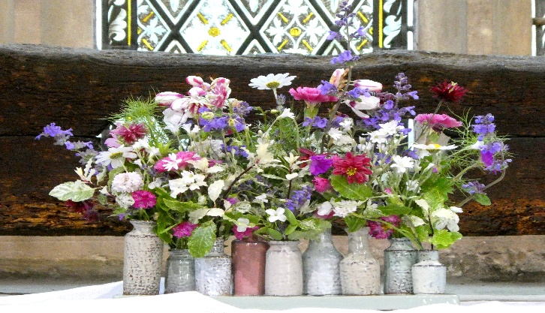

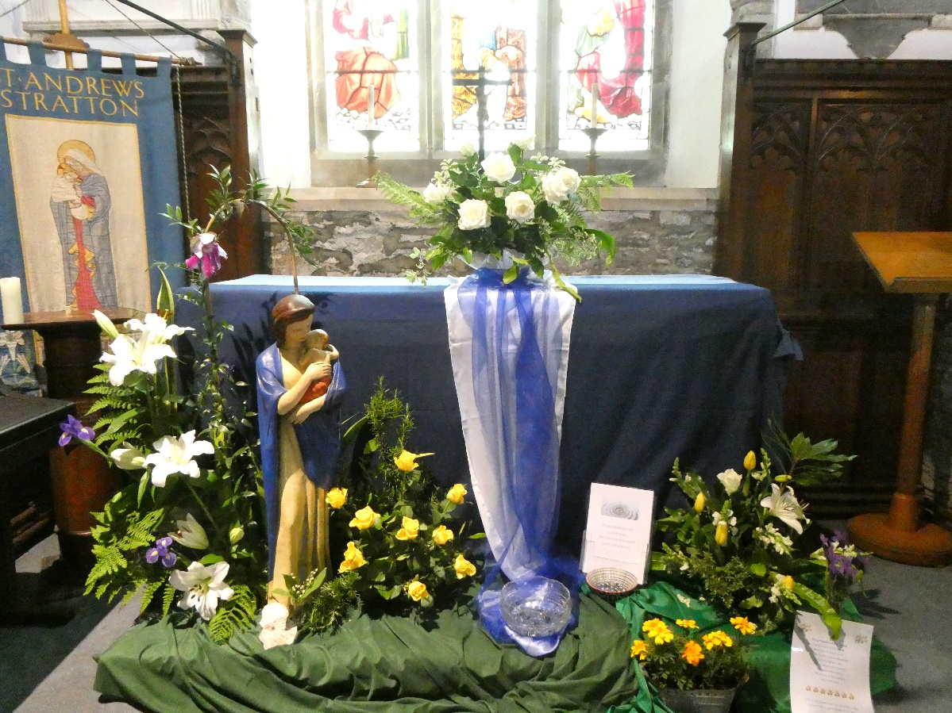

‘Our Lady’s Garden’

Arrangement by Sheila Waring, situated in the Lady Chapel, at the recent Flower Festival.

On the next page there is a photograph of an arrangement by Jeanette Norman of Kilkhampton. It was entitled ‘Paradise’.

Flower Festival photographs by Reg Godwin at Wild Stage Photography.

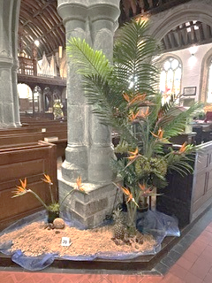

A very special Thank You to Sheila for once again coordinating the Festival. Her people skills go a long way in making the event such a successful and joyous occasion. We are grateful for all you do.

For the month of June 2026
We remember in our prayers all those living in:
Week beginning:
Sunday 7th | Spicers Lane, Huntfield Close, Treworden Close, Gibraltar Square, Church Square
Sunday 14th | Corner Gardens, Howells Road, The Leat
Sunday 21st | Howard Lane, Parc Fer Close, Barnfield Park
Sunday 28th | Bridge Street, Union Hill, Bowden

Those who have asked for our prayers:
Allan Gouldson, Molly Hooper, Gloria Braund, Mick Carter
We bring before God, especially at this time, all who work in our local hospitals, the inpatients and all undergoing investigations and outpatient treatment. We remember too those of our church family who are ill at home or housebound.
The recently departed: Lyzette Bevan May she rest in peace and rise in glory.
We remember and pray for all who mourn her passing.

For the month of June
Those in our Year’s Mind:
Sunday 7th | Mary Cobbledick, George Pearce, Peter Ellis, Diane Brett.
Sunday 14th | Michael Trzaska Nartowski, William Heard, Myrtle Metherall, Edna Daniels, Ronald Nash, Edith Sykes.
Sunday 21st | Phyllis Coker, Jacob Hawker (Priest), Ann Morgan, Brian Worland, Jennifer Yeo, Eileen Beer.
Sunday 28th | Robert Pooley, Katherine Bryant, Grenville Martin, William Hingston, David Perkins, Oscar J Conoley.

