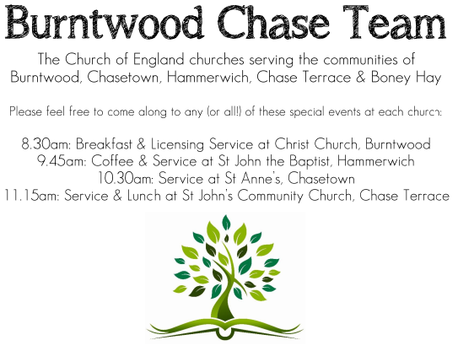
CHRIST CHURCH
Registered Charity Nos. 1217129

SERVICE ON SUNDAY 7th June 2026 at 10am

Morning Worship

1st Sunday after Trinity

Readings:
Romans 4: 13-25

¹³ For the promise that he would inherit the world did not come to Abraham or to his descendants through the law but through the righteousness of faith. ¹⁴ If it is the adherents of the law who are to be the heirs, faith is null and the promise is void. ¹⁵ For the law brings wrath; but where there is no law, neither is there violation.
¹⁶ For this reason it depends on faith, in order that the promise may rest on grace and be guaranteed to all his descendants, not only to the adherents of the law but also to those who share the faith of Abraham (for he is the father of all of us, ¹⁷ as it is written, ‘I have made you the father of many nations’)—in the presence of the God in whom he believed, who gives life to the dead and calls into existence the things that do not exist. ¹⁸ Hoping against hope, he believed that he would become ‘the father of many nations’, according to what was said, ‘So numerous shall your descendants be.’ ¹⁹ He did not weaken in faith when he considered his own body, which was already as good as dead (for he was about a hundred years old), or when he considered the barrenness of Sarah’s womb. ²⁰ No distrust made him waver concerning the promise of God, but he grew strong in his faith as he gave glory to God, ²¹ being fully convinced that God was able to do what he had promised. ²² Therefore his faith ‘was reckoned to him as righteousness.’ ²³ Now the words, ‘it was reckoned to him’, were written not for his sake alone, ²⁴ but for ours also. It will be reckoned to us who believe in him who raised Jesus our Lord from the dead, ²⁵ who was handed over to death for our trespasses and was raised for our justification.
Matthew 9: 9-13, 18-26
⁹ As Jesus was walking along, he saw a man called Matthew sitting at the tax booth; and he said to him, ‘Follow me.’ And he got up and followed him.
¹⁰ And as he sat at dinner in the house, many tax-collectors and sinners came and were sitting with him and his disciples. ¹¹ When the Pharisees saw this, they said to his disciples, ‘Why does your teacher eat with tax-collectors and sinners?’ ¹² But when he heard this, he said, ‘Those who are well have no need of a physician, but those who are sick. ¹³ Go and learn what this means, “I desire mercy, not sacrifice.” For I have come to call not the righteous but sinners.’
¹⁸ While he was saying these things to them, suddenly a leader of the synagogue came in and knelt before him, saying, ‘My daughter has just died; but come and lay your hand on her, and she will live.’ ¹⁹ And Jesus got up and followed him, with his disciples. ²⁰ Then suddenly a woman who had been suffering from haemorrhages for twelve years came up behind him and touched the fringe of his cloak, ²¹ for she said to herself, ‘If I only touch his cloak, I will be made well.’ ²² Jesus turned, and seeing her he said, ‘Take heart, daughter; your faith has made you well.’ And instantly the woman was made well. ²³ When Jesus came to the leader’s house and saw the flute-players and the crowd making a commotion, ²⁴ he said, ‘Go away; for the girl is not dead but sleeping.’ And they laughed at him. ²⁵ But when the crowd had been put outside, he went in and took her by the hand, and the girl got up. ²⁶ And the report of this spread throughout that district.

COLLECT FOR TODAY
O God,
the strength of all those who put their trust in you,
mercifully accept our prayers
and, because through the weakness of our
mortal nature
we can do no good thing without you,
grant us the help of your grace,
that in the keeping of your commandments
we may please you both in will and deed;
through Jesus Christ your Son our Lord,
who is alive and reigns with you,
in the unity of the Holy Spirit,
one God, now and for ever.

WHAT’S GOING ON
Upcoming Services and Events
Wednesday 10th June Morning Prayer 9.30am
Sunday 14th June Holy Communion 10am
Wednesday 17th June Morning Prayer 9.30am
Sunday 21st June Morning Worship 10am

DATES FOR YOUR DIARY
Saturday 27th June Cream Tea £6
Saturday 11th July Shelfield Choir Concert
Saturday 14th November Christmas Fayre

FLOODLIGHTING
If you think about commemorating a special occasion by floodlighting our Church. Please contact Chris Brown on 01543 683862 for details.

PRAYER CHAIN
Christ Church is blessed with a very active prayer chain. If you, or anyone you know, feel that they would like others to pray for them, please speak to Chris Brown on 01543 683862.

HOME COMMUNION
For anyone who is unable to attend church and would like a Home Visit and Communion, please contact the Vicar and he will be able to carry this out.

VICAR CONTACT DETAILS
Rev’d Stephen Morgan Tele: 07305 852152
CHURCH WARDENS CONTACT DETAILS
Judith Rogers Tele: 01543 324718
Mike Holmes Tele: 01543 672970
Church Office Tele: 01543 642187 [leave a message and we will respond]
Church Web Site:www.christchurchburntwood.org.uk
Church Email: christchurchburntwood15@gmail.com
Facebook: www.facebook.com/group/christchurchburntwood/

Other Contacts
Rev’d Matt Wallace St. John’s, Chase Terrace— Tele: 01543 670078

NEXT SUNDAY SERVICE
Sunday 14th June at 10am
Holy Communion
Romans 5: 1-8
Matthew 9: 35-10:8
2nd Sunday after Trinity

