The Winterbournes and Compton Valence

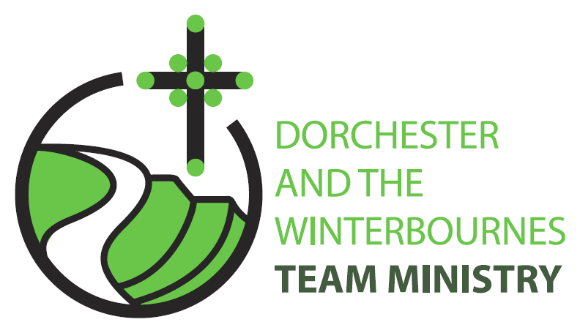

Trinity 1
7th June 2026

Welcome to this service in the Ordinary Season. We rejoice today in God’s forgiveness and unconditional love; shown in the mercy Jesus extends to Matthew and an unknown woman. We pray that we in turn might bring others to find solace in God’s love. So, we look out at our broken world and continue to pray for communities afflicted by war and for the continued peace processes in Iran and Israel and Ukraine.

Collect
God of truth,
help us to keep your law of love
and to walk in ways of wisdom,
that we may find true life
in Jesus Christ your Son.
All: Amen

Reading: Hosea 5:15-6.6

I will return again to my place
until they acknowledge their guilt and seek my face.
In their distress they will beg my favour:
‘Come, let us return to the Lord;
for it is he who has torn, and he will heal us;
he has struck down, and he will bind us up.
² After two days he will revive us;
on the third day he will raise us up,
that we may live before him.
³ Let us know, let us press on to know the Lord;
his appearing is as sure as the dawn;
he will come to us like the showers,
like the spring rains that water the earth.’
⁴ What shall I do with you, O Ephraim?
What shall I do with you, O Judah?
Your love is like a morning cloud,
like the dew that goes away early.
⁵ Therefore I have hewn them by the prophets,
I have killed them by the words of my mouth,
and my judgement goes forth as the light.
⁶ For I desire steadfast love and not sacrifice,
the knowledge of God rather than burnt-offerings.

This is the word of the Lord.
All: Thanks be to God.

Gospel Reading: Matthew 9: 9-13,18-26

Hear the Gospel of our Lord Jesus Christ according to Matthew.
All: Glory to you, O Lord.

⁹ As Jesus was walking along, he saw a man called Matthew sitting at the tax booth; and he said to him, ‘Follow me.’ And he got up and followed him.
¹⁰ And as he sat at dinner in the house, many tax-collectors and sinners came and were sitting with him and his disciples. ¹¹ When the Pharisees saw this, they said to his disciples, ‘Why does your teacher eat with tax-collectors and sinners?’ ¹² But when he heard this, he said, ‘Those who are well have no need of a physician, but those who are sick. ¹³ Go and learn what this means, “I desire mercy, not sacrifice.” For I have come to call not the righteous but sinners.’

¹⁸ While he was saying these things to them, suddenly a leader of the synagogue came in and knelt before him, saying, ‘My daughter has just died; but come and lay your hand on her, and she will live.’ ¹⁹ And Jesus got up and followed him, with his disciples. ²⁰ Then suddenly a woman who had been suffering from haemorrhages for twelve years came up behind him and touched the fringe of his cloak, ²¹ for she said to herself, ‘If I only touch his cloak, I will be made well.’ ²² Jesus turned, and seeing her he said, ‘Take heart, daughter; your faith has made you well.’ And instantly the woman was made well. ²³ When Jesus came to the leader’s house and saw the flute-players and the crowd making a commotion, ²⁴ he said, ‘Go away; for the girl is not dead but sleeping.’ And they laughed at him. ²⁵ But when the crowd had been put outside, he went in and took her by the hand, and the girl got up. ²⁶ And the report of this spread throughout that district.

This is the Gospel of the Lord.
All: Praise to you, O Christ.

Post Communion Prayer
Eternal Father,
we thank you for nourishing us
with these heavenly gifts:
may our communion strengthen us in faith,
build us up in hope,
and make us grow in love;
for the sake of Jesus Christ our Lord.
All: Amen

NOTICES:
Fundraising event for The Winterbourne Valley Churches: 14th June
A Message from Tom Webb “This is a "save the date" notice for the 14th June.
Phil and Roelie Newman are opening their garden in Martinstown as part of the National Garden Scheme. The scheme itself raises money for a cancer charity but they have expressed a willingness that we provide, tea, coffee, cake, sausage rolls and other refreshments of our choosing to raise money for the valley churches.
Closer to the time I will be seeking 🙂....
- Cake and sausage roll donations for delivery on the 13th June.
- Volunteers to man/woman the stand on the day.
Best wishes, Tom Webb

PRAYERS FOR THE WEEK
Almighty God, we ask you guide your Church especially when differences amongst people in our towns and cities seem to threaten our life together. In these troubled times we are tempted to make "an other" of one another. Help us now to look again, to see Jesus in the face of everyone we meet

Creator God, we are part of the tensions and injustices of the world: heal the resentment between people and intervene in the world’s conflicts. Help us to walk humbly with you at our side; take from us hard words and the cynical look. Let us be to others as we would wish them to be to us and, when we fail, forgive us and when they fail, heal us.

Caring God, we pray for all those who are afflicted by physical, emotional or mental illness. Help them to keep their eyes fixed on you, and give them the courage to face the trials and temptations that may come. Especially we pray for Bruce Robertson and Maggie, Andreas, Clare Rootham, Mandy Reed, John Reed, Di Honeybun, Margaret and Baby Wren

Holy God, your love reaches beyond the grave. At the end of our days on earth be with us and with those we love and with those whom we love and have gone before us. We pray now for those who have recently died and those bereaved by their passing; for Malcolm Mitchell and Marjorie Duckworth who have died recently and for those whose year’s mind occurs this month we pray for: Roger Axford, Brian Thompson, Phyllis Dight, Pamela Crumbleholme, and Alistair Ball

