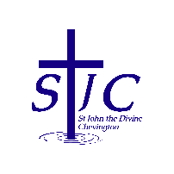
St John the Divine Welcome to our service today
Chevington 7th June 2026
First Sunday after Trinity

What’s on  = . = . = . = . = . = . = . = . = . = . = . = . = . = . = . = . = . = . = .  PCC meeting today  Our PCC meets this morning after our worship.  You are welcome to stay for a coffee as usual, but PCC members please gather promptly in the kitchen to get the meeting underway.  = . = . = . = . = . = . = . = . = . = . = . = . = . = . = . = . = . = . = .  Summer Fair – June 27th  Our Summer Fair will be from 10am on Saturday June 27th in the Community Centre.  We need raffle and tombola prizes and bottles please.  You can leave items in the church kitchen or bring them to the Community Centre on Friday June 26th after 3pm when we will be setting up.  Please can you also let Sheila know if you’re able to help at all on the day – manning a stall, selling raffle tickets, etc.  Thank you!  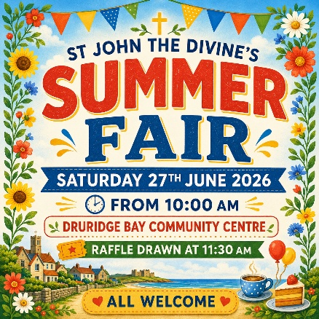 |  | St Cuthbert’s Mothers Union  Have a bring and share lunch on Wednesday June 10th at 12 noon, with the Warkworth Singers entertaining at 1pm.  14 Leslie Drive, Amble, NE65 0PX (the home of Penny and Colin Horseman).  Please let Penny know if you are planning to go so she can make sure there are enough chairs.  = . = . = . = . = . = . = . = . = . = . = . = . = . = . = . = . = . = . =  Coquet Churches Together – Popup Praise  Sunday 19th July.  Speak to Sheila if you’d like to get involved as CCT are looking for poems, readings or other contributions; hoping someone from St John’s might be willing to take part.  = . = . = . = . = . = . = . = . = . = . = . = . = . = . = . = . = . = . =  This week, we remember  We pray this week for all those who live in Bondicar Road, Hedgehope Crescent and The Parks, those who manage our Community Centre and everyone who uses it.  And from our memorial book  = . = . = . = . = . = . = . = . = . = . = . = . = . = . = . = . = . = . =  Church contacts  Priest in charge Revd Rachael Dines - 07763 211901  Churchwarden Sheila Orgill (also Parish Safeguarding Officer) – 07484 825203  Reader Cynthia Bishop – 07498 182350
  Sunday June 7th  9:00am Holy Communion  10:30am Holy Communion | St Cuthbert’s  St John’s
  Sunday June 7th  11:30am PCC | St John’s
  Wednesday June 10th  12 noon Mothers Union lunch | Amble – see notice below
  Wednesday June 10th  7:00pm Bingo | Druridge Bay Community Centre
  Sunday June 14th  9:00am Holy Communion  10:30am Holy Communion | St Cuthbert’s  St John’s
  George | Bates | 1917
  Janet | Clarkson | 2000
  Dixon | Donkin | 1917
  Jack | Dunn | 1995
  Thomas | Edwards | 1917
  Henry | English | 1979
  Annie | Hunt | 2008
  Ralph | Leightley | 1942
  Evelyn | Lennon | 1996
  Mark Lowthian | Nicholls | 2022
  Alexander | Robinson | 1915
  Kathleen | Russell | 2020
  George | Smith | 1941
  Frances Mary | Taylor | 1990
  John | Whinham | 1941

