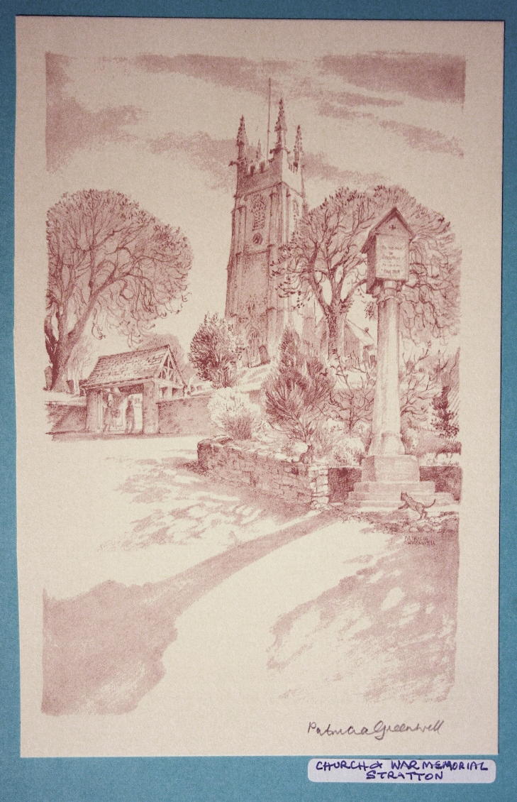 | The Parish Church  of St Andrew, Stratton  Priest in Charge  The Revd Teresa Folland  Tel: 01288 352599  e-mail: revteresa.folland@gmail.com  Churchwarden  Mrs Diana Ohlson  Tel: 01288 354441  e-mail: dohlson24@gmail.com
July 2026

Eternal God, teach us, though our destination lies beyond this world, to celebrate the journey of life, recognising the innumerable ways it can fill us with joy, touch us with wonder and move us to gratitude. Save us from being so full of heaven that we lose sight of earth, from dwelling so much on joys to come that we close our eyes to blessings now. You offer life in all its fullness. Teach us to live it now. Amen.

Nick Fawcett

Services at St Andrew’s July 2026

Wed  1st | Christian Meditation 9.30am  Midweek Mass Wed. 10.30am – Officiant: Rev Jane Bradbury
Sun  5th | 5th Sunday after Trinity  Readings: Zechariah 9:9-12; Psalm 145:8-15; Romans 7:15-25a; Matthew 11:16-19, 25-end.  Morning Worship 9.30am – LWLs  Evensong 4pm with Val Barker Cantor: Dafydd Thomas  Psalm: 56 or 57  Readings: 2 Sam 2:1-11; 3:1 Luke 18:31 – 19:10 Reader: Simon Waring
Wed  8th | Christian Meditation 9.30am Midweek Mass Wed. 10.30am – Officiant: Rev Doug Adams
Sun  12th | 6th Sunday after Trinity  Readings: Isaiah 55:10-13; Psalm 65 [or 8-end]; Romans 8:1-11; Matthew 13:1-9, 18-23.  Parish Mass with Baptism 10.00am (Joint with Launcells) Officiant: Rev Richard Ward-Smith
Wed  15th | Christian Meditation 9.30am  Midweek Mass Wed. 10.30am – Officiant: Rev Richard Ward-Smith
Sun  19th | 7th Sunday after Trinity  Readings: Wisdom 12:13, 16-19 or Isaiah 44:6-8; Ps 86:11-end; Rom 8:12-25; Matt 13:24-30, 36-43  Morning Worship 9.30am – LWLs Judy Dunne & Val Hopper  Service of the Word 4pm in Celebration of the East Window Conservation & the Restoration Work in the Belfry. Officiant: Bishop David Williams with Rev Teresa, Val Barker and Sheila Waring.
Wed  22nd | Christian Meditation 9.30am  Midweek Mass Wed. 10.30am – Officiant: Rev Teresa Folland
Sun  26th | 8th Sunday After Trinity  Readings: 1 Kings 3:5-12; Psalm 119:129-136; Romans 8:26-end; Matthew 13:31-33, 44-52.  Parish Mass 9.30am – Officiant: Rev Doug Adams
Wed  29th | Christian Meditation 9.30am  Midweek Mass Wed. 10.30am – Officiant: Rev Jane Bradbury
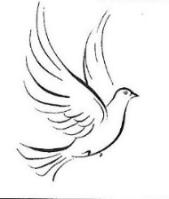
FROM THE PARISH REGISTERS 2026

Wedding at St Andrew’s on 20th June 2026

Brandon MEAGAN and Rebekah GLIDDON

Dates for your diary
Thurs 2nd July | Pastoral Meeting 10.30am at 6 Drovers Way
Mon 6th July | There is not going to be a M U Branch Meeting today
Sat 11th July - Sun 19th July | “One Week in Summer” St Andrew’s Music and Arts Festival
Sat 11th July | “Wayward Winds” 7.30pm Concert in the Church Tickets £15 in advance £20 on the door Under 18s Free
Sun 12th July | Open Gardens 2pm – 5pm Tickets £5 Under 18s Free Strawberry Teas in Church Adults £5 Under 12s £2.50
Mon 13th July | Bude Youth Orchestra & Choir at 6pm in the Church Tickets £5 Under 18s Free
Wed 15th July | ‘Music from the Temperate Trio’, piano, violin and double bass with High Tea. Tickets in advance only – Adults £15 Under 12s £5
Thurs 16th July | 10am closing date for entries to the children’s art and poetry competitions
Fri 17th & Sat 18th July | 10am – 4pm Art and Craft exhibition in the Church. Free Entry. (Competition entries will be on display).
Sun 19th July | Morning Worship 9.30am Service of Celebration 4pm with the Bishop of Truro ‘Last Night of the Festival’ concert at 7.30pm in Church with Hartland Chamber Orchestra. Tickets £15 in advance £20 on the door Under 18s Free
Thurs 30th July | Drop-in Coffee Morning 10am to 12md at St Andrew’s
St Andrews News

Our second car boot sale was held on June 14th. It was hot in the sun but we were able to sell all our cakes, and raise a good £250 from the tombola and lucky dip, including a very welcome donation.

Our third sale is on July 5th, so please keep collecting items for the tombola and leave them in the box at church. Thank you. Judy

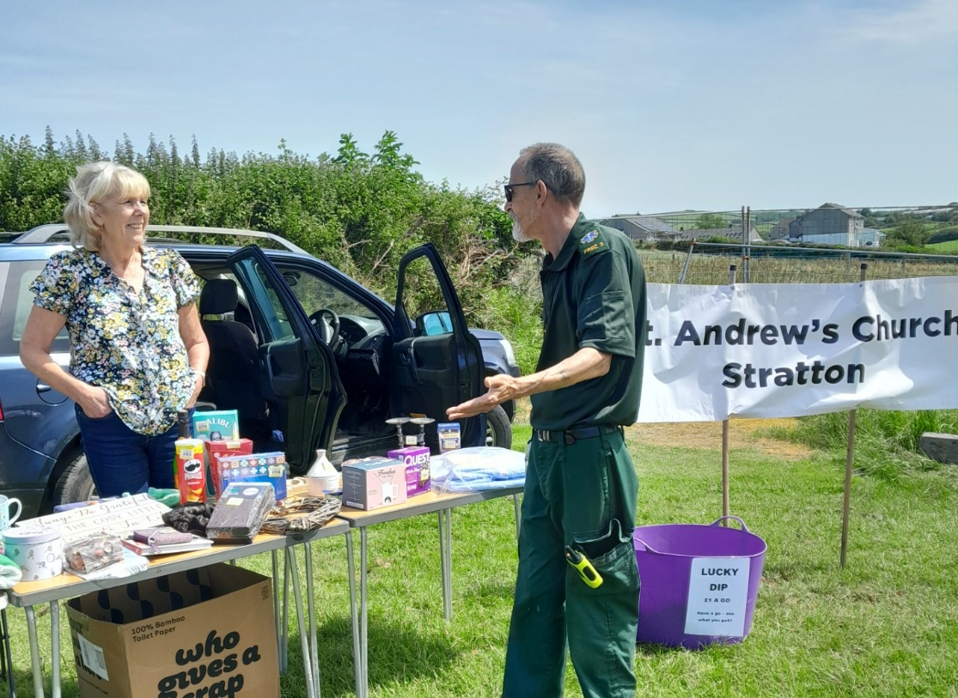

The Flower Festival

We now have the final total raised during the flower festival, a wonderful £2987.72. Thank you to everyone who visited the festival over the bank holiday, your generosity is greatly appreciated and thank you to all those who worked so hard to make it all happen.
“One Week in Summer” – See you there??
Tickets are available and selling well for the events during the week of 11th - 19th July. There are concerts, open gardens, strawberry teas, art and craft exhibitions, and a special high tea so something for everyone. Tickets are cheaper bought in advance and for the high tea must be purchased in advance to aid catering. Brochures are available in church giving all the details. Tickets are available from Stratton Stores, Val on 01288 353435 or Jennie on 01288 359601. Please support this new venture in fundraising as well as providing events in a beautiful building for all to enjoy. (All details on page 6)

Mothers’ Union – Kledh Kernow Branch
In this ever-turbulent world, our branch meeting for June focused on peace. We came together holding our families, friends, local communities and the world in prayer for calm and understanding in uncertain times. Our prayers asked for peace throughout the world, in our communities, our families, friends and within ourselves. We followed this time of worship with a fun quiz and lots of laughter. Also, in June some members of the branch travelled to Truro for the Members Open Afternoon in the Cathedral. We met up with MU members from across the county and listened to an informative talk on cyber-crime protection. A member of the Devon and Cornwall police passed on some very interesting facts and ways in which people can feel safer on the internet. We have been promised a summary of the talk which I will pass on to members.
July Dates Please note there will be no meeting in July as our fundraising cream tea was on the 29th June. The next branch meeting will be on August 3rd at Stamford House, Stamford Hill 2pm when we will have a celebration of Mary Sumner Day.
Mothers’ Union Diocesan Quiet Day 23rd July 10.30am – 3.30pm at St Endellion’s Church, St Endellion. The Theme this year is ‘Hidden Treasure’ led by our MU Chaplain Rev Niki Farr. The day will end with a cream tea followed by Evensong. Please bring a packed lunch. All welcome.
“One Week in Summer”
Festival of Music and Art
11th-19th July 2026
St Andrew’s Church, Stratton EX23 9DP

Sat 11th 7.30pm ‘Wayward Winds’
a programme of light music and tuneful classics
Tickets £15 in advance £20 on the door
Sun 12th 2-4pm 5 Stratton Open Gardens £5
Strawberry tea in church £5
Mon 13th 6pm Bude Youth Orchestra & Choir
A chance to hear and support the very promising talent of our local young people. Tickets £5
Wed 15th 5–7pm High Tea with ‘Temperate Trio’
Enjoy a sumptuous high tea with musical entertainment.
Tickets £15 in advance only
Fri 17th& Sat 18th 10-4 Arts & Crafts Exhibition
with winners announced for the children’s art & poetry competitions at 3pm Saturday
Local artists and craft makers exhibiting their work to inspire you to get creative!
Sun 19th 4pm Festival service with Bishop David
to bless the restored East Window and Bells
Sun 19th 7.30pm ‘Last Night of the Festival’
Hartland Chamber Orchestra - a programme of music you will recognise! Tickets £15 in advance £20 on the door

Refreshments at all events.
Tickets in advance from Church members, Stratton Stores,
Jennie 01288 359601, Val 01288 353435

For the month of July 2026
We remember in our prayers all those living in:
Week beginning:
Sunday 5th | Bridge Street, Union Hill & Bowden
Sunday 12th | Poundfield Lane, Hospital Road, Ward Close
Sunday 19th | St Martins Road, St Peters Road, Gladwell Gardens & Binhamy Lane
Sunday 26th | St Andrews Road, St Michaels Road, St Olafs Road

Those who have asked for our prayers:
Allan Gouldson, Molly Hooper, Karen Hunting, Mick Carter, Gloria Braund.

We bring before God, especially at this time, all who work in our local hospitals, the inpatients and all undergoing investigations and outpatient treatment. We remember too those of our church family who are ill at home or housebound.

The recently departed. May they rest in peace and rise in glory.

For the month of July 2026
Those in our Year’s Mind:
Week beginning:
Sunday 5th | Angela Fanghanel, Vera Middle, Pat Blair, Gweneth Richardson, Barry Aust, Russell Hopgood, Terence Meill, Kathleen Dinner, Dorothea Hare, William Johns, Allan Kidby
Sunday 12th | Tracey Perkins, Beryl Curtis, Cyril Davis, Marcus Davey, Gilbert Stuttaford, Wendy Seymour, Shirley Yeo, Joan Gurney, Dorothy Burley, George Bowden,
Sunday 19th | Shirley Walter, Gladys Day, Jasmine Thompson, Timothy Ellis, Robert Hill, Christopher Holwill, Marion Dymond
Sunday 26th | Ronald Troop, May Gorman, Joyce Manning

Don’t Forget

The Right Reverend David Williams, Bishop of Truro, will be coming to Stratton on July 19th when we have planned a service of thanksgiving in celebration of the conserved East Window and the restored Bells. Both will be blessed by Bishop David during the service.

Come along and join us for the service and then refreshments

after. Everyone is welcome.

News Sheet Editors:
Val Barker Tel: 01288 353435 and Sheila Waring Tel: 01288 714338

If you have anything for inclusion in the next news sheet please send it to the editors by the 10th of the month.

Please submit all documents in Calibri (Body) Font, size 12. Thank you.

