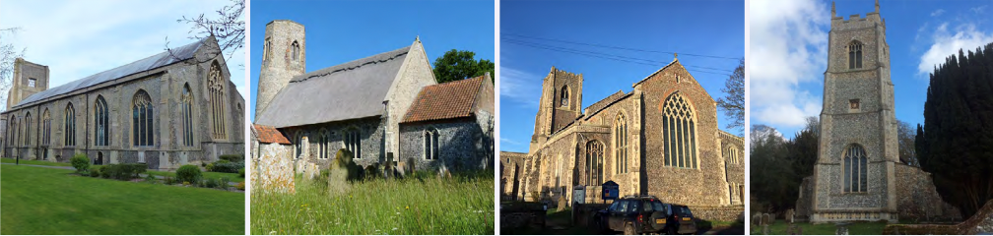

N.E.W.
North Walsham
Edingthorpe
Worstead and Westwick
NEWS
The Magazine for the North Walsham Benefice July and August 2026 40p
Transformed by Christ: Prayerful, Pastoral, Prophetic

Editor’s Bit

Contents in this issue:
- Vicar’s Page
- From the assistant curate
- Dates from the Diary
- July and August 2026 service Dates
- Upcoming Events

We hope to see you at our services; you are all welcome.

Please note the date for items to go in the September edition of NEWS needs to be at the Parish office by 20th August 2026 latest.

This magazine is published by the North Walsham Benefice. We reserve the right to edit or decline any material submitted for publication. While reasonable efforts are made to ensure that the contents of the magazine are accurate, no responsibility can be taken for errors and omissions or changes after publication. The material printed does not necessarily represent the views of the Benefice. In accepting advertisements for publication, no recommendation of products or services is implied and we cannot accept responsibility for any unsatisfactory transactions.

Financial Information

Please may we remind you, that if you are giving us a cheque for any of the Churches, they need to be made payable to the following:
St Nicholas’ Church – North Walsham PCC
All Saints’ – Edingthorpe PCC
St Mary’s – Worstead PCC
St Botolph’s – Diocesan Churches Trust
Please may we ask if you are sending any payments to us via an online service that you put a meaningful reference on the payment to ensure we know where the payment should go to.

Live-streamed services are available on YouTube - please search St Nicholas North Walsham. Do you participate in our live-streamed services - we would love to hear your feedback: contact David on 07506 723946 or davidnorthwalsham@gmail.com

If you are considering a change to your Committed Giving for St. Nicholas, please inform Chris Sherman (Committed Giving Officer)
Please support St. Nicholas Church, North Walsham on #easyfundraising, you can raise FREE donations when you shop online with over 5,000 retailers. It is simple and only takes 2 minutes to sign up! Plus, once you have raised your first £15, easy fundraising will match it!
Sign up now: https://www.easyfundraising.org.uk/causes/stnicholaschurchnw/

The Vicar’s page:
July dawns, and the church has new priests and we have another two years to enjoy with Dan as our curate, now ordained a priest himself. Those who attended his ordination, and first celebration of the Eucharist will have been moved by Dan's prayerfulness, preparation, and concentration on what really matters: service to the church and to our communities.

In the old days, once a Curate was priested the Vicar would go on long holidays and leave them to it, while the Curate carried on in their name. Not so here (however tempted I might be!). We're continuing to build our ministry and outreach across the communities we serve, with regular visits to all of our care homes, visits to people with Holy Communion, supporting our schools, youth organisations, Churches Together, our veterans and arranging events and worship to give thanks, to lament, and to look forward in hope. In recent months, the Toddler group we've taken over has built its attendance and we have more than 35 families registered!. That's only possible with energy and commitment, and it doesn't all happen because one or two do it all, but as a committed team effort: the continuing fundraising efforts by folk at Edingthorpe and Worstead are a huge testament to this.

We give continued thanks to God for the gift that Dan is, and we look forward to the rest of his time with us. We rejoice with him that his ordination means he finally stands before us as that which God called him to be: a priest of the new covenant, and a steward of the mysteries of Christ.

Have a good summer, wherever it takes you, or if you're staying at home - July and August offer times of rest and refreshment, as well as times of joy and celebration: enjoy!

David


The Curate’s Page
‘Ye have not chosen me, but I have chosen you, and ordained you, that ye should go and bring forth fruit, and that your fruit should remain.’
On Saturday the 27th day of June the year of Our Lord 2026 something happened, something that I’ve been preparing for since I can remember. By the grace of God, following His call to this sacred ministry, I’ve been ordained a Priest. It is most common knowledge that those who want to be priest are most looking forward to celebrating the Eucharist. And it’s also most common knowledge that if this is your answer during your discernment process, you won’t go far.
But there is something very special and unique about the celebration of Holy Communion. Of course, the priest’s responsibility for the pastoral care of their flock, the management and care of the church and community and prayer both individual and corporal are of utmost importance. But for those of us, for whom like me, the Real Presence of Christ is most visible and tangible on the altar, the celebration of the Eucharist is the centre of my life as a Christian and now as a Priest.
This most beautiful gift of Real God, not felt by heart or mind or soul, but felt tangibly in the piece of bread, is the closest and most beautiful thing to our God, whom we will meet face to face when we die.
And so being able to invite people to this extraordinary meal, to be able to be the steward of this Most Holy and Sacred Mysteries of our faith, is the most important responsibility and the most fantastic gift I could have ever received. This is the fruit which we all bear and I pray that this fruit may last until that time, when there is no more need for this celebration, because we will join together in the banquet in the presence of our Loving God, in His heavenly kingdom.
As always, I give thanks to God for this call, for all of you and reassure you of my thoughts and prayers now and into our future together.
God bless, Dan

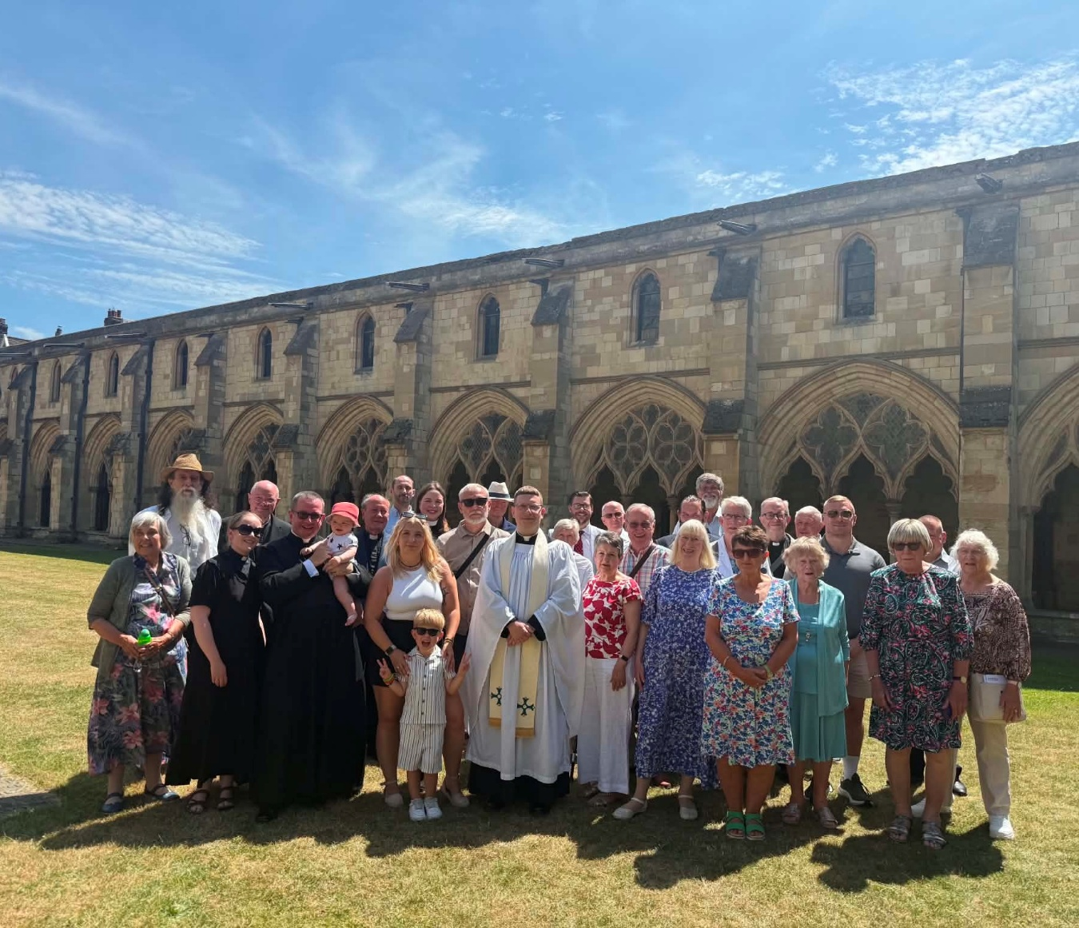
Norwich Cathedral cloister post ordination – Saturday 27th June

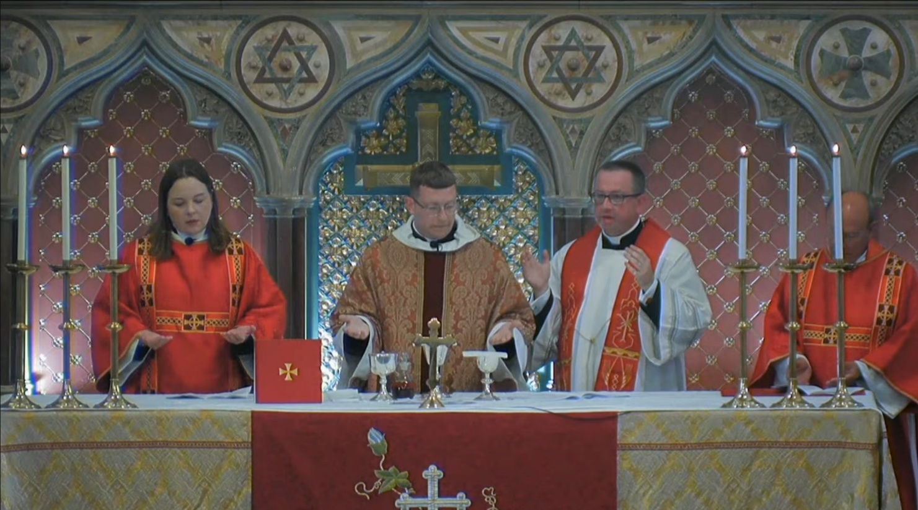
Dan celebrating for the first time – Sunday 28th June

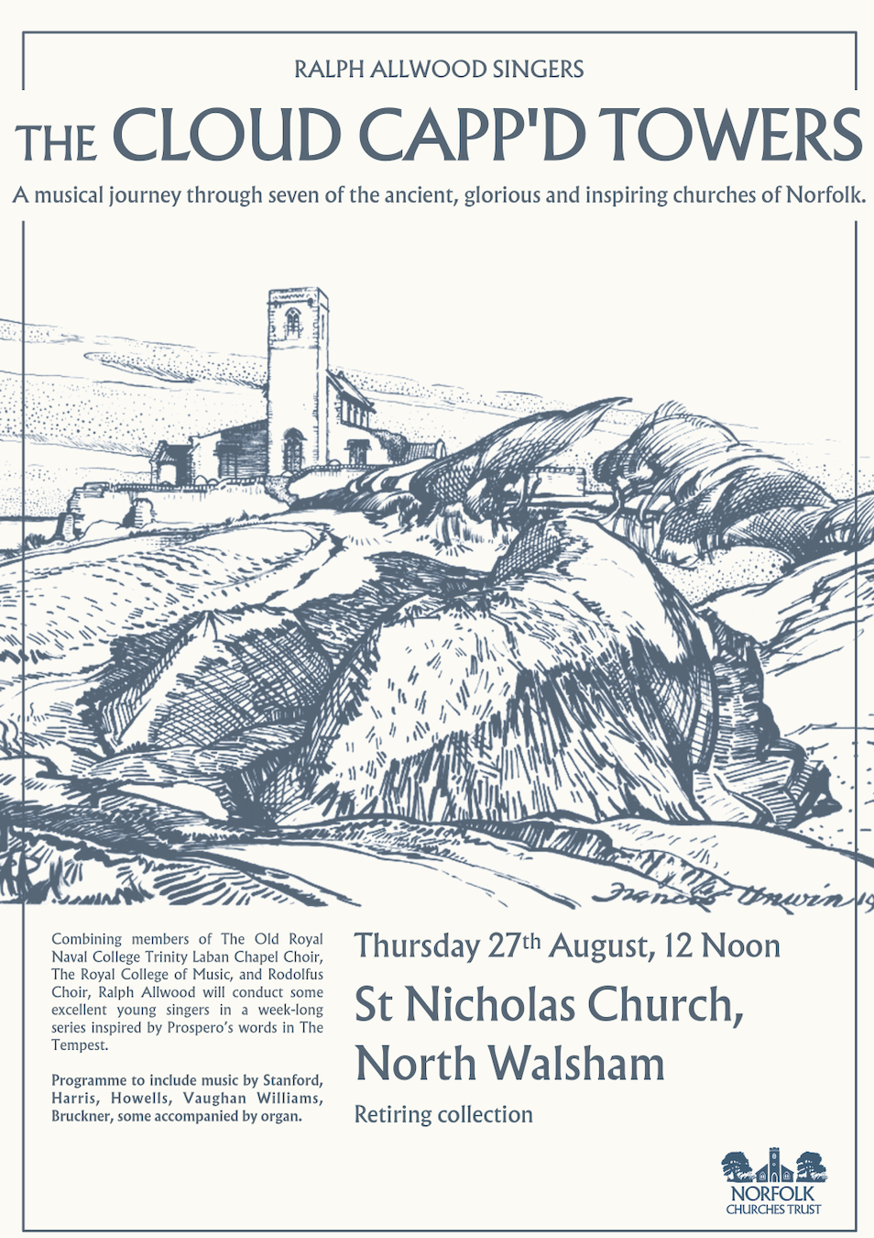
Care Home Ministry

Over the past month, we've added regular visits to Furze Hill to our monthly round of Home Communions and visits to care homes - we now visit all the care homes of the benefice on a regular basis, and alongside our Pastoral Assistants we're doing what we can to support residents, staff and families.

Over recent weeks Dan and I have attended many 'end of life' visits - these are times of intense beauty as we gather around a bedside with staff and families, to hold someone in prayer and to bid them farewell, fortified and uplifted by the Rites of the Church. In death as in life, the Church draws around those we are called to care for, pray for, and love in Christ's name.

I'm struck by the commitment of care home and hospital staff to ensure that a person's wishes are honoured, and that visits are made - my 'phone is always on, and we'll do what we can to get there when needed.

This ministry isn't perhaps glamorous, and these often aren't folk who will ever come to church, but on average we see around 40 people a month for Holy Communion - that's another medium sized congregation on top of those who worship in our churches. This ministry to those who may have given their lives to service and the Gospel, is what we're really called to do, and it is a huge privilege.

Please pray for all in our care homes, the staff, residents and families, and for God's mission, and our duty in these places.

All Saints Church, Edingthorpe

12th July. 9.15am Holy Communion
26th July. 9.15am. Morning Prayer
2nd August 4 p.m. Blessings of the Graves
9th August 9.15am Holy Communion
23rd August 9.15am. Morning Prayer

Our thoughts and prayers are with the family and friends of Christina (Chris) Plum who passed away recently. Chris helped us with the raffle at our Christmas Coffee morning for several years.
We would like to thank all who attended the Quiz and making it such an enjoyable but challenging evening.
18th July at 6pm is our Summer Concert with Jane Everard and Joseph Ballard followed by refreshments. This is always a very popular evening. Tickets are £12.50 and are available from Chris Martin 07787561850 or wardenallsaints@gmail.com or June Hannant 01592 402337.
19th July there is a Bug Hunt at the Church from 10.30am to 3pm. Several activities include helping to build our bug hotel, painting a ladybird pebble and many more. Do come along with your families. Light refreshments available. This is a free event but donations welcomed to NWT, Butterfly Conservation and Buglife.
Dates for your diary;
2nd August at 4pm. Blessing of the Graves Service.
6th September at 4pm. Pet Service.
27th September at 11am Harvest Day followed by Harvest Service at 4pm.
All events and information about the Church are available on the website hhtps;//www.achurchnearyou.com/church/10076 or the village website
www.edingthorpe.village.org.uk.
June Hannant 01692 402337.

ST MARY’S, WORSTEAD

Well, Summer has certainly returned with a vengeance, not that we are complaining of course. What it does mean, thought, is that St Mary’s continues to be the coolest place, in every sense of the word!
Our newly-fitted kitchen is set to be redecorated in the next couple of weeks, well in time for the Festival. Then there’s the Porch Roof. A preliminary estimate has been obtained from the Diocesan Architect and an initial application for a grant towards the cost has been lodged with the Worstead Festival Committee.
Speaking of the Festival, planning is now in earnest, with a small band of cooks and bakers getting ready to supply our hundreds of anticipated visitors refreshed. If you can help to serve refreshments, in whatever way, we would love to hear from you. Talk to Sue, her contact details are inside the front cover.
You may have noticed that the grass in the Churchyard looks decidedly long, and a bit wild. We have too. Accordingly, representations have been made to NNDC who are responsible for its upkeep. They have assured us it will be cut on, or by, July 7th.
The life of the Church goes on. We have another three weddings scheduled for this Summer, namely, July 11th, July 30th and August 16th. We look forward to welcoming the Happy Couples on their special day.
Looking towards the Autumn, we are hoping to arrange a return visit by East Anglia’s Premier Brass Band, the Cawston Band, probably during October. An occasion not to be missed.
Dates for your diaries:
Sunday, 5th July - Morning Prayer at 9.15 am
Sunday, 19th July - Holy Communion at 9.15 am
Sunday, 2nd Aug - Morning Prayer at 9.15 am
Sunday, 16th Aug - Patronal Service at 10.30 am. Holy Communion and Confirmation.

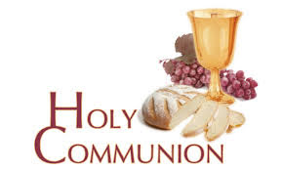
You may have read items in the press relating to the use of 'gluten free' wafers at Holy Communion - for those who require them, we use wafers which are approved and recommended for use by Coeliac UK - more information here. If you need a gluten free wafer, please advise the churchwardens/welcomers when you arrive for the service, and please indicate to the clergy distributing Holy Communion.
The Church teaches that receiving Holy Communion in both kinds (wafer and wine), or in one kind (the wafer or the wine) are acceptable and contain the fulness of the Sacrament. There are many reasons why this will be the case at different times in our lives, and there will be times when we cannot physically receive but join in an Act of Spiritual Communion (as those who watch online do - see below).

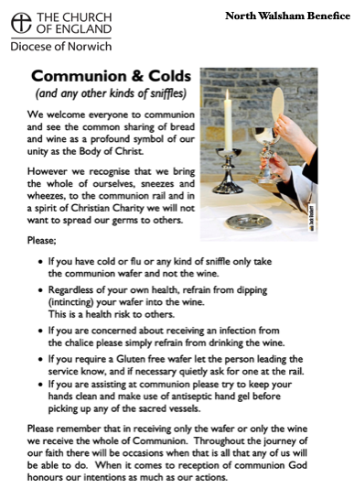
​Intinction (that is, dipping your wafer into the wine) is not permitted, both for hygiene reasons and because it might introduce gluten to the wine, which could be consumed by someone who is allergic to it.
If you wish to discuss any of this, please speak to David.

An Act of Spiritual Communion
In union, O Lord, with the faithful at every altar of your Church, where the Holy Eucharist is celebrated, I desire to offer you praise and thanksgiving. I present to you my soul and body with the earnest wish that I may always be united to you. And since I cannot now receive you sacramentally, I ask you to come spiritually into my heart.
I unite myself to you and embrace you with all the affections of my soul. Let nothing ever separate you from me. May I live and die in your love. Amen.



Why not come along to Sunday Kids and find out how to learn about what we do? We meet on the 1st and 3rd Sunday of the month at St Nicholas Church during the 10.30am service. You are most welcome.

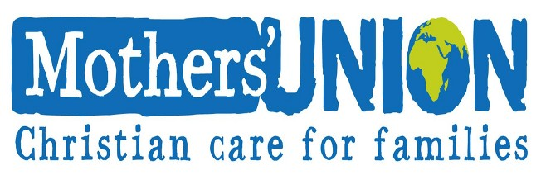

North Walsham Mothers’ Union. We meet in St Nicholas Room on the second Tuesday of the month at 2.00 p.m. Following a short act of worship and a few notices our speaker then takes the floor, after which, over tea and biscuits, there is an opportunity to ask questions and socialise. We usually finish about 3.30 pm.
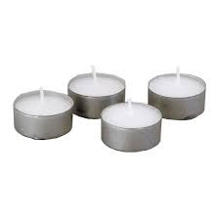
Thanks to all who’ve provided tealights for prayer stations at St Nicholas!
All donations of white, unscented tealights gratefully received!

Services and Events for July and August 2026

Wednesday 1st July
9am Morning Prayer at North Walsham

Thursday 2nd July
9am Morning Prayer at North Walsham
9.30am Market Day coffee morning in the St Nicholas Room
10.30am Holy Communion at North Walsham
1230pm Organ Recital at North Walsham

Friday 3rd July
9.30 – 11.30 am Cuddles and Catch Up in the St Benet Hall
Sunday 5th July – Trinity 6
8am Holy Communion (1662) at North Walsham
9.15am Morning Prayer at Worstead
10.30am Holy Communion at North Walsham
5pm Choral Evensong at North Walsham
Monday 6th July
9am Morning Prayer at North Walsham

Tuesday 7th July
9am Morning Prayer at North Walsham
Wednesday 8th July
9am Morning Prayer at North Walsham

Thursday 9th July
9am Morning Prayer at North Walsham
9.30am Market Day coffee morning in the St Nicholas Room
10.30am Holy Communion at North Walsham
1230pm Organ Recital at North Walsham

Friday 10th July
9.30 – 11.30 am Cuddles and Catch Up in the St Benet Hall
Sunday 12th July – Trinity 7
8am Holy Communion (1662) at North Walsham
9.15am Holy Communion at Edingthorpe
10.30am Holy Communion at North Walsham
Monday 13th July
9am Morning Prayer at North Walsham

Tuesday 14th July
9am Morning Prayer at North Walsham
2pm Mothers’ Union at North Walsham
Wednesday 15th July
9am Morning Prayer at North Walsham

Thursday 16th July
9am Morning Prayer at North Walsham
9.30am Market Day coffee morning in the St Nicholas Room
10.30am Holy Communion at North Walsham
1230pm Organ Recital at North Walsham

Friday 17th July
9am Morning Prayer at North Walsham
9.30 – 11.30 am Cuddles and Catch Up in the St Benet Hall
Sunday 19th July Trinity 8
8am Holy Communion (1662) at North Walsham
9.15am Holy Communion at Worstead
10.30am Holy Communion at North Walsham

Monday 20th July
9am Morning Prayer at North Walsham
Tuesday 21st July
9am Morning Prayer at North Walsham
Wednesday 22nd July
9am St Mary Magdalene: Holy Communion at North Walsham
10am Knitting group in St Nicholas
Thursday 23rd July
9am Morning Prayer at North Walsham
9.30am Market Day coffee morning in the St Nicholas Room
10.30am Holy Communion at North Walsham
1230pm Organ Recital at North Walsham
Friday 24th July
9am Morning Prayer at North Walsham
9.30am Quiet Prayer at North Walsham
Sunday 26th July – Trinity 9
8am Holy Communion (1662) at North Walsham
9.15am Morning Prayer at Edingthorpe
10.30am Holy Communion at North Walsham 4pm Songs of Praise at Worstead
Monday 27th July
9am Morning Prayer at North Walsham
Tuesday 28th July
9am Morning Prayer at North Walsham
Wednesday 29th July
9am Morning Prayer at North Walsham
Thursday 30th July
9am Morning Prayer at North Walsham
9.30am Market Day coffee morning in the St Nicholas Room
10.30am Holy Communion at North Walsham
1230pm Organ Recital at North Walsham

Friday 31st July
9am Morning Prayer at North Walsham
9.30am Quiet Prayer at North Walsham
Sunday 2nd August – Trinity 10
8am Holy Communion (1662) at North Walsham
9.15am Morning Prayer at Worstead
10.30am Holy Communion at North Walsham
4pm Blessings of the Graves at Edingthorpe
Monday 3rd August
9am Morning Prayer at North Walsham
Tuesday 4th August
9am Morning Prayer at North Walsham
Wednesday 5th August
9am Morning Prayer at North Walsham
10am Knitting group in St Nicholas
Thursday 6th August
9am Morning Prayer at North Walsham
9.30am Market Day coffee morning in the St Nicholas Room
10.30am Holy Communion at North Walsham
Friday 7th August
9am Morning Prayer at North Walsham
9.30am Quiet Prayer at North Walsham

Sunday 9th August – Trinity11
8pm Holy Communion at North Walsham
915 Holy Communion at Edingthorpe
1030 Holy Communion at North Walsham
Monday 10th August
9am Morning Prayer at North Walsham

Tuesday 11th August
9am Morning Prayer at North Walsham

Wednesday 12th August
9am Morning Prayer at North Walsham

Thursday 13th August
9am Morning Prayer at North Walsham
9.30am Market Day coffee morning in the St Nicholas Room
10.30am Holy Communion at North Walsham
Friday 14th August
9am Morning Prayer at North Walsham
9.30am Quiet Prayer at North Walsham
9.30 – 1130 am Cuddles and Catch Up in the St Benet Hall

Sunday 16th August – Trinity12
8am Holy Communion (1662) at North Walsham
10.30am Patronal Holy Communion and Confirmation at Worstead
Monday 17th August
9am Morning Prayer at North Walsham

Tuesday 18th August
9am Morning Prayer at North Walsham
Wednesday 19th August
9am Morning Prayer at North Walsham
10am Knitting group in St Nicholas
Thursday 20th August
9am Morning Prayer at North Walsham
9.30am Market Day coffee morning in the St Nicholas Room
10.30am Holy Communion at North Walsham
Friday 21st August
9am Morning Prayer at North Walsham
9.30am Quiet Prayer at North Walsham

Sunday 23rd August – Trinity13
8am Holy Communion (1662) at North Walsham
915am Morning Prayer at Edingthorpe
10.30am Holy Communion at North Walsham
Monday 24th August
9am Saint Bartholomew: Holy Communion at North Walsham

Tuesday 25th August
9am Morning Prayer at North Walsham

Wednesday 26th August
9am Morning Prayer at North Walsham

Thursday 27th August
9am Morning Prayer at North Walsham
9.30am Market Day coffee morning in the St Nicholas Room
10.30am Holy Communion at North Walsham
Friday 28th August
9am Morning Prayer at North Walsham
9.30am Quiet Prayer at North Walsham

Sunday 30th August – Trinity14
8am Holy Communion (1662) at North Walsham
10.30am Holy Communion at North Walsham
Each week, the 10.30am service on Sundays, and 9am Morning Prayer Mon-Fri are live-streamed to YouTube - click link below or search 'St Nicholas North Walsham’
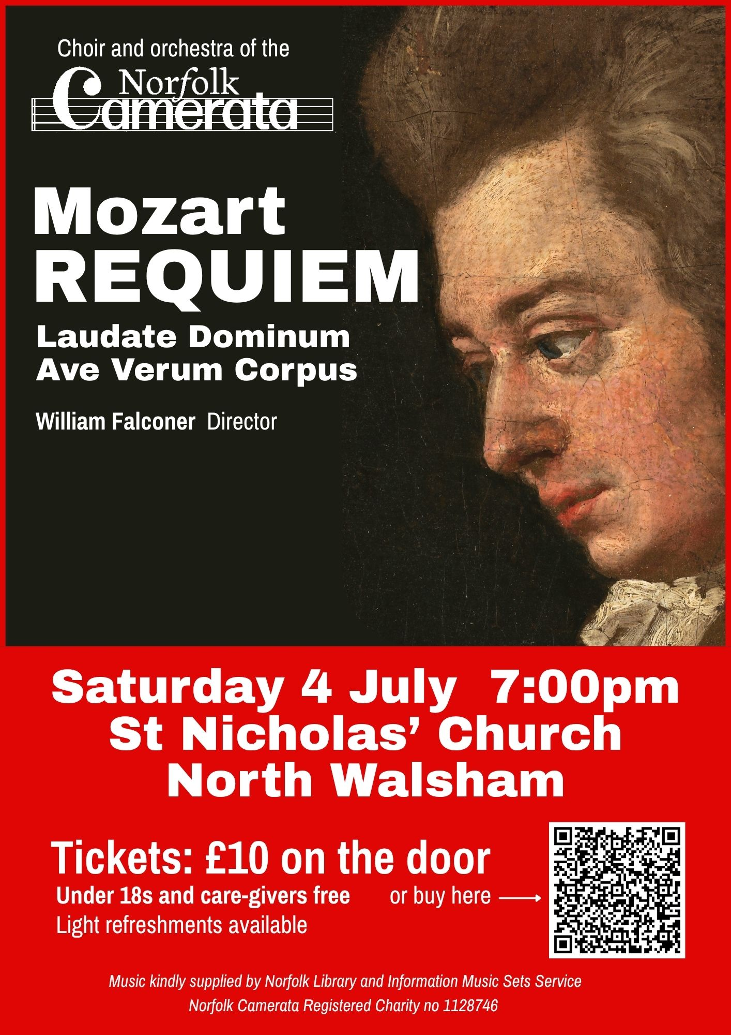

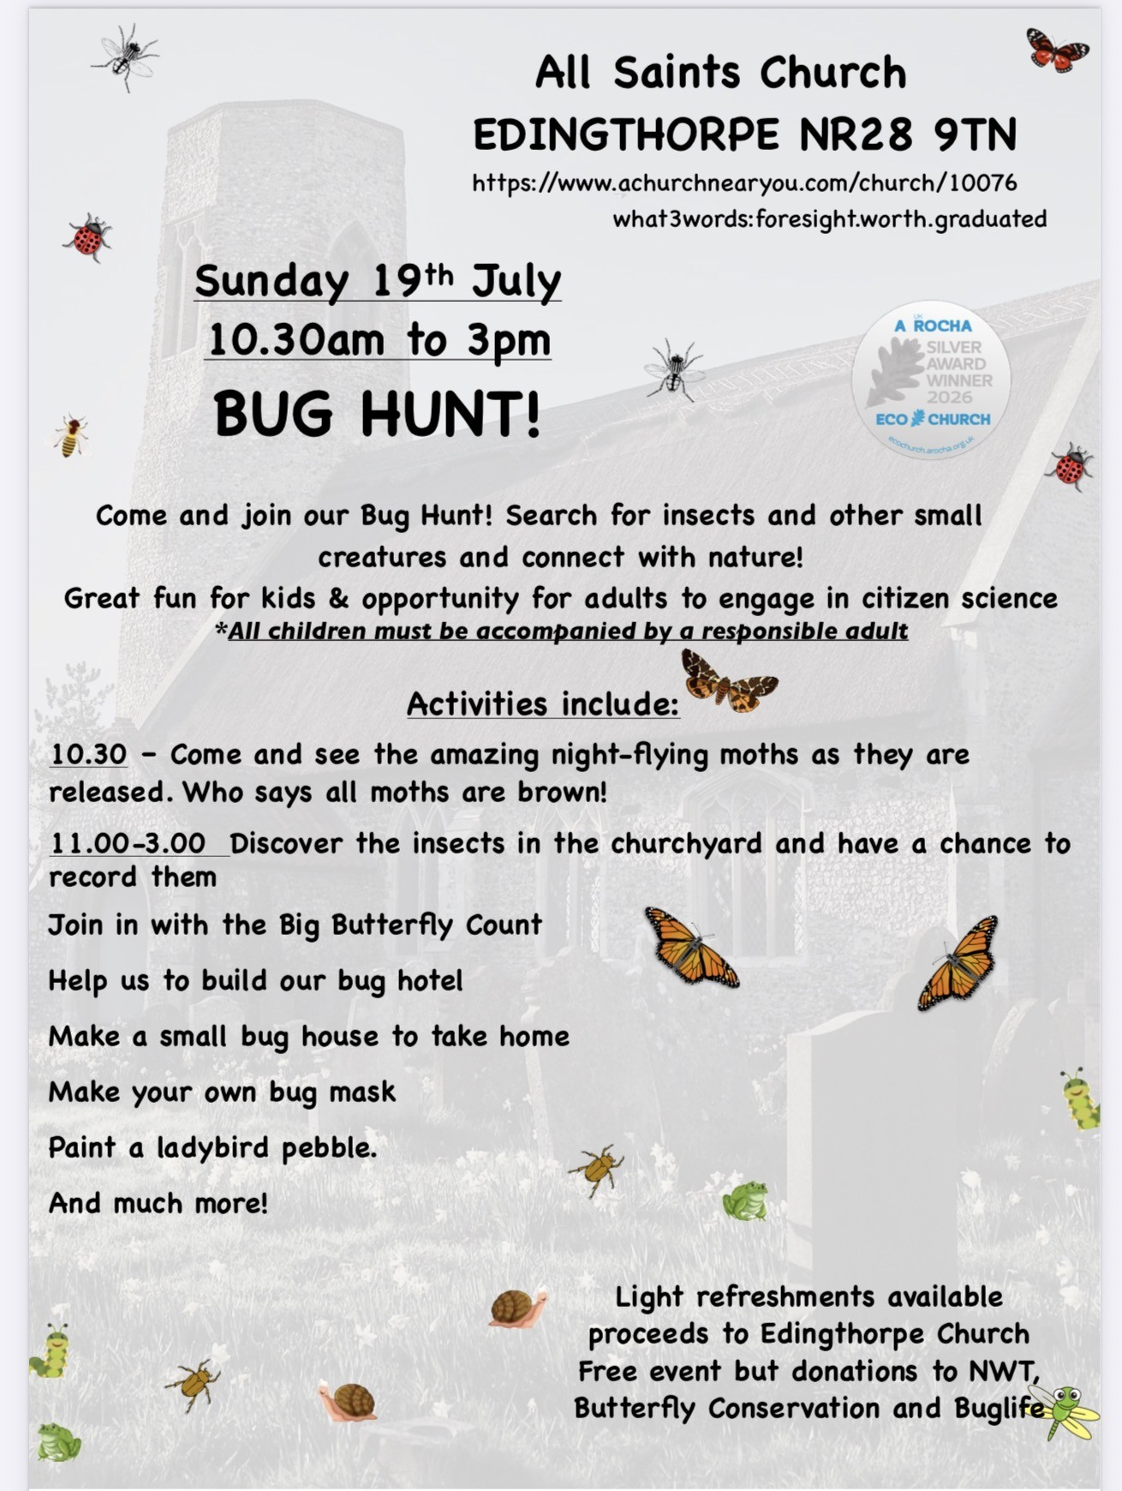

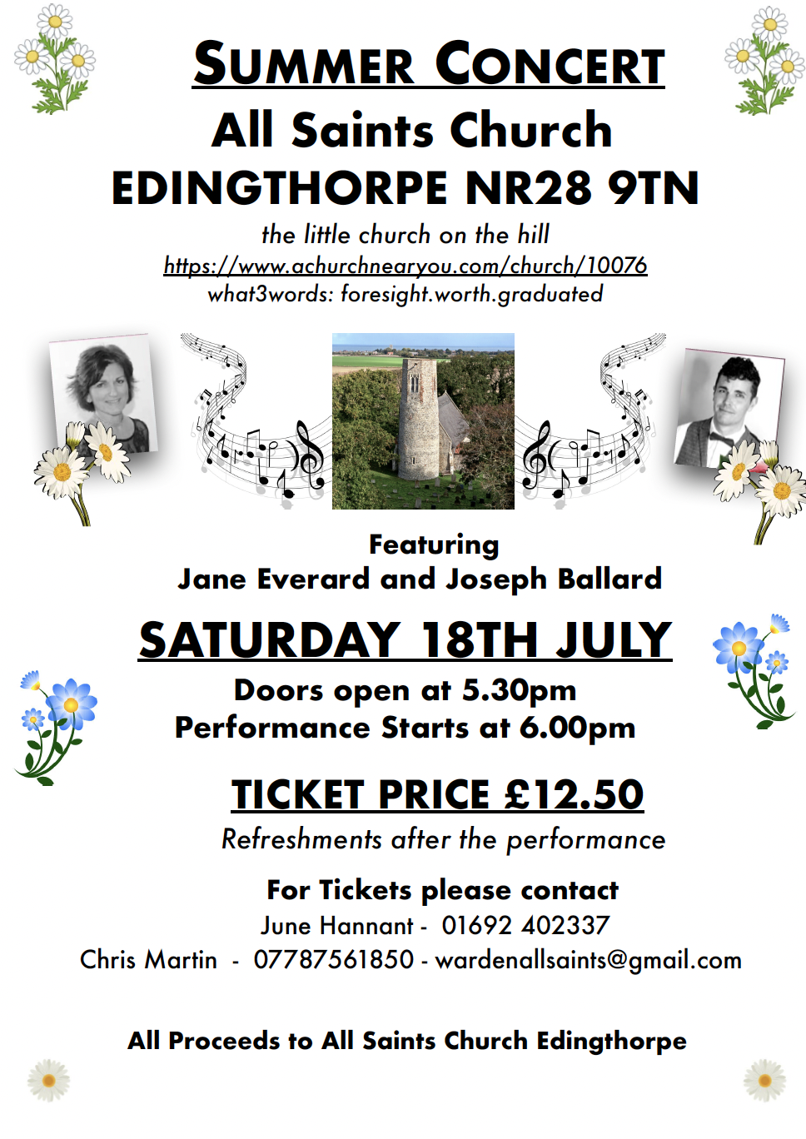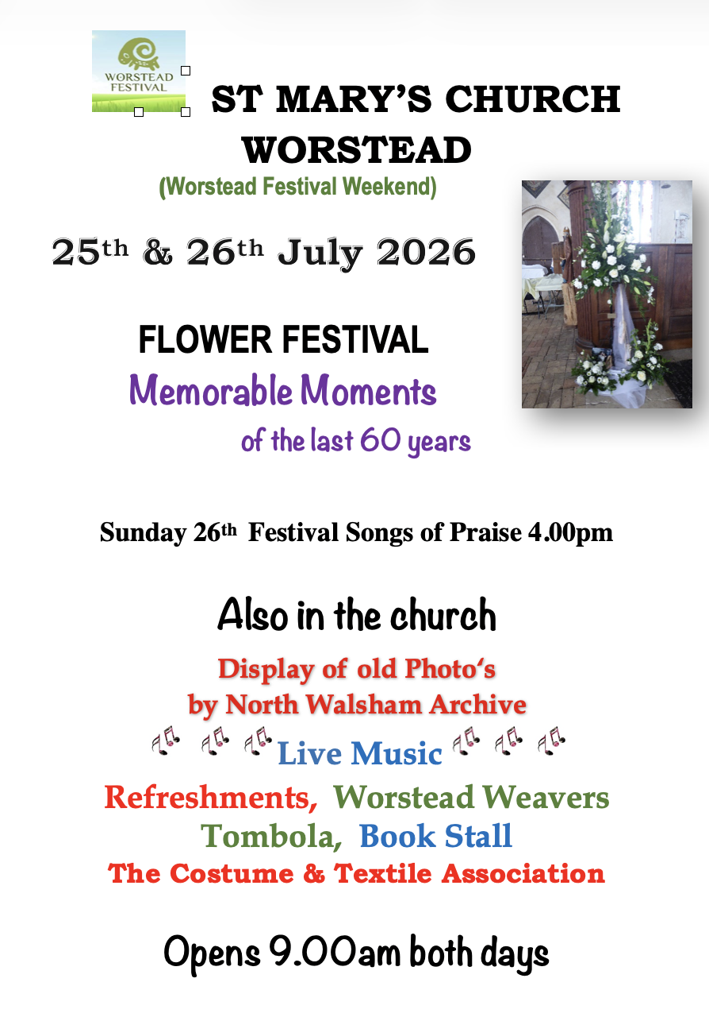


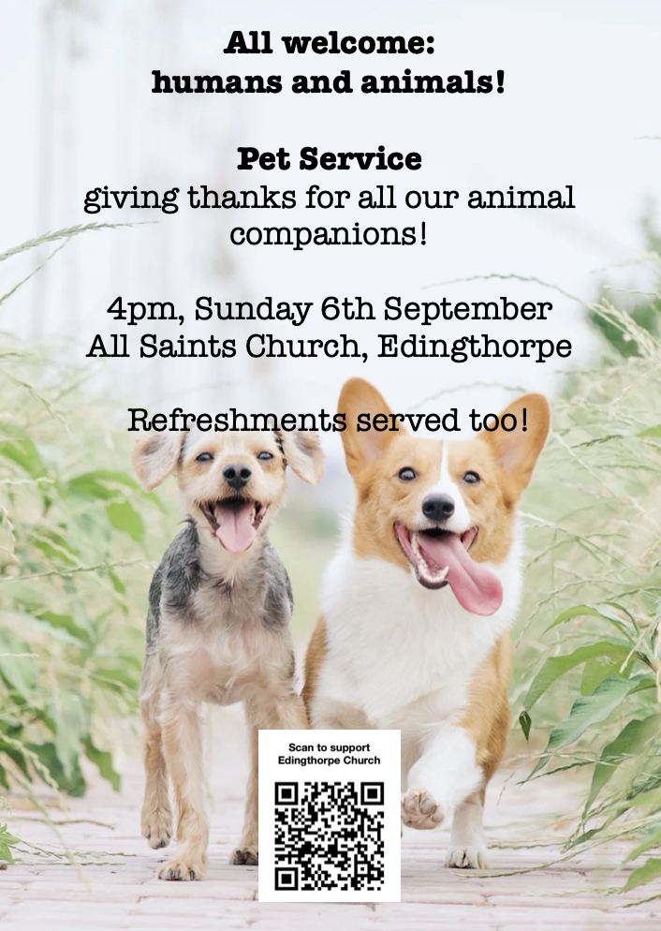

We are privileged to hold special
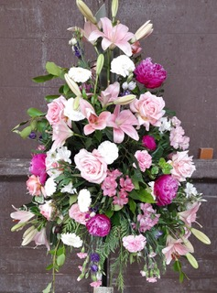
services at any of our churches
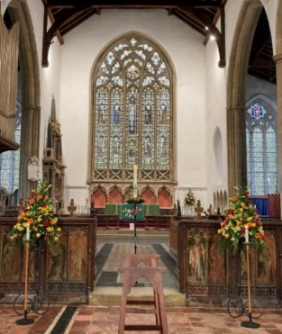
All who live in the benefice are entitled to a baptism, wedding or funeral service in church, and our clergy can officiate at the crematorium and cemeteries too. The church is here for you, through every moment of life.
************************************************************************************


Dates from the Diary

Baptisms
Ava Armiger
Elias Wilkes

Funerals
Ralph Bedford
Brian Churchward
Hugh Fraser
Ernest Wordingham
Frank Bone
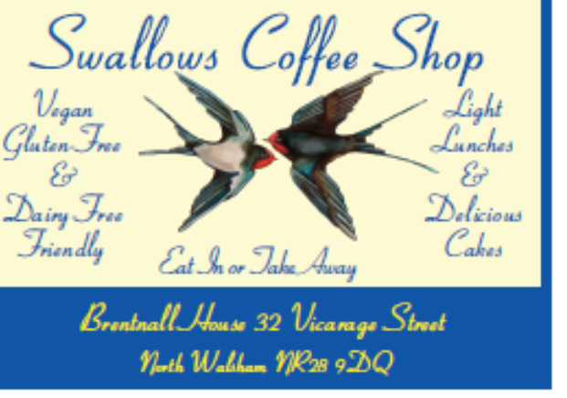


Thank you to everyone for raising donations for St. Nicholas Church, North Walsham with #easyfundraising! If you have not signed up yet, it is easy and completely FREE. 8,100 brands will donate to us when you use easy fundraising to do your everyday online shopping - at no extra cost to you! Every donation you raise makes a difference to us so please sign up & share today. https://join.easyfundraising.org.uk/stnicholaschurchnw/XT7MPH/at/TSX8RX7z/RTND2/facebook/
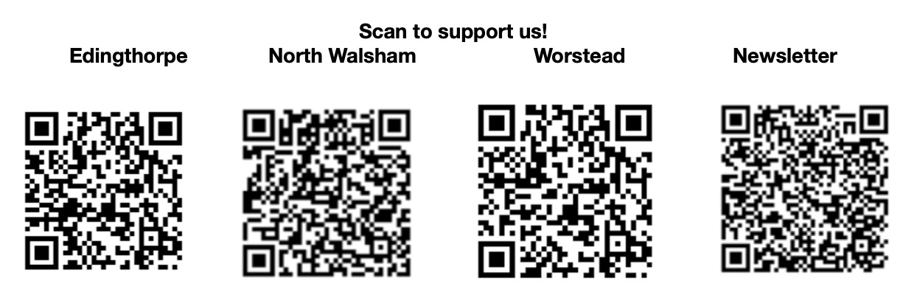


Please support the work of our Churches, by using the contactless giving point at St Nicholas or St Mary’s, leaving your gift on the offering plates or in the wall safes, or through these QR codes. Thank you.

Do you have a Business you would like to advertise in this magazine?
Whole, half or quarter page space is available.
Full Page £ 150.00
Half Page £ 75.00
Quarter Page £ 50.00
Please contact the Benefice office on 01692 408971
or email saintnicholasnw@gmail.com
for details and prices

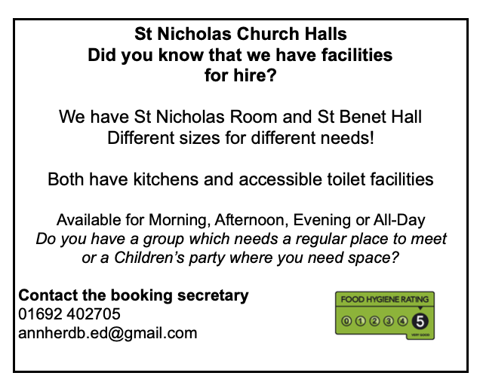
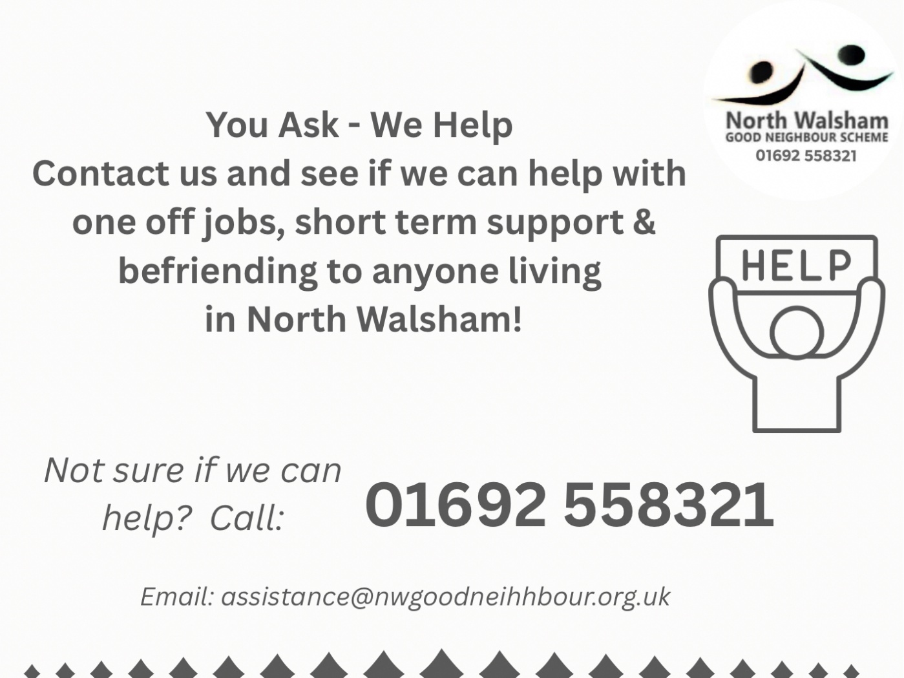

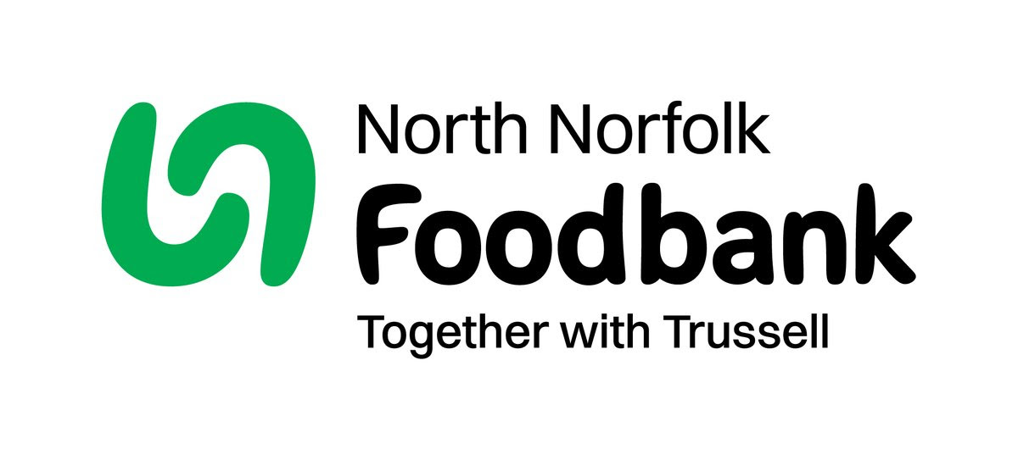
Dear Foodbank supporter,
Thank you for your donation
Receipt and thank you.
Dear Foodbank supporter,
Thank you for your donation from St Nicholas Church
last month of 44.10 kg.
As a small charity we rely on food and financial donations to operate, and we are extremely grateful when people choose to support us.
During the 24/25 year we gave out 2012 food parcels, providing food for 4,520 people; 2,843 adults and 1,677 children.
Whilst Trussell campaigns to end the need for foodbanks, we will be here helping those who need us right now. But that can only be done with kind donations from our supporters.
To see what we need most right now, our wish list is published on our website and social media, and the list gets updated throughout the month on our donation page https://northnorfolk.foodbank.org.uk/give-help/donate-food/
Thank you for thinking of us and enabling us to serve the people facing hardship across our district.
Kind regards
Julie and the Foodbank team
North Norfolk Foodbank
Cromer Methodist Church Hall, West Street, Cromer, NR27 9DT
07826 376343
Ready to tick off your list – Will Made?

"The Church of England have teamed up with Farewills to provide a free will writing service: Online Will Writing Service | Legal Will In 15 Minutes . Anyone can use this service and it is not compulsory to leave something to your church, but it would be nice if you did. It is important for each one of us to leave our earthly matters in good order so why not take advantage of this opportunity now? It is good to remember a gift in your will to a charity is tax free. If you already have a will, you could consider leaving a legacy to the church by adding a codicil. https://farewill.com/norwich-diocese

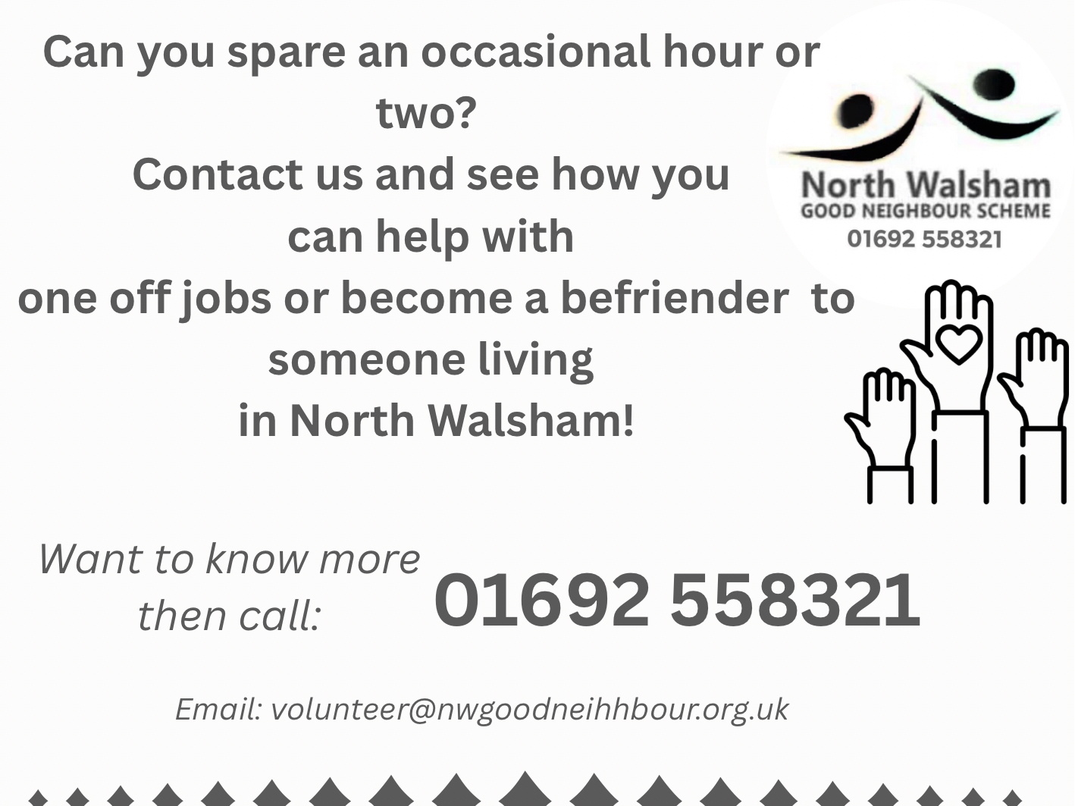

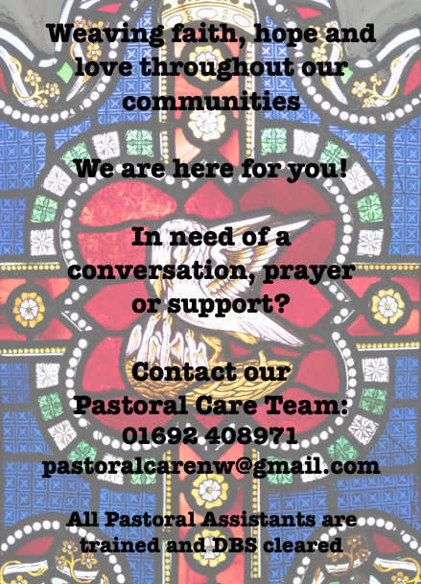

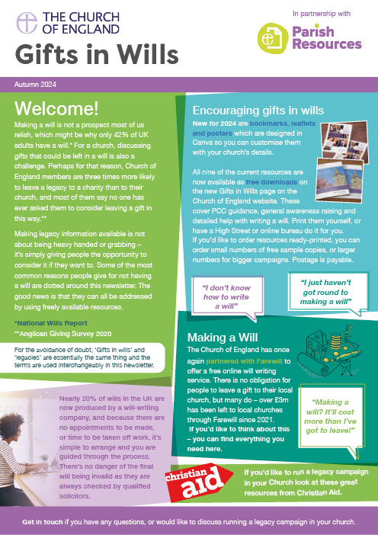
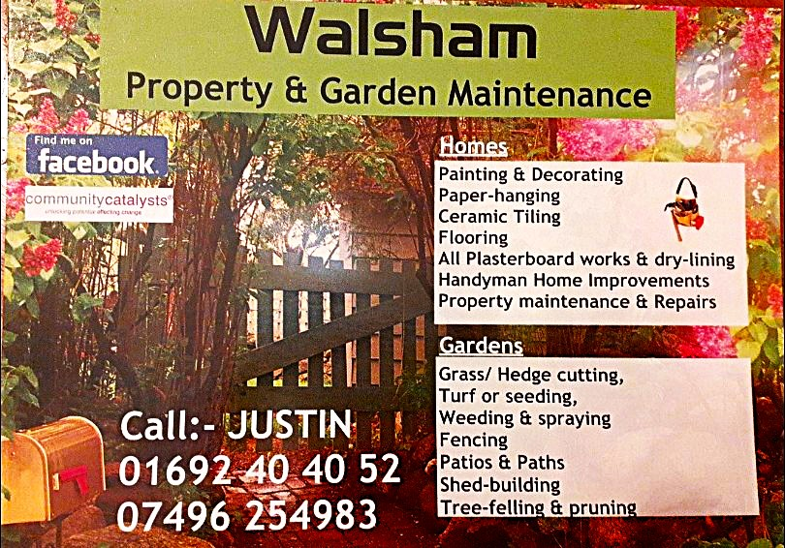

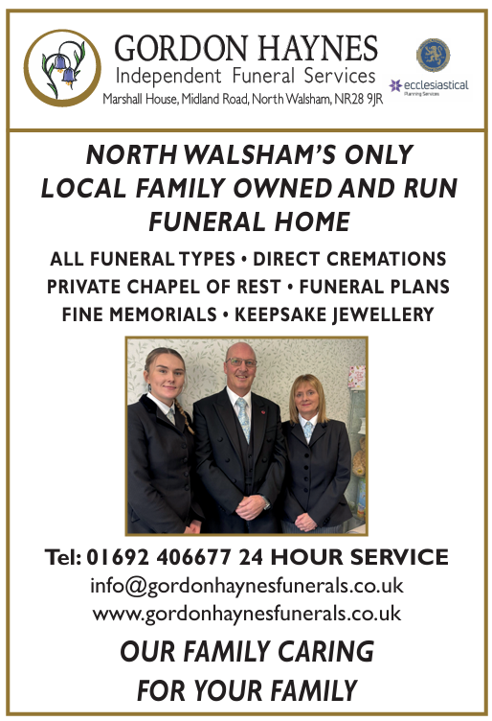
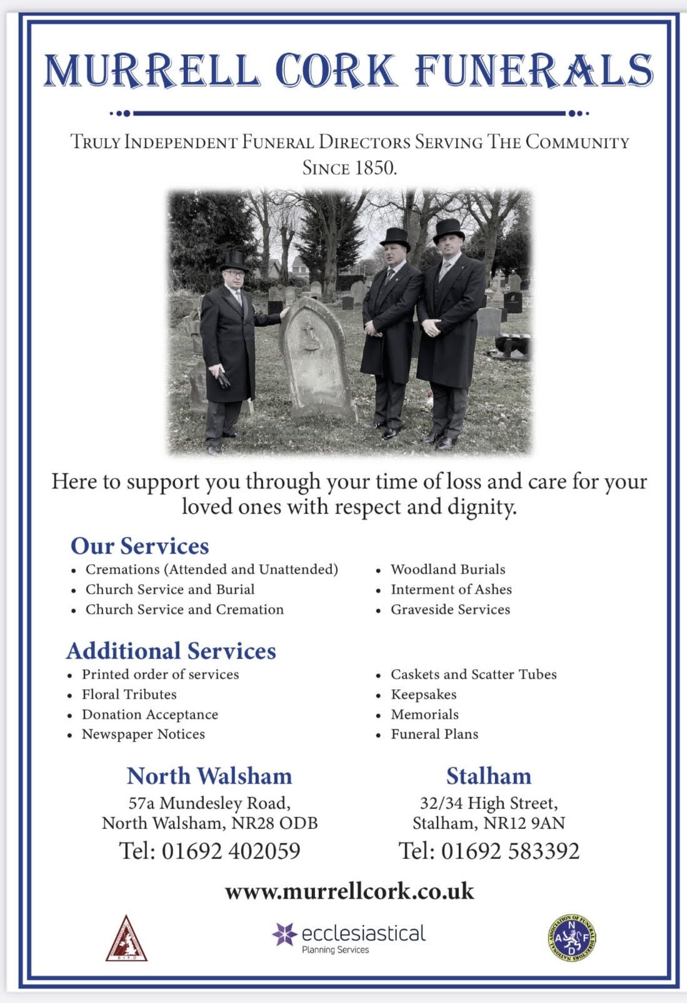
r Sale and Wants Page

Money Matters …
A regular report for our readers written by James Reginald Drake at ClearView Financial Consultants
Burgh Road, Aylsham - 01263 734859, Station Road, Hoveton - 01603 273590 and North Walsham 07773 626662

Lasting Powers of Attorney – Why are they so Important?
Lasting Powers of Attorney (LPA’s) are documents that give an individual you trust (your attorney) the legal authority to make decisions on your behalf should you either lose the mental capacity to make them, or you no longer wish to make these decisions yourself. Lasting Powers of Attorney come in 2 forms, these coming under the heading of ‘Property & Financial Affairs’ and ‘Health & Welfare’
So, how can they help?
The Property & Financial Affairs LPA covers things such as running your bank and savings accounts, making or selling investments, paying bills, buying or selling property and applying for benefits.
The Health & Welfare LPA covers things such as the type of health care and medical treatment you receive (including decisions on life sustaining treatment), where you live, as well as the type of care that you receive in areas such as diet and daily routine.
Given the wide range of areas that these documents cover, it becomes quite obvious as to why they are so important. However, according to ‘The Office of the Public Guardian’ via an article produced in 2022, less than 1% of the UK population have a Lasting Powers of Attorney in place.
So, why do so few people have them in place? One of the most commonly mentioned reasons is that people assume that their spouse will automatically have the right to make decisions for them should they ever reach the stage where they are unable to. This however is a common misconception and it is very often discovered far too late that they actually have no legal authority at all. Cost is another reason people put it off, I can assure you are costs for this type of work are minimal, in the hope this is not a reason to delay.
What should you do?
Well, the answer to this one is quite simple……. get on and set up both types of LPA as soon as you can. It is never too soon to set one up, but it certainly can be too late. By law, once your mental capacity has gone, so has your opportunity to appoint attorneys to act on your behalf. At this point your loved ones will be required to go down a different route and apply to the Court of Protection for a Deputyship order. This requires more forms, more cost and more time, which can all be easily avoided with a bit of forward planning.
So, if setting up Lasting Powers of Attorney(s) is something that you think would benefit you and your loved ones, please feel free to contact me and we can discuss how they can be put in place in a way that is best suited to your own personal requirements.
This short article in no way should be taken by readers as advice.
James can be contacted on either of the above landline numbers or via email at support@smithifa.co.uk
ClearView Financial Consultants is a trading name of Martin Smith Independent Financial Adviser Ltd, a company registered in England
under number 11439150 and authorised and regulated by the Financial Conduct Authority under number 944677.



