The Winterbournes and Compton Valence

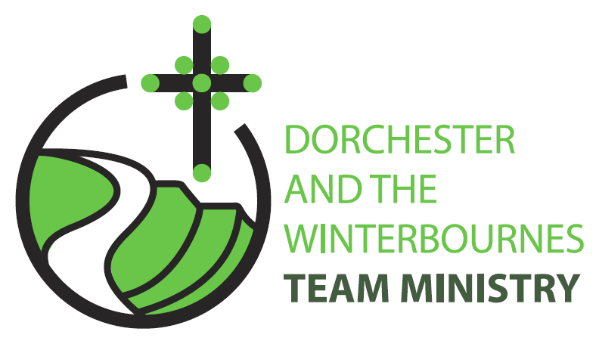

Trinity 4
28th June 2026

Welcome to this service in the Ordinary Season. We rejoice today in God’s presence in our lives and in the lives of those around us. We are reminded that the heart of the gospel is not that God solves every problem, but that God is with us. We reflect on what this means for our ministry in the Winterbourne Valley as we learn to trust the God who remains faithful even when we cannot see the whole picture. In our prayers we continue to pray for refugees and for communities afflicted by war and for the continued peace processes in Iran and Israel and Ukraine.

Collect
Gracious Father,
by the obedience of Jesus
you brought salvation to our wayward world:
draw us into harmony with your will,
that we may find all things restored in him,
our Saviour Jesus Christ.
All: Amen

Reading: Jeremiah 28: 5-9

⁵ Then the prophet Jeremiah spoke to the prophet Hananiah in the presence of the priests and all the people who were standing in the house of the Lord; ⁶ and the prophet Jeremiah said, ‘Amen! May the Lord do so; may the Lord fulfil the words that you have prophesied, and bring back to this place from Babylon the vessels of the house of the Lord, and all the exiles. ⁷ But listen now to this word that I speak in your hearing and in the hearing of all the people. ⁸ The prophets who preceded you and me from ancient times prophesied war, famine, and pestilence against many countries and great kingdoms. ⁹ As for the prophet who prophesies peace, when the word of that prophet comes true, then it will be known that the Lord has truly sent the prophet.’
This is the word of the Lord.
All: Thanks be to God.

Gospel Reading: Matthew 10: 40-42

Hear the Gospel of our Lord Jesus Christ according to Matthew.
All: Glory to you, O Lord.

40 Whoever welcomes you welcomes me, and whoever welcomes me welcomes the one who sent me.
41 Whoever welcomes a prophet in the name of a prophet will receive a prophets reward; and whoever welcomes a righteous person in the name of a righteous person will receive the reward of the righteous;
42 and whoever gives even a cup of cold water to one of these little ones in the name of a disciple-truly I tell you, none of these will lose their reward.

This is the Gospel of the Lord.
All: Praise to you, O Christ.

Post Communion Prayer
Eternal God,
comfort of the afflicted and healer of the broken,
you have fed us at the table of life and hope:
teach us the ways of gentleness and peace,
that all the world may acknowledge
the kingdom of your Son Jesus Christ our Lord.
All: Amen

NOTICES:

Dorchester Choral Society: A celebration of American music: Saturday 27th June 5.30pm, St Martin’s Church
Come along for a wonderful evening celebrating the 250th anniversary of American Independence. Refreshments will be served at the concert. Donations welcome on the night towards the Church.

Winterbournes Parish weekend retreat at Lee Abbey- 2027
If you would be interested in joining a group from our parish churches on a weekend retreat at Lee Abbey next spring/summer, please speak to Cathie (01305 889244) or Nigel (01305 889910).

Lee Abbey is a Christian retreat centre in Lynton, North Devon. Their Renew, Refresh and Resource weekends offer individuals and church groups an opportunity to spend time resting, worshipping, discussing and learning together in a beautiful costal setting.

The cost is around £210 per person for full board (en-suite facilities, of which there is limited availability, cost a little more). If enough people are interested we would be able to receive a group discount.

We think this could be an exciting opportunity for us to have time and a shared experience together listening to God and to each other. There will be time also to participate in a variety of activities.

PRAYERS FOR THE WEEK

From the Franciscan Action Network: Intercessions for Justice and Peace

United in the body of Christ, we pray for all people.

- That our leaders will be dedicated to Your standards of order, equity, and justice

- That we be inspired to work each day against all that creates injustice and oppresses the poor and that we will be strong in this journey

- That the Church continues to proclaim and defend fundamental human rights to life, food, shelter, work, health care, protection of the family, and respect for the dignity of humankind
- That Your holy and life-giving Spirit may so move every human heart, that barriers which divide us may crumble, suspicions disappear, and hatreds cease; that our divisions being
healed, we may live in justice and peace

Lord Jesus, You identified with the poor, the hungry, the captives and the strangers. You spent Your ministry reaching out to the oppressed and abandoned. You reminded us that we will be judged by Your treatment of the “least” of our brothers and sisters.
Expand deep within our hearts a longing to stand with You and the poor, a desire to live a simpler life so that others may simply live, and a passion to work for justice because it has its source in You.
Amen

