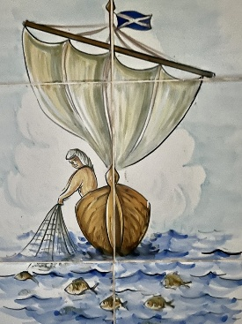
Rota St. Andrew’s Church Puerto Pollensa
June 2026
7th June | 14th May | 21st June | 28th June
First Sunday after Trinity  (Green)  Genesis 12:1-9  Romans 4:13-end  Matthew 9:3-13, 18-26 | Second Sunday after Trinity  (Green)  Genesis 18:1-15  Romans 5:1-8  Matthew 9:35-10.8 | Third Sunday after Trinity  (Green)  Genesis 21:8-21  Romans 6:1-11  Matthew 10:24-39 | Fourth Sunday after Trinity  (Green)  Genesis 22:1-14  Romans 6:12-end  Matthew 10:40-end
Morning Prayer with Vicky pacey  11am | Holy Communion 11am | Holy Communion  11am | Holy Communion 11am
40 Years of the Anglican Church in Puerto Pollensa!
This year we will be celebrating our 40th anniversary of Anglican Worship here in Puerto Pollensa.
Do you have any memories from any point in the last 40 years which you would like to share? Do let me know!
Revd. Sara
chaplain@standrewspuertopollensa.org

