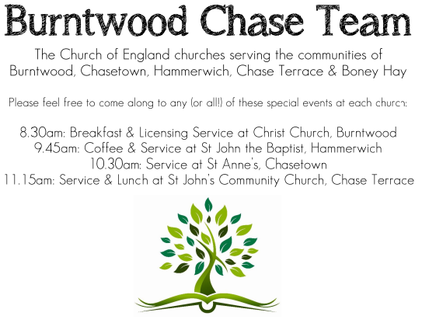
CHRIST CHURCH
Registered Charity Nos. 1217129

SERVICE ON SUNDAY 14th June 2026 at 10am

Holy Communion

2nd Sunday after Trinity

Readings:
Romans 5: 1-8

Therefore, since we are justified by faith, we have peace with God through our Lord Jesus Christ, ² through whom we have obtained access to this grace in which we stand; and we boast in our hope of sharing the glory of God. ³ And not only that, but we also boast in our sufferings, knowing that suffering produces endurance, ⁴ and endurance produces character, and character produces hope, ⁵ and hope does not disappoint us, because God’s love has been poured into our hearts through the Holy Spirit that has been given to us.
⁶ For while we were still weak, at the right time Christ died for the ungodly. ⁷ Indeed, rarely will anyone die for a righteous person—though perhaps for a good person someone might actually dare to die. ⁸ But God proves his love for us in that while we still were sinners Christ died for us.

Matthew 9: 35-10:8
³⁵ Then Jesus went about all the cities and villages, teaching in their synagogues and proclaiming the good news of the kingdom and curing every disease and every sickness. ³⁶ When he saw the crowds, he had compassion for them because they were harassed and helpless, like sheep without a shepherd. ³⁷ Then he said to his disciples, “The harvest is plentiful, but the laborers are few; ³⁸ therefore ask the Lord of the harvest to send out labourers into his harvest.”

The Twelve Apostles
¹⁰ Then Jesus summoned his twelve disciples and gave them authority over unclean spirits, to cast them out, and to cure every disease and every sickness. ² These are the names of the twelve apostles: first, Simon, also known as Peter, and his brother Andrew; James son of Zebedee and his brother John; ³ Philip and Bartholomew; Thomas and Matthew the tax collector; James son of Alphaeus and Thaddaeus; ⁴ Simon the Cananaean and Judas Iscariot, the one who betrayed him.

The Mission of the Twelve
⁵ These twelve Jesus sent out with the following instructions: “Do not take a road leading to gentiles, and do not enter a Samaritan town, ⁶ but go rather to the lost sheep of the house of Israel. ⁷ As you go, proclaim the good news, ‘The kingdom of heaven has come near.’ ⁸ Cure the sick; raise the dead; cleanse those with a skin disease; cast out demons. You received without payment; give without payment.

COLLECT FOR TODAY
O God,
the strength of all those who put their trust in you,
mercifully accept our prayers
and, because through the weakness of our
mortal nature
we can do no good thing without you,
grant us the help of your grace,
that in the keeping of your commandments
we may please you both in will and deed;
through Jesus Christ your Son our Lord,
who is alive and reigns with you,
in the unity of the Holy Spirit,
one God, now and for ever.

WHAT’S GOING ON
Upcoming Services and Events
Wednesday 17th June Morning Prayer 9.30am
Sunday 21st June Morning Worship 10am
Wednesday 24th June Morning Prayer 9.30am
Sunday 28th June Holy Communion 10am

DATES FOR YOUR DIARY
Saturday 27th June Cream Tea 2-4pm
Saturday 11th July Shelfield Choir Concert 7pm
Saturday 14th November Christmas Fayre 2-4pm

Cream Tea

Cream Tea is on Saturday 27th June 2-4pm, tickets available for £6 each.

FLOODLIGHTING
If you think about commemorating a special occasion by floodlighting our Church. Please contact Chris Brown on 01543 683862 for details.

PRAYER CHAIN
Christ Church is blessed with a very active prayer chain. If you, or anyone you know, feel that they would like others to pray for them, please speak to Chris Brown on 01543 683862.

HOME COMMUNION
For anyone who is unable to attend church and would like a Home Visit and Communion, please contact the Vicar and he will be able to carry this out.

VICAR CONTACT DETAILS
Rev’d Stephen Morgan Tele: 07305 852152
CHURCH WARDENS CONTACT DETAILS
Judith Rogers Tele: 01543 324718
Mike Holmes Tele: 01543 672970
Church Office Tele: 01543 642187 [leave a message and we will respond]
Church Web Site:www.christchurchburntwood.org.uk
Church Email: christchurchburntwood15@gmail.com
Facebook: www.facebook.com/group/christchurchburntwood/

Other Contacts
Rev’d Matt Wallace St. John’s, Chase Terrace— Tele: 01543 670078

NEXT SUNDAY SERVICE
Sunday 21st June at 10am
Morning Worship
Romans 6: 1-11
Matthew 10: 24-39
3rd Sunday after Trinity

